Test Ace Ver.6.1 Operation Guide

Copyright

Test Ace Ver.6.1 Operation Guide

The copyright of this software belongs to SystemEXE Inc., the licensor of this documet.

This software and Installation Guide are protected by copyright laws.

Reproduction and distribution of any part of this software and Installation Guide without permission is prohibited by law. The software described in this Installation Guide is provided under a license agreement contract. SystemEXE Inc. cannot guarantee that there is no error in this Installation Guide. The information described in this Installation Guide is subject to change without notice in accordance with product specifications.

This product includes software developed by Apache Software Foundation (<http://www.apache.org/>) [ Note 1 ]

Java Runtime Environment and Java SE Development Kit are products of Oracle Corporation and/or its affiliates.

ORACLE JDBC DRIVER is a product of Oracle Corporation.

Microsoft SQL Server JDBC Driver is a product of Microsoft Corporation.

PostgreSQL is Copyright 1996-2014 by the PostgreSQL Global Development Group.

JDBC Driver of PostgreSQL is distributed under the same license with PostgreSQL.

For other Open Source Software (OSS), usage of their copyrights is based on their licenses respectively.

In this document, the © mark is omitted.

【Distribution Note】

[ Note 1 ]

・Source Text (Apache License, Version 1.1)

"This product includes software developed by the Apache Software Foundation (http://www.apache.org/)."

・Source Text (Apache License, Version 2.0)

Licensed under the Apache License, Version 2.0 (the "License");

you may not use this file except in compliance with the License.

You may obtain a copy of the License at

http://www.apache.org/licenses/LICENSE-2.0

Unless required by applicable law or agreed to in writing, software

distributed under the License is distributed on an "AS IS" BASIS,

WITHOUT WARRANTIES OR CONDITIONS OF ANY KIND, either express or implied.

See the License for the specific language governing permissions and

limitations under the License.

Registered Trademark

Company names, system names, product names mentioned in this software and installation guide are either trademarks or registered trademarks of their respective owners.

Microsoft and SQL Server are either registered trademarks or trademarks of Microsoft Corporation in the United States and/or other countries.

Oracle and Java are registered trademarks of Oracle and/or its affiliates in the United States and/or other countries.

Oracle Database 10g, Oracle Database 11g, Oracle Database 12c are trademarks or registered trademarks of Oracle Corporation in the United States and/or other countries.

PostgreSQL is a trademark or registered trademark of PostgreSQL in the United States and/or other countries.

Test Ace is a trademark of SystemEXE Inc.

In this document, ™ and ® marks are omitted.

Index

1. Introduction 1

1.1 Target Audience 1

1.2 Document Structure 1

2 About Test Ace 2

3 Create Test Data 3

3.1 Test Ace Startup 3

3.1.1 Run Test Ace from Start Menu 3

3.1.2 Run Test Ace from Desktop Shortcut 4

3.1.3 Input Password 4

3.2 Connection Settings 5

3.2.1 Outline of Connection Info 5

3.2.2 DB Connection Settings 5

3.2.3 File Connection Settings 8

3.3 Create Dataflow 11

3.3.1 Display New Dataflow Screen 11

3.3.2 Save Dataflow 12

3.4 Input Info Settings 19

3.4.1 Outline of Input Info 19

3.4.2 DB Input Info Settings 20

3.4.3 File Input Info Settings 24

3.5 Conversion Settings 28

3.5.1 Display Conversion Settings Screen 28

3.5.2 Data Analysis 31

3.5.3 Conversion Rule Settings 33

3.5.4 Preview 36

3.5.5 Save Conversion Settings 38

3.6 Output Info Settings 38

3.6.1 Outline of Output Info 38

3.6.2 DB Output Info Settings 39

3.6.3 File Output Info Settings 41

3.7 Settings Validation 43

3.7.1 Press “Validation” Button 43

3.7.2 Validation Result 44

3.8 Run Conversion Processing 46

3.8.1 Press “Run” Button 46

3.8.2 Execution Result 49

3.9 Report Confirmation 51

3.9.1 Display Report 51

3.10 Exit Test Ace 53

3.10.1 Exit Test Ace from Menu 53

3.10.2 Exit Test Ace from Window 54

4 Create Test Data Automatically 55

4.1 CUI Run Settings 55

4.1.1 Select Dataflow 55

4.1.2 Display CUI Run Settings Screen 56

4.1.3 CUI Run Settings 58

4.1.4 CUI Run Log File Output 59

4.1.5 CUI Run Trigger File Output 62

4.1.6 Save CUI Run Settings 64

4.1.7 Close CUI Run Settings Screen 65

4.1.8 Register Trigger File 65

5 Screen Explanation 66

5.1 Main Screen 66

5.1.1 Screen Outline 66

5.1.2 Dataflow Menu 67

5.1.3 Environment Settings Menu 67

5.1.4 Help 68

5.1.5 Create New Group 69

5.1.6 Change Group Name 69

5.1.7 Delete Group 70

5.1.8 Create New Dataflow 72

5.1.9 Copy & Paste Dataflow 75

5.1.10 Edit Dataflow 77

5.1.11 Delete Dataflow 79

5.1.12 Dataflow Detail 80

5.2 DB Connection Info Screen 84

5.2.1 Screen Outline 84

5.2.2 Create New DB Connection Info 85

5.2.3 Edit DB Connection Info 90

5.2.4 Delete DB Connection Info 92

5.2.5 Create New Group 93

5.2.6 Change Group Name 94

5.2.7 Delete Group 95

5.3 File Connection Info Screen 96

5.3.1 Screen Outline 96

5.3.2 Create New File Connection Info 97

5.3.3 Edit File Connection Info 99

5.3.4 Delete File Connection Info 100

5.3.5 Create New Group 101

5.3.6 Change Group Name 102

5.3.7 Delete Group 103

5.4 Pseudo Data Screen 104

5.4.1 Screen Outline 104

5.4.2 Create New Pseudo Data 105

5.4.3 Edit Pseudo Data 111

5.4.4 Delete Pseudo Data 113

5.4.5 Create New Group 114

5.4.6 Change Group Name 115

5.4.7 Delete Group 117

5.5 User-Defined Functions Screen 118

5.5.1 Screen Outline 118

5.5.2 Create New User-Defined Functions 119

5.5.3 Edit User-Defined Functions 122

5.5.4 Delete User-Defined Funtions 123

5.5.5 Create New Group 124

5.5.6 Change Group Name 125

5.5.7 Delete Group 126

5.5.8 Create User-Defined Functions 127

5.5.9 Location of User-Defined Functions 150

5.6 User Password Change Screen 151

5.6.1 Screen Outline 151

5.6.2 Change User Password 151

5.7 Pseudo Data Coefficient Eigenvalue Initial Value Settings Screen 153

5.7.1 Screen Outline 153

5.7.2 Change Initial Value of Coefficient and Eigenvalue 154

5.8 CUI Run Login File Screen 157

5.8.1 Screen Outline 157

5.8.2 Change the Setting of CUI Login File Output Destination 158

5.9 Conversion By The Column Name Settings Screen 160

5.9.1 Screen Outline 160

5.9.2 Add Conversion By The Column Name Settings 161

5.9.3 Delete Conversion By The Column Name Settings 164

5.9.4 Delete All Conversion By The Column Name Settings 165

5.10 Help Screen 166

5.10.1 Screen Outline 166

5.11 Version Information Screen 167

5.11.1 Screen Outline 167

5.11.2 End-User License Agreement Display 167

5.12 DB Input Information Screen 169

5.12.1 Screen Outline 169

5.12.2 DB Connection Info Selection 170

5.12.3 Table Selection Screen 171

5.12.4 Reference Relationship Notification At The Time Of Selection 172

5.12.5 Reference Relationship Notification Screen 173

5.13 DB Output Information Settings Screen 177

5.13.1 Screen Outline 177

5.13.2 DB Connection Information Selection 178

5.14 File Input Information Settings Screen 179

5.14.1 Screen Outline 179

5.14.2 File Connection Information Selection 180

5.14.3 File Selection Screen 181

5.15 File Output Information Settings Screen 182

5.15.1 Screen Outline 182

5.15.2 File Connection Information Selection 183

5.16 Conversion Settings Screen 184

5.16.1 Screen Outline 185

5.16.2 Conversion Settings Line Data 187

5.16.3 Conversion Setting Column Data 189

5.16.4 Multiple Columns Conversion Settings 215

5.16.5 Data Analysis 218

5.16.6 Extraction Condition 221

5.16.7 Import 226

5.16.8 Export 228

5.16.9 Preview 229

5.16.10 Reference Relationship 231

5.16.11 Refresh 237

5.16.12 Data Type That Can Be Converted 239

5.17 Report Settings Screen 242

5.17.1 Screen Outline 242

5.17.2 Output Converted Data in Report 243

5.18 CUI Settings Screen 244

5.18.1 Screen Outline 244

5.18.2 CUI Run 245

5.18.3 CUI Settings Validation 246

5.19 DB Output Destination Screen 247

5.19.1 Screen Outline 247

5.19.2 DB Output Destination Settings 251

5.19.3 Clear DB Output Destination Settings 252

5.20 DB Output Screen 253

5.20.1 Screen Outline 253

5.20.2 DB Output Settings 254

5.21 Format Setting Screen 256

5.21.1 Screen Outline 256

6 Constraint 257

6.1 Windows 2008 Server’s User Account Control Feature 257

6.1.1 Outline 257

6.1.2 Detail 257

6.1.3 Avoid Restriction 257

6.2 Conversion Issue regarding Microsoft Windows Codepage 932 Shift – JIS and Unicode 257

6.2.1 Outline 257

6.2.2 Detail 257

6.3 Oracle JDBC Driver’s Character Consistency Problem 258

6.3.1 Outline 258

6.3.2 Detail 258

6.4 PostgreSQL JDBC Driver’s Error Message Garbled Text 259

6.4.1 Outline 259

6.4.2 Detail 259

6.5 Test Ace Feature Constraint 259

6.5.1 Constraint of the Conversion Types “Foreign Key”, “Dependent Column” 259

6.5.2 Constraint of User-Specific Pseudo Data Registration 259

6.5.3 Constraint of creating new user-Specific Pseudo Data 259

# Introduction

This document explains how to operate “Test Ace Ver.6.1” (Test Ace). Please read this document carefully before operating this software.

## Target Audience

This document is written for users who want to operate Test Ace.

## Document Structure

Part 1, “Introduction”

This part gives the outline of this document.

Part 2, “About Test Ace”

This part gives general explanation about Test Ace.

Part 3, “Create Test Data”

This part shows the steps to create test data.

Part 4, “Create Pseudo Data Automatically”

This part shows the steps to create test data automatically.

Part 5, “Screen Explanation”

This part explains each screen in Test Ace.

Part 6, “Constraint”

This part discusses about constraints.

# About Test Ace

Test Ace is a software used for creating test data, setting conversion rules to convert data based on database’ info.

The created test data are output to database or file.

Below are the main features.

1. Analyze table attribute info of database.

(2) Convert personal info data of a software product to similar string.

(3) Output converted test data to database or file.

(4) Output a report of converted content.

# Create Test Data

This part explains about the chain of operations from starting Test Ace to creating test data to exiting Test Ace.

## Test Ace Startup

You can run Test Ace from Start Menu or its desktop shortcut.

### Run Test Ace from Start Menu

1. Click “Start” – “Test Ace” – “Test Ace Login”

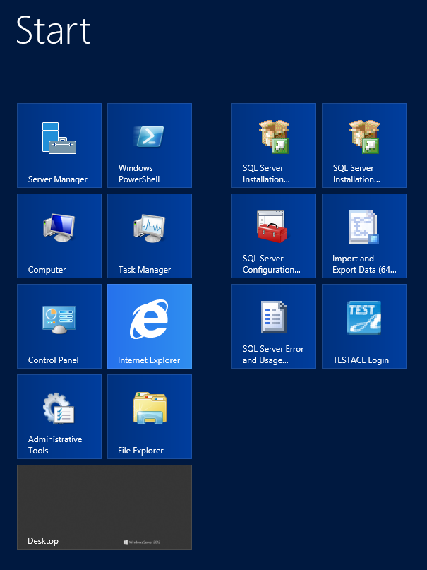

### Run Test Ace from Desktop Shortcut

1. Double click on shortcut icon from desktop.

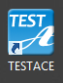

### Input Password

(1) Input user name and password, click “Log in”.

For user name, input “system”.

The default password to log in for the first time after installation is “system”.

※Please change password after the first time you log in.

For how to change password, please refer to “5.6.2 Change User Password”.

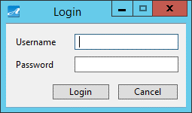

1. Then Main screen of Test Ace is displayed.

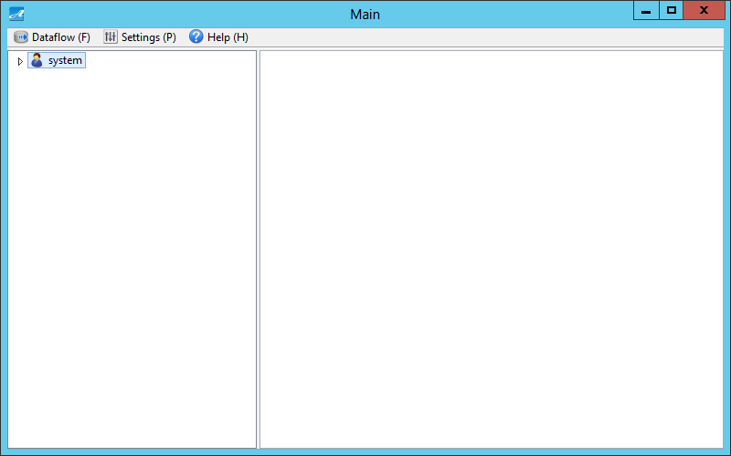

## Connection Settings

This section explains about connection settings for file or database in Test Ace.

### Outline of Connection Info

Test Ace acquires data which will be converted from database. You can select the output destination of the converted test data to be database or file. Before creating test data, you need to set database connection, file connection in Test Ace.

### DB Connection Settings

1. From menu bar on Main Screen, click “Settings (P)” - “Connection Info (C)” - “DB Connection Info (D)”.

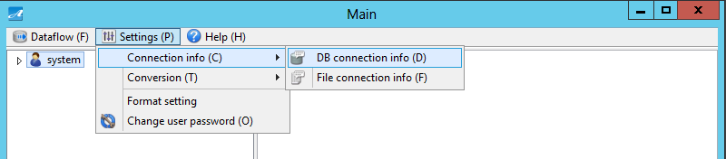

1. On the tree view of the left window, right click on a group under “DB Connection Info”, then click “DB new connection info”.

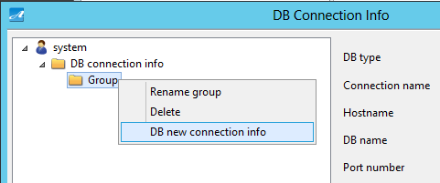

1. Input the values for these items, then click “Test connection”.

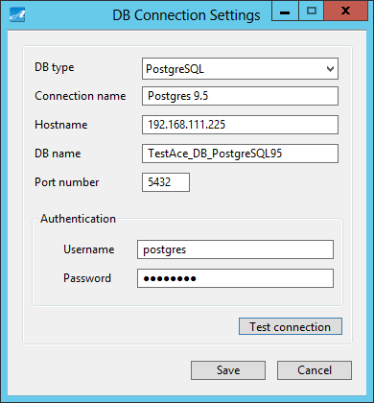

※For information about items to be input, please refer to “5.2.2 Create New DB Connection Information”.

1. Then a message is displayed to inform that connection test has been run successfully. Click “OK”.

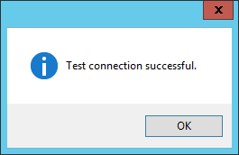

1. Click “Save”.
2. Then DB connection settings are displayed on screen.

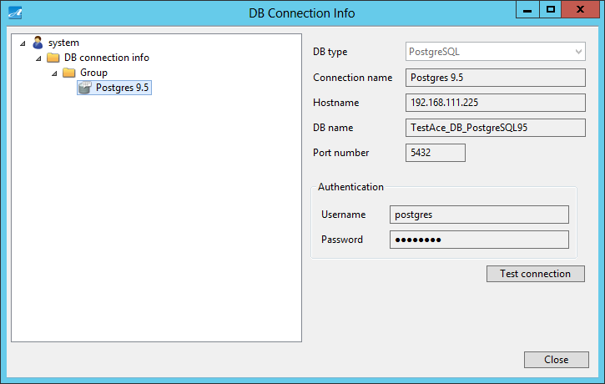

### File Connection Settings

1. From menu bar on Main screen, click “Settings (P)” - “Connection Info (C)” - “File Connection Info (F)”.

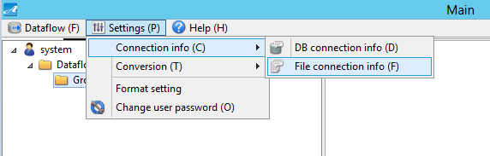

1. On the tree view of the left window, right click on a group under “File Connection Info”, then click on “New file connection info”.

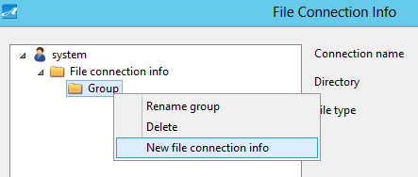

1. Input values for displayed items, then click “Save”.

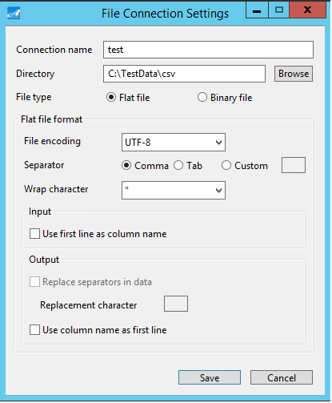

※ For more information about items to be input, please refer to “5.3.2 Create New File Connection Info”.

1. Then file connection settings are displayed on screen.

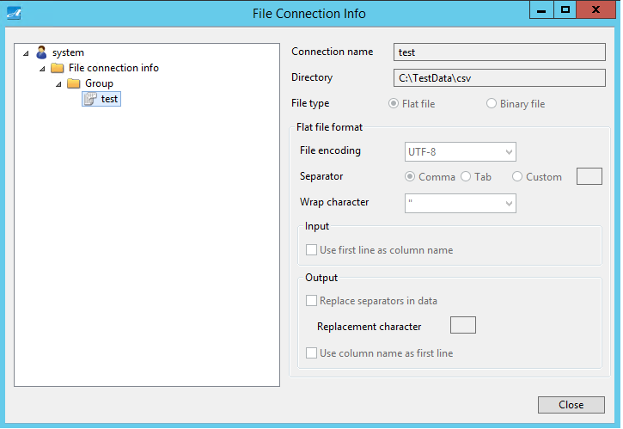

## Create Dataflow

This section explains how to create Dataflow in Test Ace.

### Display New Dataflow Screen

1. On the tree view of the left window, right click on a group, then click on “New Dataflow”.

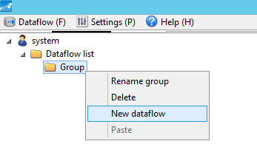

1. Then a screen is displayed to create new Dataflow.

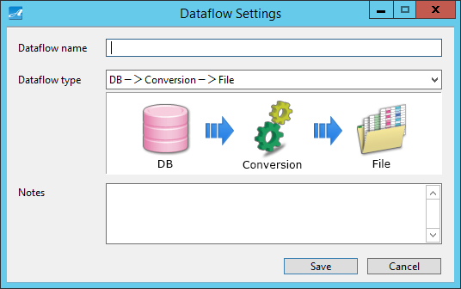

### Save Dataflow

(1) On Dataflow Settings screen, input values for displayed items.

(2) Click “Save”.



Below are types of Dataflow.

※Depending on the license, you may or may not select some Dataflow type.

①DB - > Conversion - > File

Select this one if input data is Database, and you want to output test data to File after the conversion processing.

②DB - > Conversion - > DB

Select this one if input data is Database, and you want to output test data to Database after the conversion processing.

③Load

Select this one if you want to output converted test data File to Database.

④File - > Conversion - > File

Select this one if input data is File, and you want to output test data to File after the conversion processing.

⑤Generation - > File

Select this one if you want to output test data to File after data is generated.

⑥Generation - > DB

Select this one if you want to output test data to Database after data is generated.

(2) After that, Dataflow is created.

①If you select the Dataflow type “DB - > Conversion - > File”:

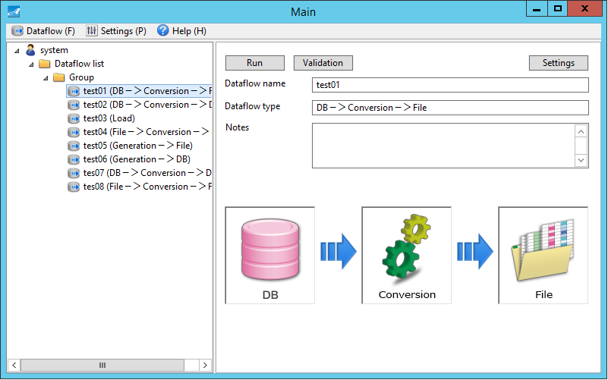

After that, you need to “set DB Input Info”, “set Conversion Info”, “set File Output Info”.

Please refer to “3.4.2 DB Input Info Settings”, “3.5 Conversion Settings”, “3.6.3 File Output Info Settings”.

② If you select the Dataflow type “DB - > Conversion - > DB”:

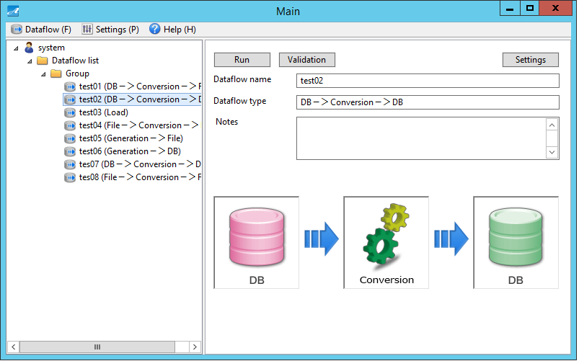

After that, you need to “set DB Input Info”, “set Conversion Info”, “set DB Output Info”.

Please refer to “3.4.2 DB Input Info Settings”, “3.5 Conversion Settings”, “3.6.2 DB Output Info Settings”.

③ If you select the Dataflow type “Load”:

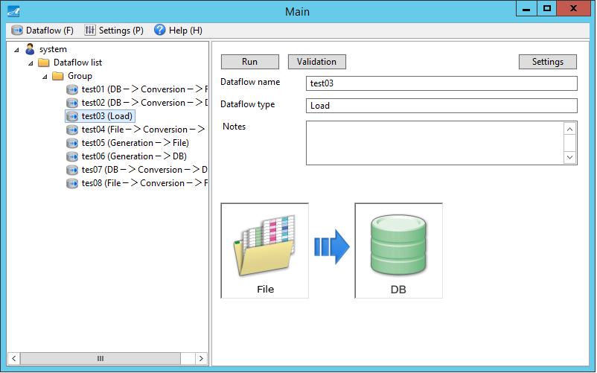

After that, you need to “set File Input Info”, “set DB Output Info”.

Please refer to “3.4.3 File Input Info Settings”, “3.6.2 DB Output Info Settings”.

④ If you select the Dataflow type “File - > Conversion - > File”:

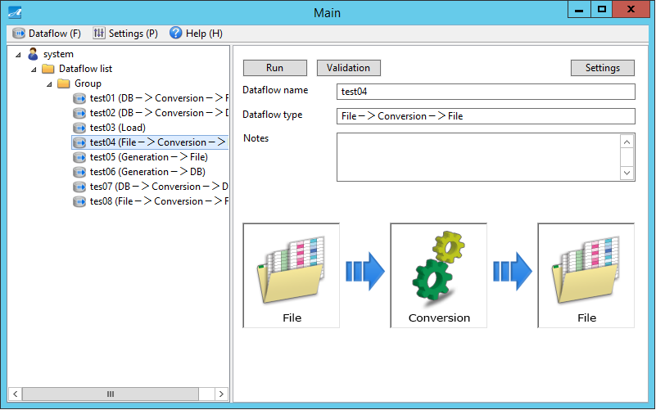

After that, you need to “set File Input Info”, “set Conversion Info”, “set File Output Info”.

Please refer to “3.4.3 File Input Info Settings”, “3.5 Conversion Settings”, “3.6.3 File Output Info Settings”.

⑤ If you select the Dataflow type “Generation - > File”:

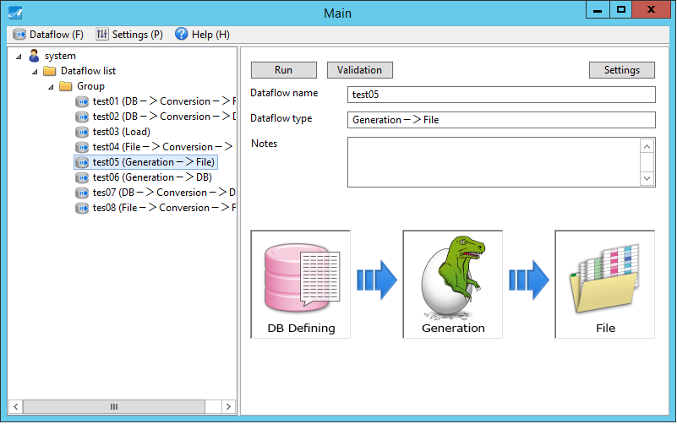

After that, you need to “set DB Defining Info”, “set Conversion Info”, “set File Output Info”.

The process of “setting DB Defining Info” is the same with the description in “3.4.2 DB Input Info Settings”.

Please refer to “3.4.2 DB Input Info Settings”, “3.5 Conversion Settings”, “3.6.3 File Output Info Settings”.

⑥ If you select the Dataflow type “Generation - > DB”:

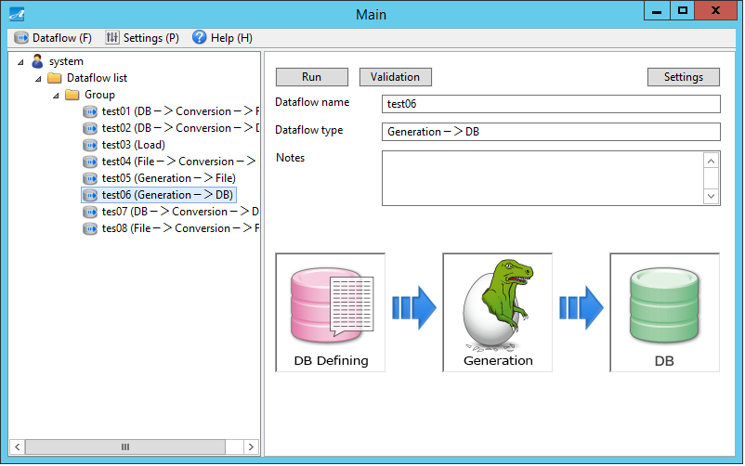

After that, you need to “set DB Defining Info”, “set Conversion Info”, “set DB Output Info”.

The process of “setting DB Defining Information” is the same with the description in “3.4.2 DB Input Information Settings”.

Please refer to “3.4.2 DB Input Info Settings”, “3.5 Conversion Settings”, “3.6.2 DB Output Info Settings”.

## Input Info Settings

This section explains about settings of input info of DB and / or file in Test Ace.

### Outline of Input Info

Input info varies depending on the Dataflow type which you select when creating Dataflow.

(1) If you select the Dataflow types “DB - > Conversion - > File” and “DB - > Conversion - > DB”:

Input info will be “DB Input Info” related to where data is acquired. Data is then converted during the conversion processing.

Setting is done by “DB Input Information Settings”.

(2) If you select the Dataflow types “Load” and “File - > Conversion - > File”:

Input info will be “File Input Info” meaning the test data file.

Setting is done by “File Input Info Settings”.

(3) If you select the Dataflow types “Generation - > File” and “Generation - > DB”:

Input info will be “DB Input Info” related to where DB Defining Info is acquired during data generation processing.

Setting is done by “DB Defining Info Settings”.

### DB Input Info Settings

1. On the tree view on the left window of Main screen, select a dataflow.
2. Click on “DB Input Info Settings” icon on the right window.

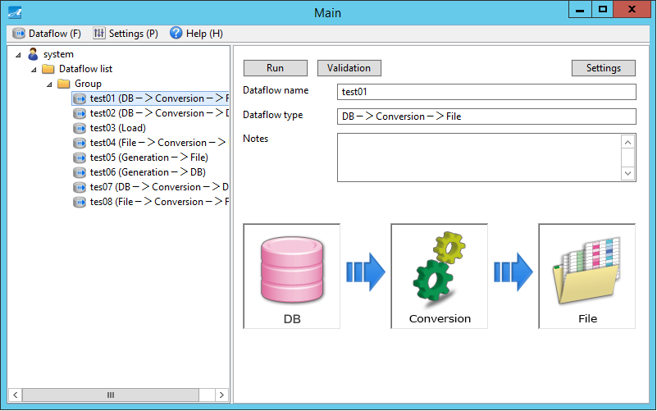

If Dataflow type involves “Generation”, click on “DB Defining Info Settings” icon on the right window.

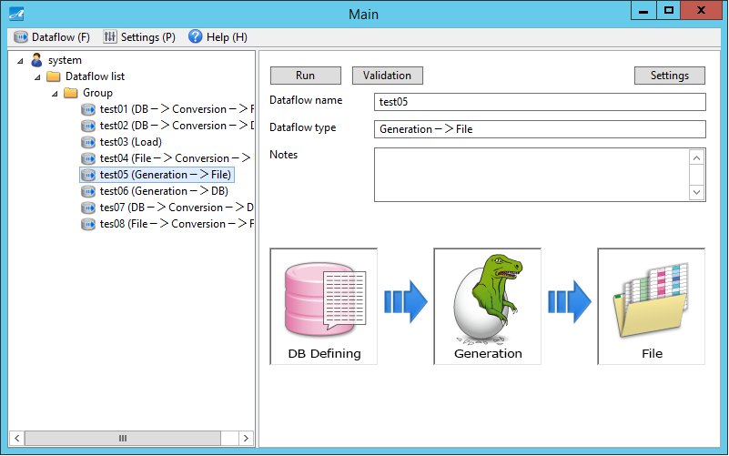

1. Then DB Input Information screen is displayed.
2. On the tree view of the left window, select a DB connection info.
3. If necessary, click “Test connection”.
4. Click “Next”.

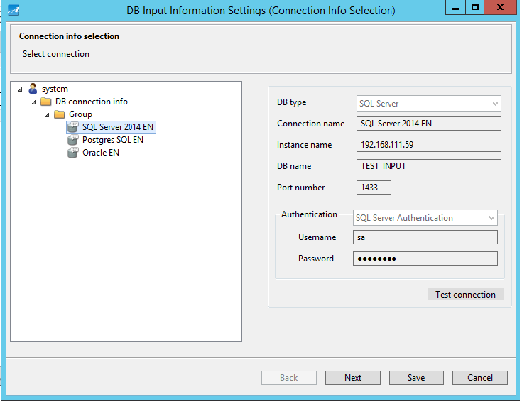

1. Table Selection screen is displayed.
2. If necessary, select an option under “Reference relationship notification at the time of selection”.
3. From the left side of the screen, select the table from which you want to acquire data that will be converted, then click “>” to move it to the right window.
4. Click “Save”.

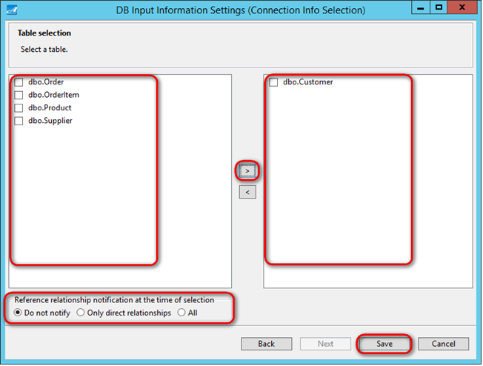

※For more information about items to be input, please refer to “5.12.3 “Table Selection Screen”, “5.12.4 Reference Relationship Notification at the time of Selecting”, “5.12.5 “Reference Relationship Notification Screen”.

### File Input Info Settings

1. On the tree view on the left window of Main screen, select a dataflow.
2. On the right window, click on “File Input Info Settings” icon.

If Dataflow type is “Load”, below screen is shown.

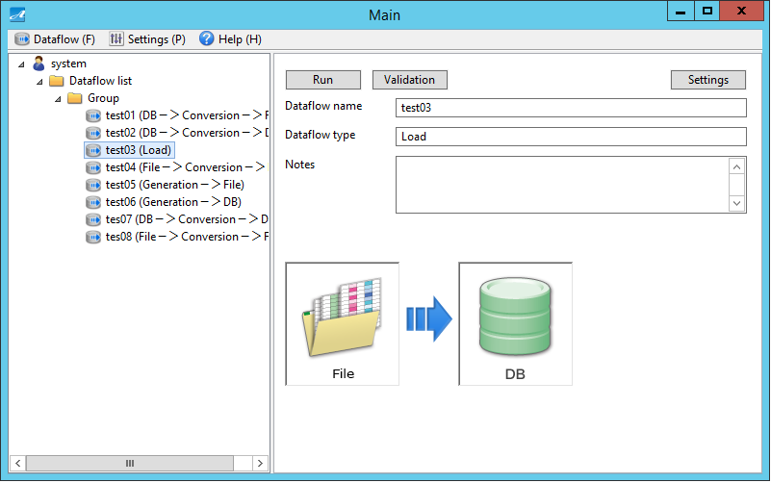

If Dataflow type is “File - > Conversion - > File”, below screen is shown.

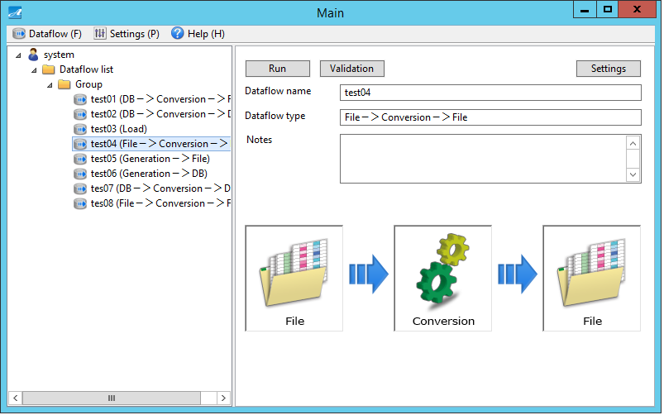

1. File Input Information Settings screen is displayed.
2. On the tree view of the left side of the screen, select “File Connection Info”.
3. Click “Next”.

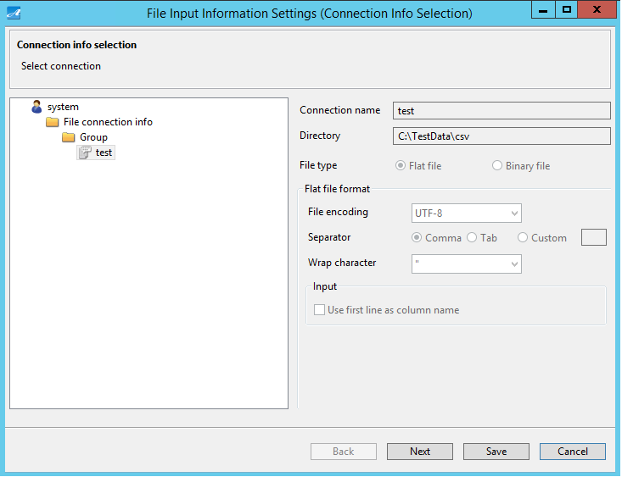

※If Dataflow type is “Load”, select “File Connection Information” with File Type is “Binary File”.

If Dataflow type is “File - > Conversion - > File”, select “File Connection Information” with File Type is “Flat”.

1. File Selection screen is displayed.
2. Select the target file from the left window, then click “>” to move it to the right window.
3. Click “Save”.

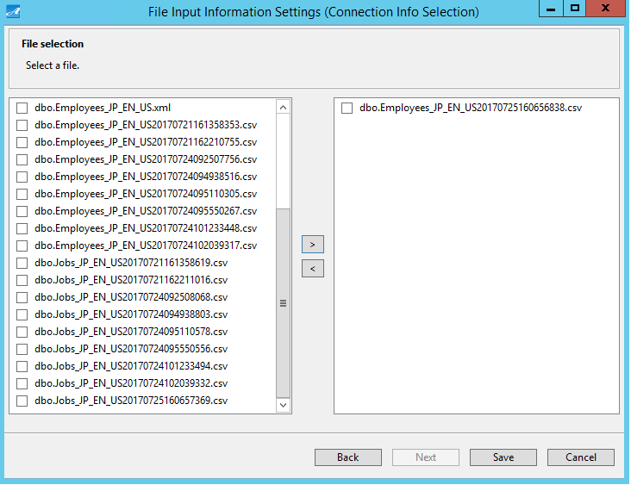

※For more information about items to be input, please refer to “5.14.3 File Selection Screen”.

## Conversion Settings

This section explains how to set conversion info which establishes conversion rules.

For more information about conversion rules, please refer to “5.16 Conversion Settings Screen”.

### Display Conversion Settings Screen

1. On the tree view of the left window of Main screen, select “Dataflow”.
2. On the right window, click on “Conversion Info Settings” icon.

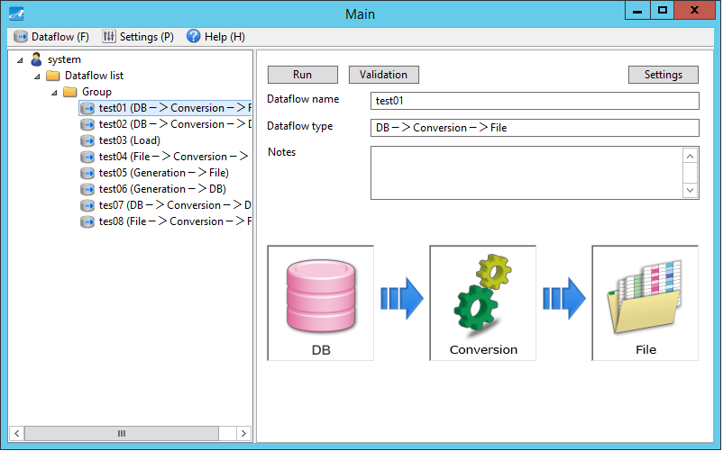

If Dataflow type involves “Generation”, on the right window, click on “Generation Info Settings” icon.

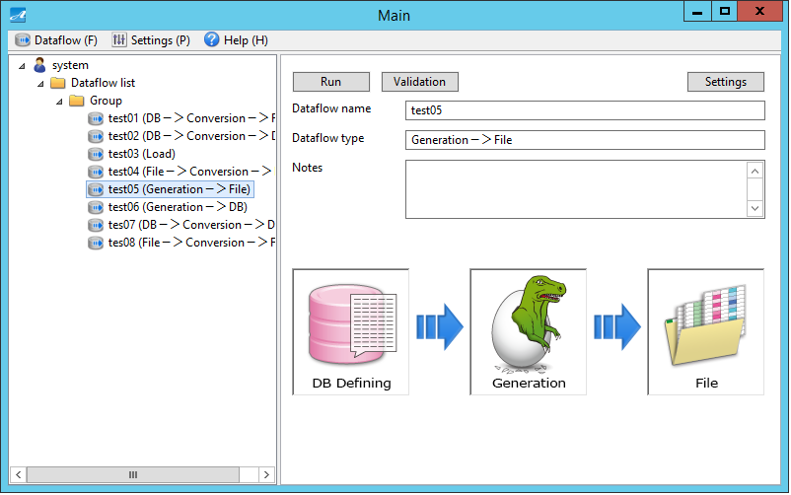

(3) Conversion Settings screen is displayed.

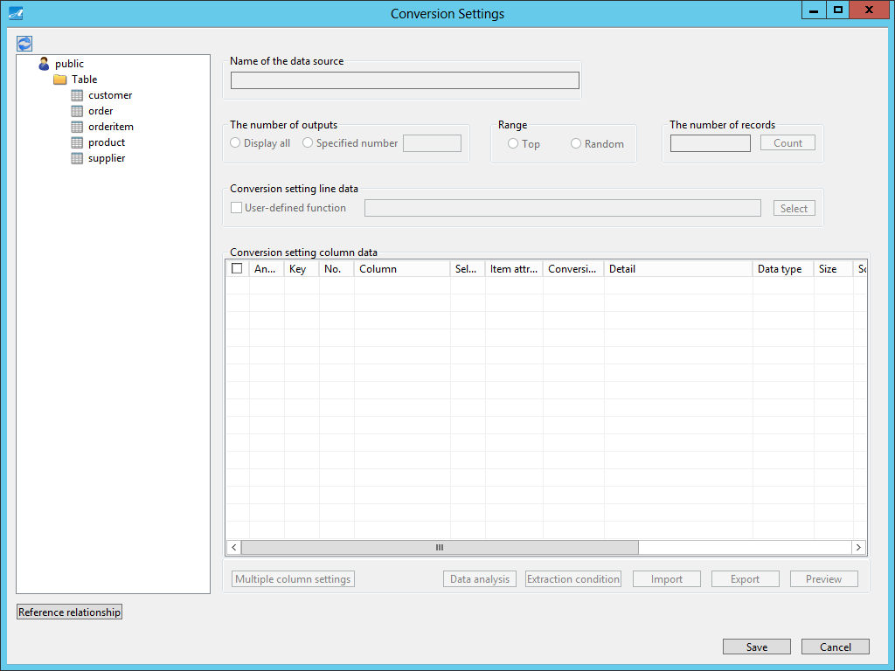

### Data Analysis

Data Analysis helps to recognize personal information from product data by using special algorithm (patent-acquired technology).

Columns which are deemed to contain personal information can be automatically set with appropriate system-default conversion rules to enhance data protection when test data is created.

1. On the tree view of the left window, select the input data for which you want to create conversion rules.

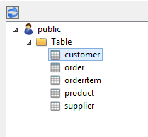

1. Click on “Data analysis”.

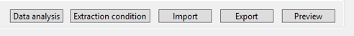

1. Data Analysis screen is displayed.
2. If necessary, set the number of samplings to be used for analysis.
3. Click “Run”.

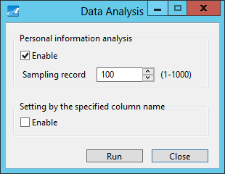

1. A screen is displayed to confirm your action. Click “Yes”.

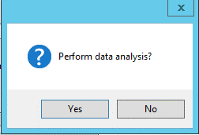

1. After analysis is done, a screen is displayed to inform data analysis has completed. Click “OK”.

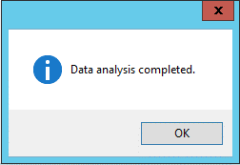

1. Conversion rules are automatically set based on analysis result.

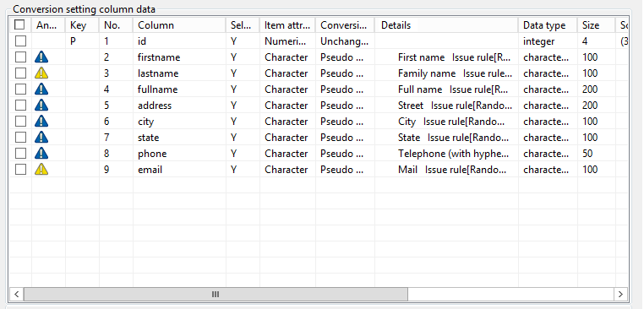

※ For more information about icons on this screen, please refer to “5.16.5 Data Analysis”.

### Conversion Rule Settings

This section explains how to set conversion rules manually.

1. Among the fields of Conversion Settings Column Data, double click on the rows for which you want to set conversion rules.



1. Conversion Settings Detail screen is displayed.

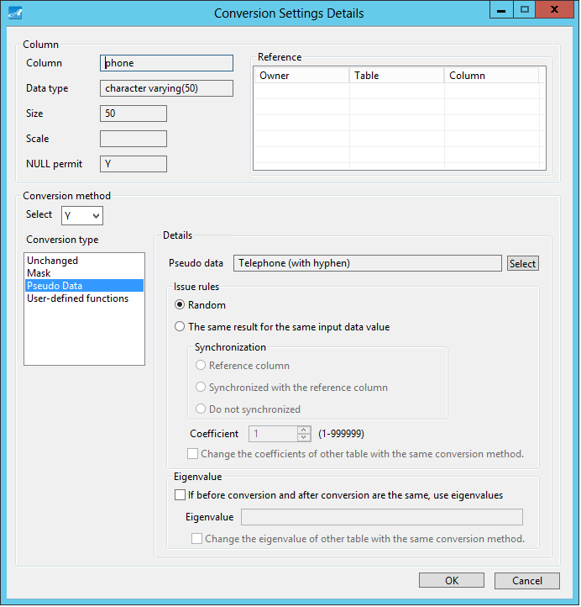

1. Select a conversion type.
2. Items of the selected conversion type are displayed.
3. Set values for these items.
4. Click “OK”.

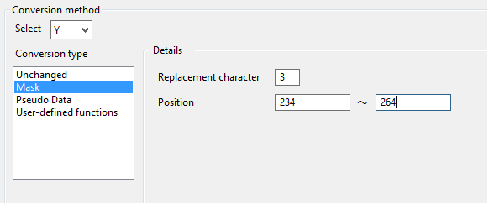

1. Then conversion rule settings are applied.

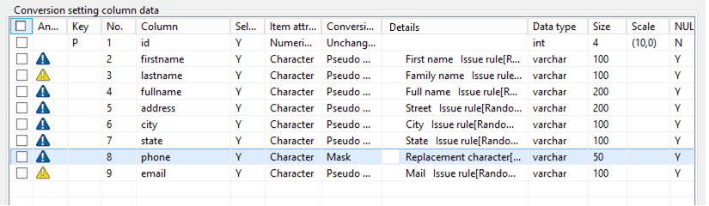

※ For more information about conversion rules, please refer to “5.16.3 Conversion Settings Column Data”.

### Preview

Check result of the conversion rules.

1. Click on “Preview”



1. If necessary, set the number of data record to be previewed.
2. Click “Run”.

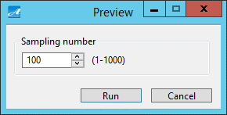

1. A message is displayed to confirm execution. Click “Yes”.

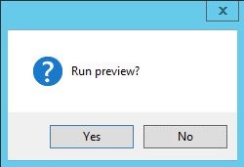

1. A message is displayed to inform that data length will be adjusted after pseudo data conversion. Click “OK”.

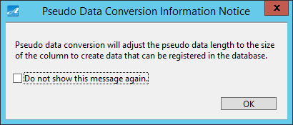

1. A message is displayed to inform that preview has been completed. Click “OK”.

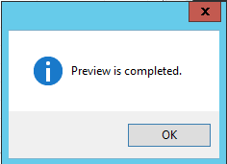

1. Then preview result is displayed.

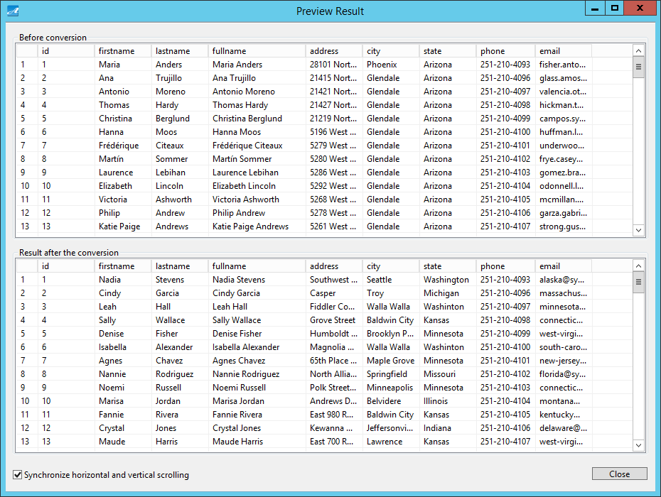

※ For more information, please refer to “5.16.9 Preview”.

### Save Conversion Settings

Save settings of conversion rule.

1. Click “Save”.

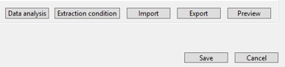

1. Then Conversion Settings screen is closed and you are returned to Main screen.

## Output Info Settings

This section explains how to set database and file output info in Test Ace.

### Outline of Output Info

Output Info varies depending on the Dataflow type which was selected when creating Dataflow.

(1) If you select the Dataflow types “DB - > Conversion - > DB”, “Load” and “Generation - > DB”,

Output Info will be “DB Output Info” related to the database which outputs test data.

Setting is done by “DB Output Info Settings”.

(2) If you select the Dataflow types “DB - > Conversion - > File”, “File - > Conversion - > File” and “Generation - > File”,

Output Info will be “File Output Info” related to test data file.

Setting is done by “File Output Info Settings”.

### DB Output Info Settings

1. On the tree view on the left window of Main screen, select a dataflow..
2. Click on “DB Output Info Settings” icon on the right window.

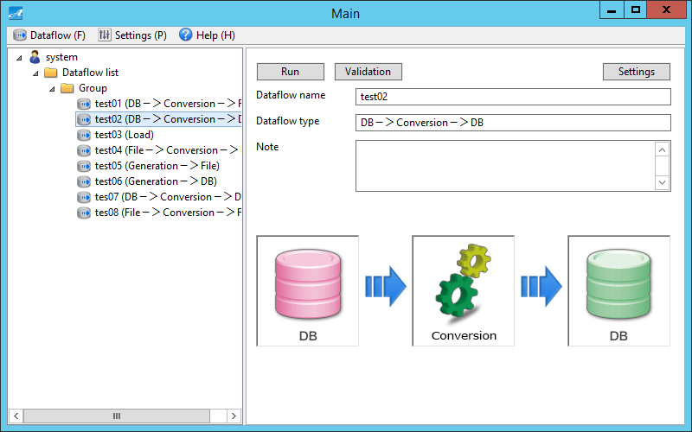

1. DB Output Information Settings screen is displayed.
2. On the tree view of the left window, select a DB connection info.
3. If necessary, click “Test connection”.
4. Click “Save”.

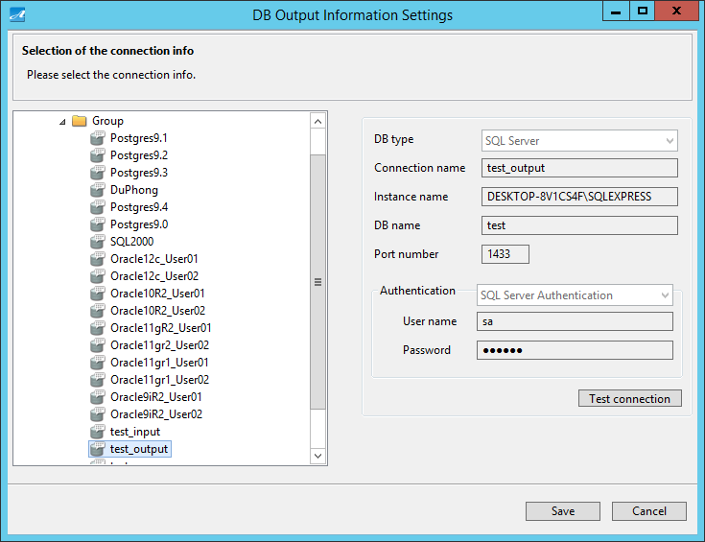

※ For more information, please refer to “5.13.2 DB Connection Info Selection”.

### File Output Info Settings

1. On the tree view on the left window of Main screen, select a dataflow.
2. Click on “File Output Info Settings” icon on the right window.

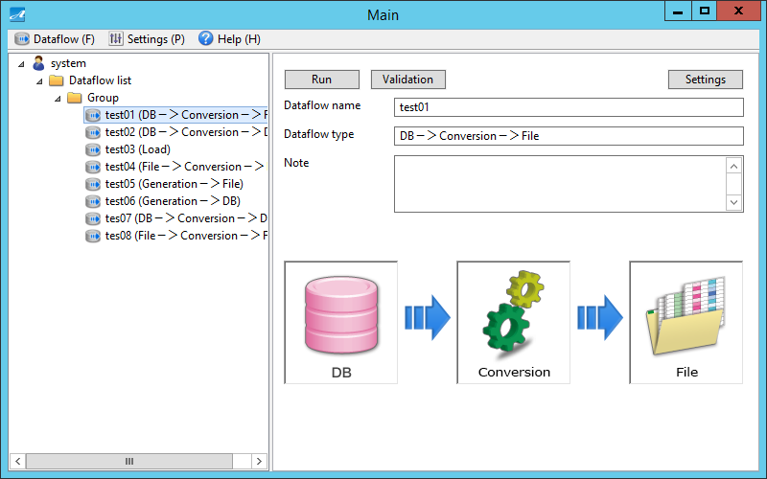

1. File Output Information Settings screen is displayed.
2. On the tree view of the left window, select a file connection info.
3. Click “Save”.

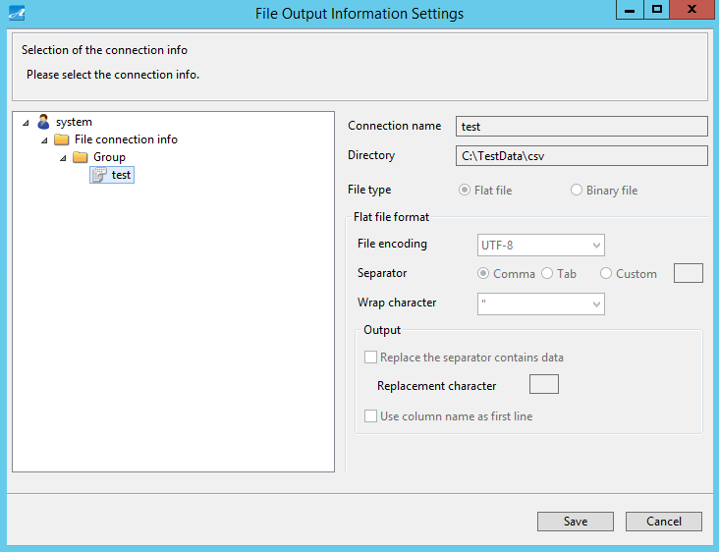

※ For more information, please refer to “5.15.2 File Connection Info Selection”.

※ If Dataflow type is “File - > Conversion - > File”, select “File Connection Information” with file type is “Flat”.

## Settings Validation

This section explains about validation of Dataflow.

### Press “Validation” Button

1. On the tree view on the left window of Main screen, select a dataflow.
2. Click “Validation” on the right window.

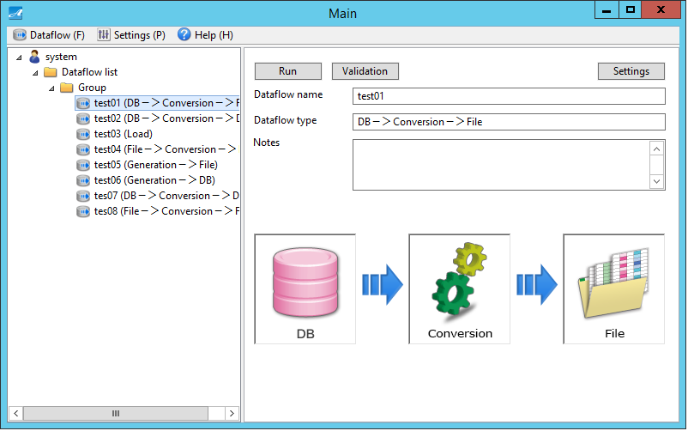

### Validation Result

1. If setting has been done successfully, below screen is displayed.

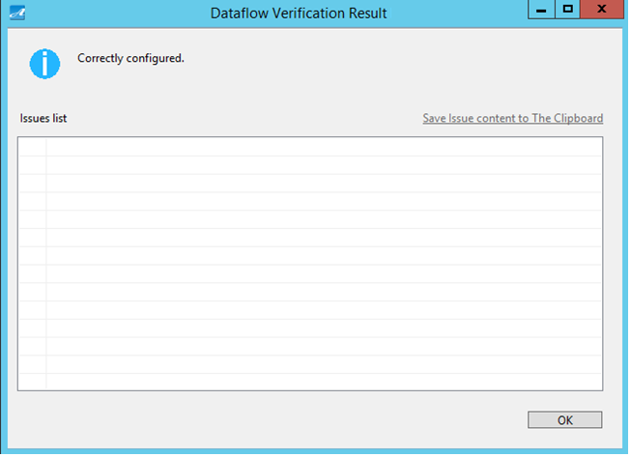

1. If setting is not done correctly, below screen is displayed.

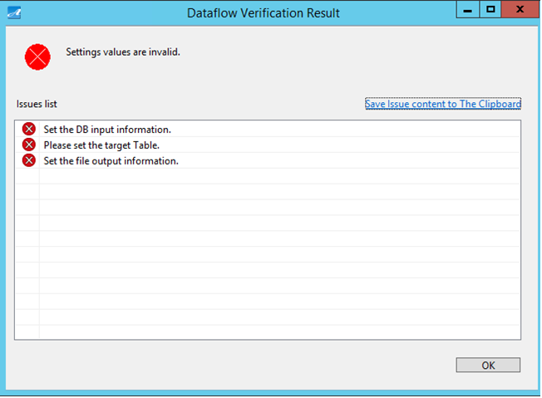

## Run Conversion Processing

This section explains how to run the conversion processing.

### Press “Run” Button

1. On the tree view on the left window of Main screen, select a dataflow.
2. On the right window, click “Run”.

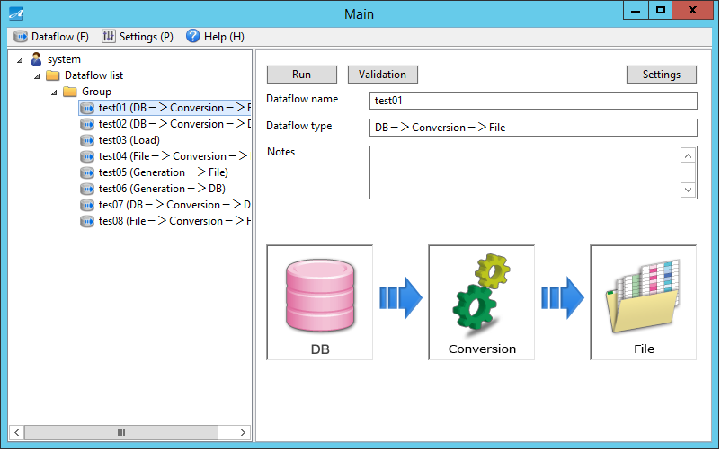

1. A message is displayed to confirm your action. Click “Run”.

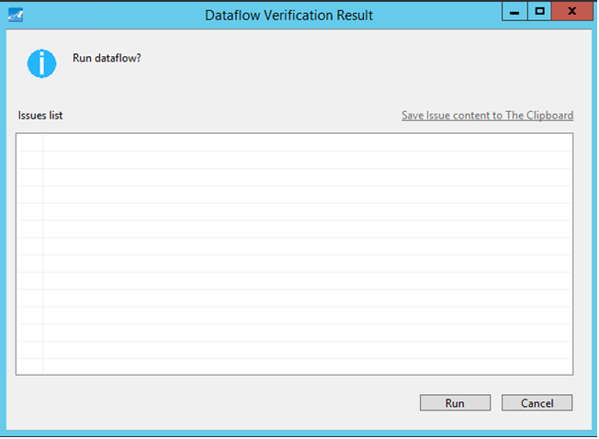

1. A message is displayed to inform that data length will be adjusted after pseudo data had been converted. Click “OK”.



1. Execution progress is displayed.

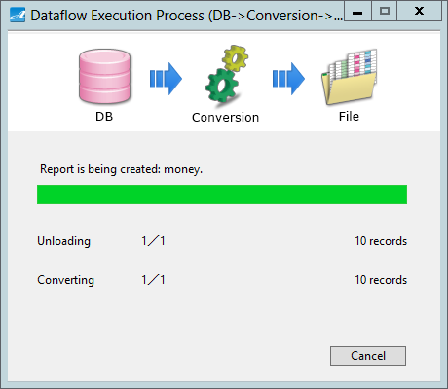

1. A message is displayed to inform that execution has finished. Click “OK”.

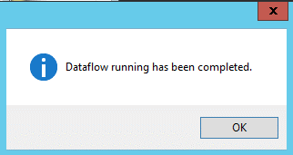

### Execution Result

(1) If you select the Dataflow type “DB - > Conversion - > File”,

By “DB Input Info Settings”, data is acquired from database.

By “Conversion Info Settings”, data is converted based on conversion rules.

By “File Output Info Settings”, test data files are output to directory in “file” format.

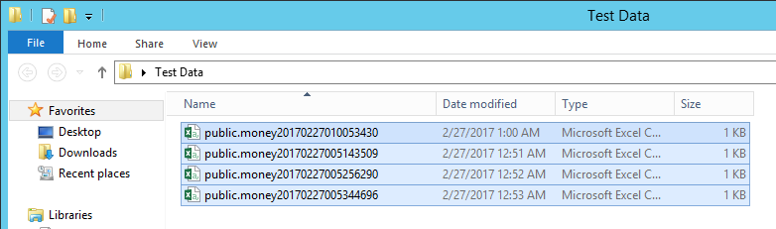

(2) If you select the Dataflow type “DB - > Conversion - > DB”,

By “DB Input Info Settings”, data is acquired from database.

By “Conversion Info Settings”, data is converted based on conversion rules.

By “DB Output Info Settings”, test data is output to database.

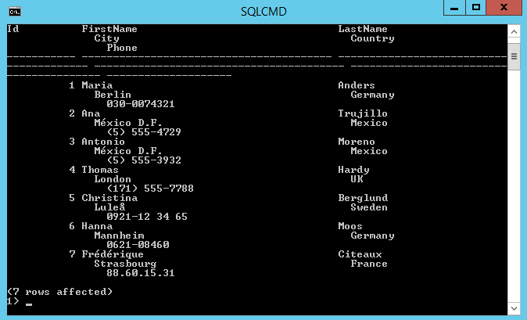

(3) If you select the Dataflow type “Load”,

By “File Input Info Settings”, the system reads test data files.

By “DB Output Info Settings”, test data is output to database.

(4) If you select the Dataflow type “File - > Conversion - > File”,

By “File Input Info Settings”, data is acquired from files.

By “Conversion Info Settings”, data is converted based on conversion rules.

By “File Output Info Settings”, test data files are output to directory in “file” format.

(5) If you select the Dataflow type “Generation - > File”,

By “Generation Info Settings”, data is converted based on conversion rules.

By “File Output Info Settings”, test data files are output to directory in “file” format.

(6) If you select the Dataflow type “Generation - > DB”,

By “Generation Info Settings”, data is converted based on conversion rules.

By “DB Output Info Settings”, test data is output to database.

## Report Confirmation

This section explains about report.

Information like table name, number of test data, conversion related info etc. are output into report.

※ There is no report for the Dataflow type “Load”.

### Display Report

1. After running Dataflow, report output location is displayed. The default folder for outputting report is [Test Ace Installation Folder]\testace_home\work\user\report.

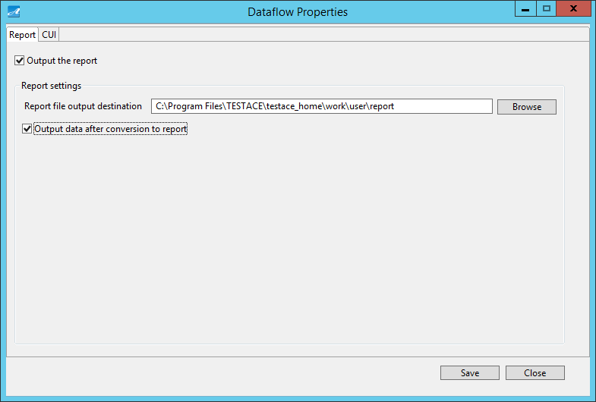

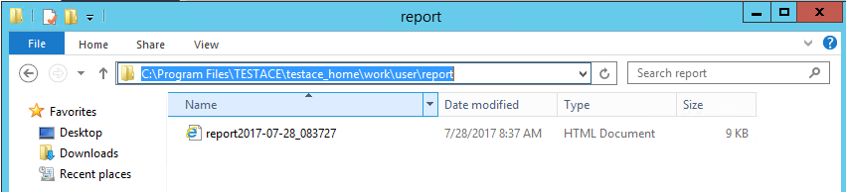

(2) Display report.

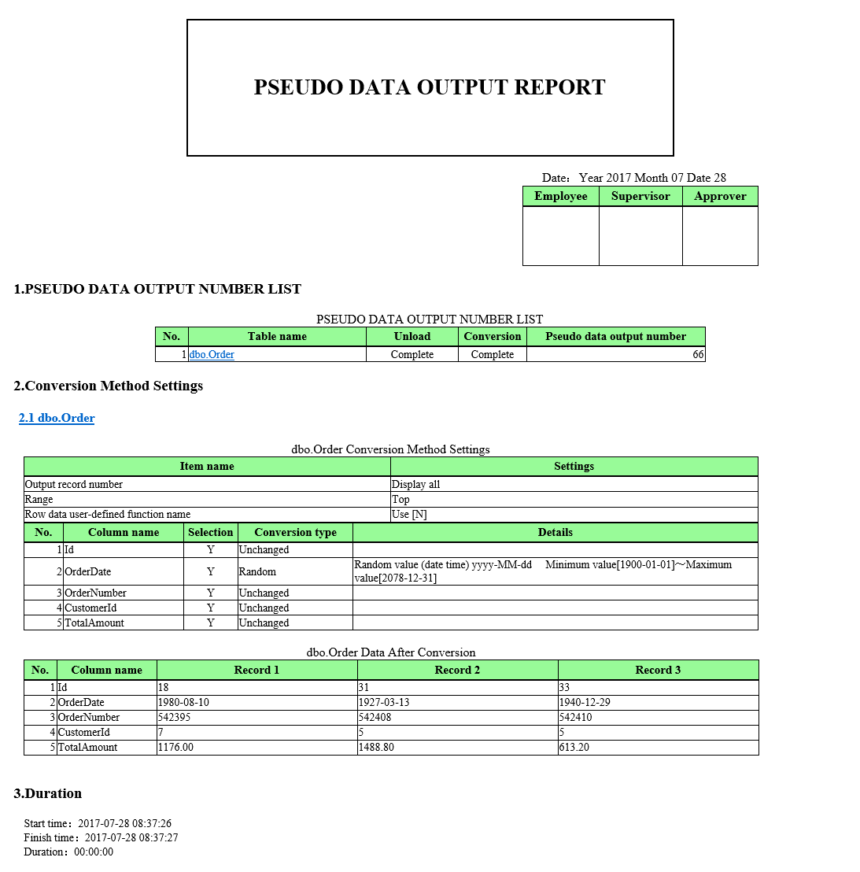

## Exit Test Ace

This section explains about exitting Test Ace.

### Exit Test Ace from Menu

1. From Menu Bar of Main screen, “Dataflow (F)” - Click “Exit (X)”

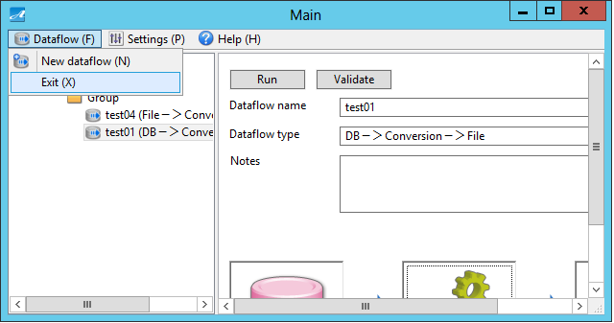

1. A message is displayed to confirm your action. Click “Yes”.

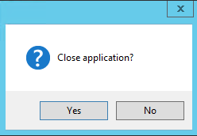

### Exit Test Ace from Window

1. Click on x button on the upper right corner of window.

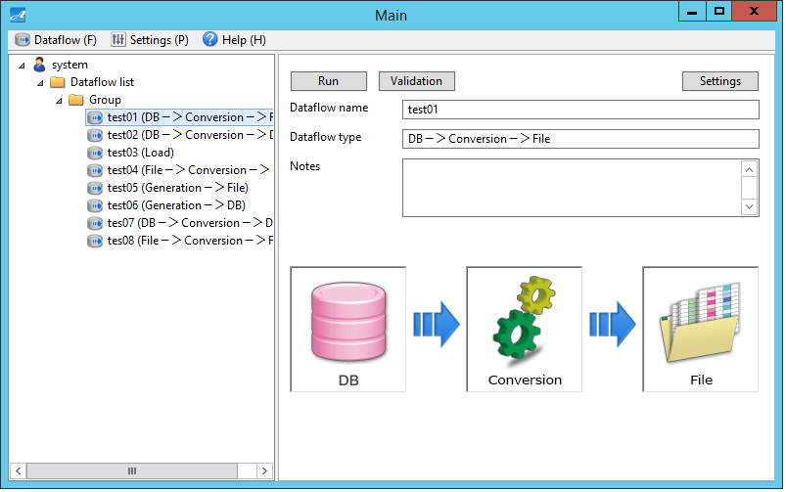

1. A message is displayed to confirm your action. Click “Yes”.



# Create Test Data Automatically

This part explains how to create test data automatically.

## CUI Run Settings

This section explains about CUI run settings which help to create test data automatically.

### Select Dataflow

1. On the tree view of the left window, select a dataflow.



### Display CUI Run Settings Screen

1. On the right window, click “Settings”.



1. Click on “CUI” tab.
2. Then CUI Run Settings screen is displayed.

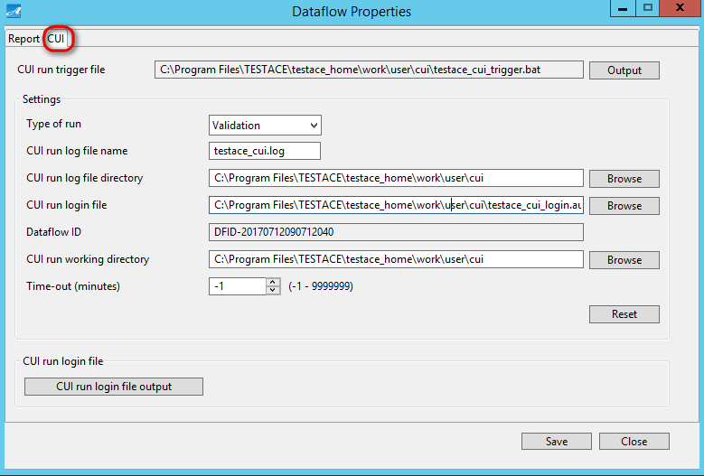

### CUI Run Settings

1. Input values for items under “Settings”.

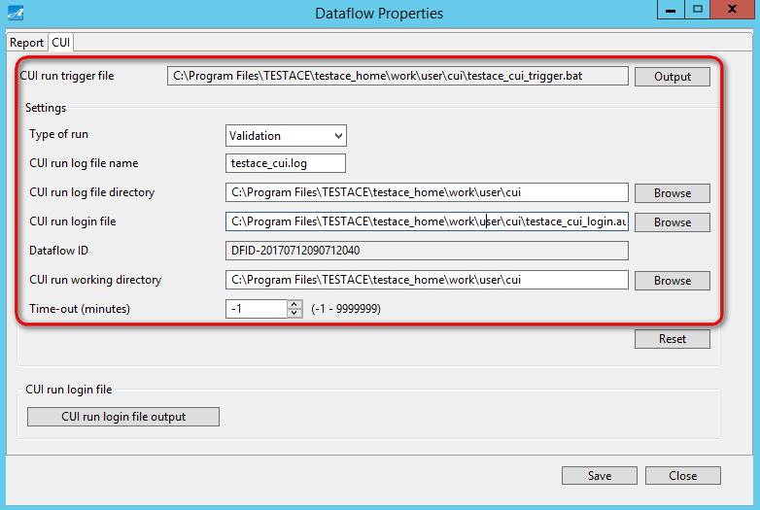

※For more information about items to be input, please refer to “5.18.1 Screen Outline”.

### CUI Run Log File Output

1. Click on “CUI Run Log File Output” on the lower left of CUI Run Settings screen.

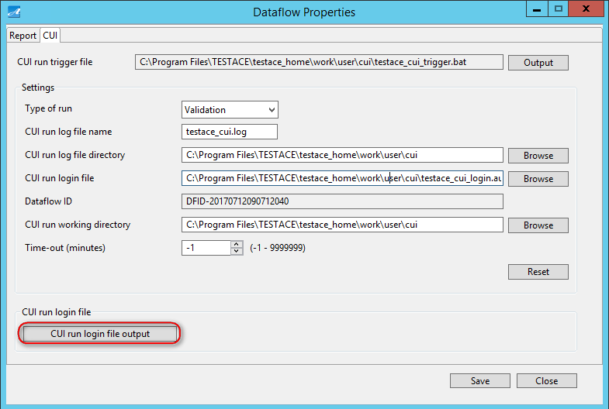

1. Then CUI Run Log File Output screen is displayed.
2. Click “Output”.

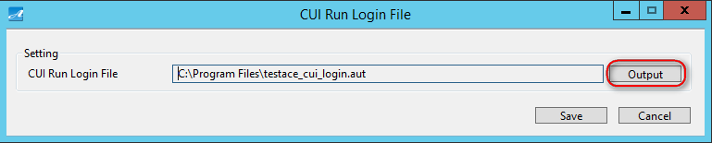

1. Set a location, then click “Save”.

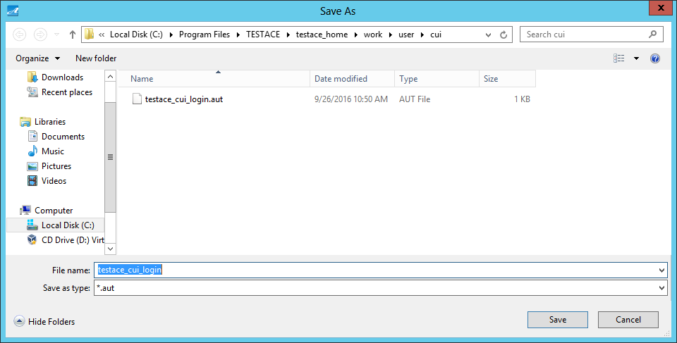

1. A message is displayed to inform that file has been output successfully. Click “OK”.

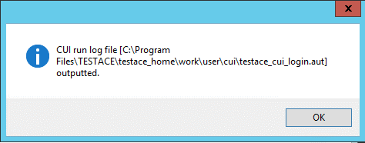

1. Click “Save”.

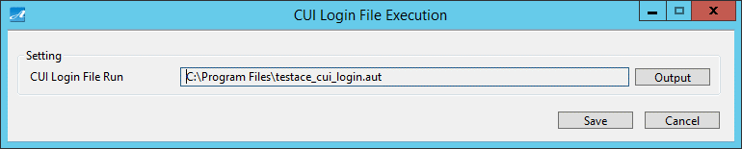

1. A message is displayed to inform that file has been saved. Click “OK”.

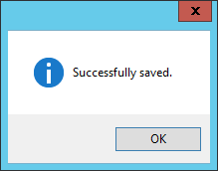

### CUI Run Trigger File Output

1. On the top right of the screen that shows CUI Run Settings, click “Output”.

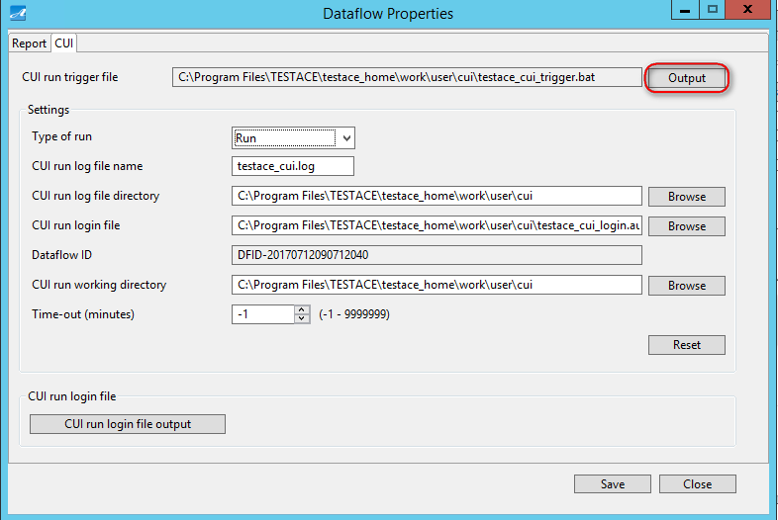

1. Choose a location, then click “Save”.

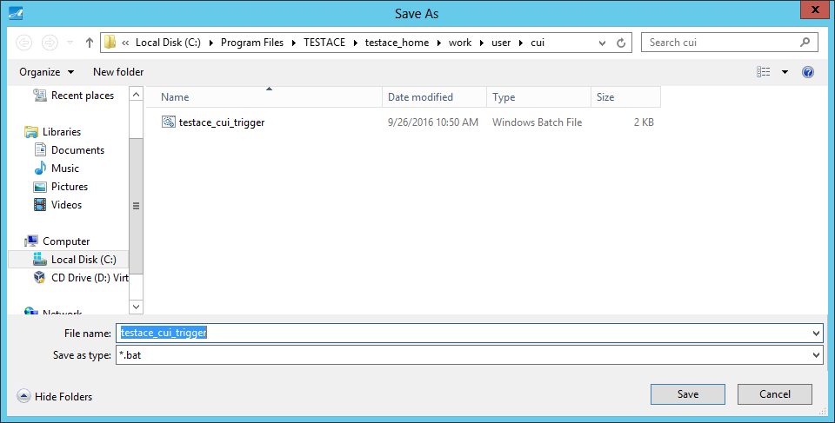

1. A message is displayed to inform that file has been output. Click “OK”.

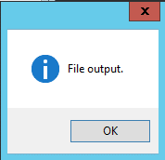

### Save CUI Run Settings

1. At the botom right of the screen that shows CUI Run Settings, click “Save”.

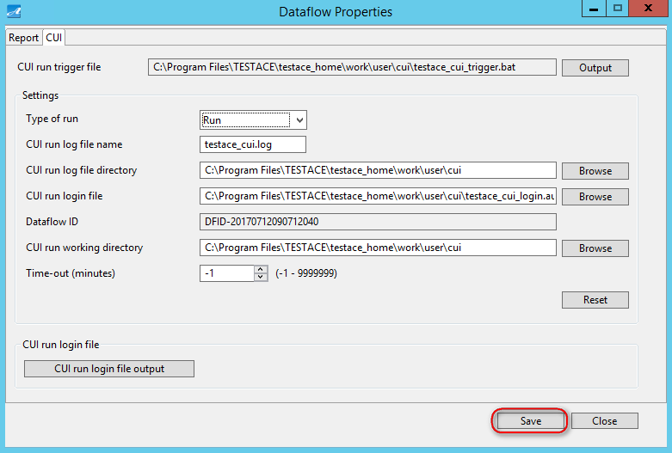

1. A message is displayed to inform that file has been saved successfully. Click “OK”.



### Close CUI Run Settings Screen

1. At the botom right of the screen that shows CUI Run Settings, click “Close.

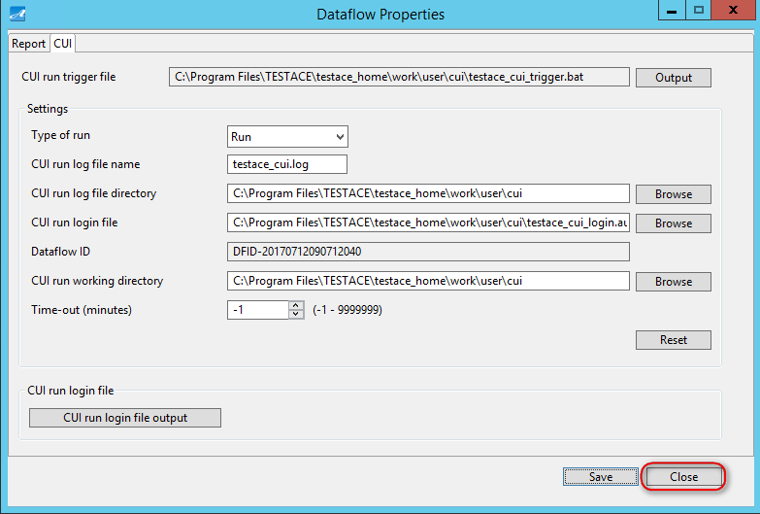

### Register Trigger File

Register to run trigger file either by the Task Scheduler of Windows or a Schedule Management product of a third party. Trigger file will automatically run regularly, or on a specific date which is scheduled in advanced.

# Screen Explanation

This part explains about each screen.

## Main Screen

All operations and settings are done from Main Screen.

Main screen is displayed right after you log in Test Ace.

### Screen Outline

Below shows the structure of Main screen.

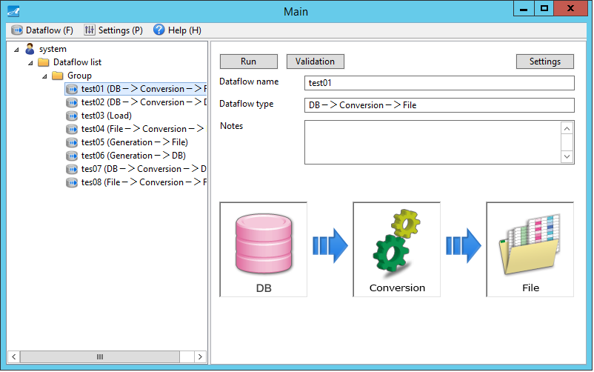

**③**

**②**

**①**

|  |  |
| --- | --- |
| Screen Item | Description |
| ① Menu Bar | Select “Dataflow (F)”, “Settings (P)” or “Help (H)” |
| ② Left Window | Create, change, delete Dataflow Group  Create, copy & paste, edit, delete Dataflow |
| ③ Right Window | Run, validate Dataflow  Report, CUI Settings  Display Dataflow Name, Dataflow Type, Notes  The icons shown are linked to specific settings |

### Dataflow Menu

In the menu of “Dataflow (F)”, below items are displayed.

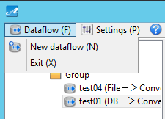

|  |  |
| --- | --- |
| Screen Item | Description |
| New Dataflow (N) | Create new Dataflow. |
| Exit (X) | Exit Test Ace. |

### Environment Settings Menu

In the “Settings (E)” menu, below items are displayed.

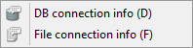

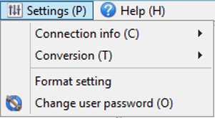

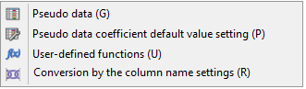

|  |  |
| --- | --- |
| Screen Item | Function |
| Connection Info (C) | DB Connection Settings  Refer to “5.2. DB Connection Information Screen” |
| File Connection Settings  Refer to “5.3 File Connection Information Screen” |
| Conversion (T) | Pseudo Data Settings  Refer to “5.4 Pseudo Data Screen” |
| Pseudo Data Coefficient Eigenvalue Initial Value Settings  Refer to “5.7 Pseudo Data Coefficient Eigenvalue Initial Value Settings Screen” |
| User-Defined Functions Settings  Refer to “5.5 User-Defined Functions Screen” |
| Conversion By The Column Name Settings  Refer to “5.9 Conversion By The Column Name Settings Screen” |
| Format setting | Format setting  Refer to “5.21 Format setting Screen” |
| Change User Password (O) | Change user’s password.  Refer to “5.6 Change User Password Screen” |

### Help

In the “Help (H)” menu, below items are displayed.

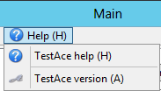

|  |  |
| --- | --- |
| Screen Item | Description |
| TestAce help (H) | Display Help  Refer to “5.10 Help Screen” |
| TestAce version (A) | Display Version Info  Refer to “5.11 Version Info Screen” |

### Create New Group

1. On the tree view of the left window, right click on “Dataflow List”, then click on “New Group”.

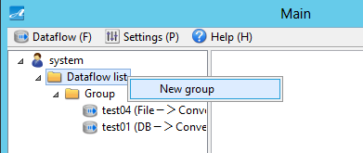

1. Then a new group is created.

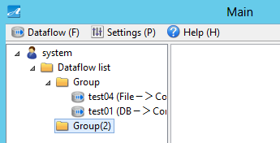

### Change Group Name

1. On the tree view of the left window, right click on a group, then click on “Rename group”.

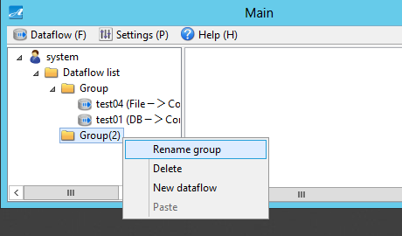

1. Input to change group name.
2. Then group name is changed.

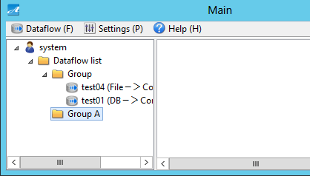

### Delete Group

1. On the tree view of the left window, right click on a group, then click “Delete”.

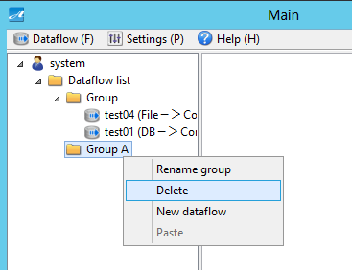

1. A message is displayed to confirm your action. Click “Yes”.

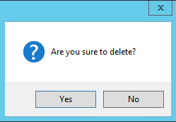

1. Then the group is deleted.

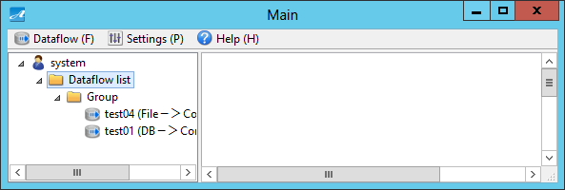

### Create New Dataflow

1. On the tree view of the left window, right click on a group, then click on “New Dataflow”.

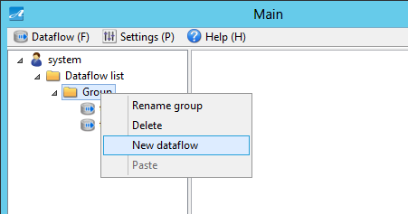

1. A screen is displayed to create new dataflow.

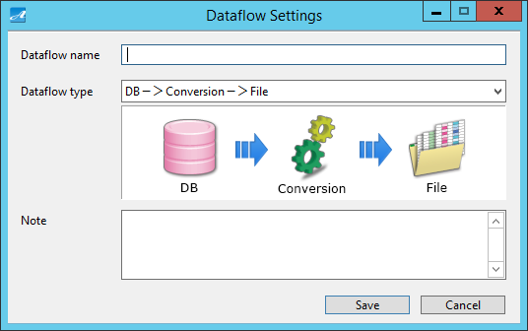

1. Input Dataflow Name.
2. Select a Dataflow Type.

|  |  |
| --- | --- |
| Dataflow Type | Explanation |
| DB - > Conversion - > File | Data is read from database, then after being converted, it is output to file. |
| DB - > Conversion - > DB | Data is read from database, then after being converted, it is output to database. |
| Load | Data of test data file is output to database. |
| File - > Conversion - > File | Data is read from file, then after being converted, it is output to file. |
| Generation - > File | After data generation processing, converted data is output to file. |
| Generation - > DB | After data generation processing, converted data is output to database. |

1. If necessary, input in “Note”.
2. Click “Save”.

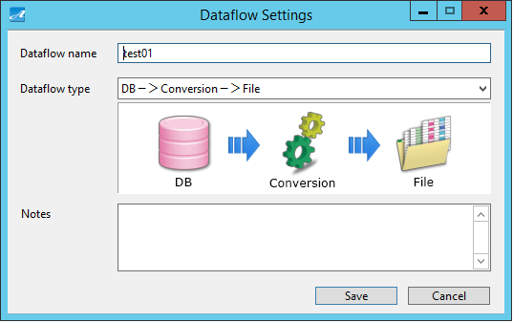

1. Then a dataflow is created.

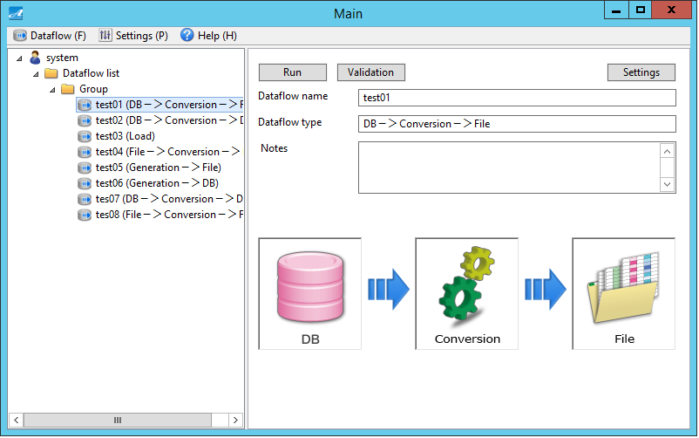

### Copy & Paste Dataflow

1. On the tree view of the left window, right click on a dataflow, then click on “Copy”.

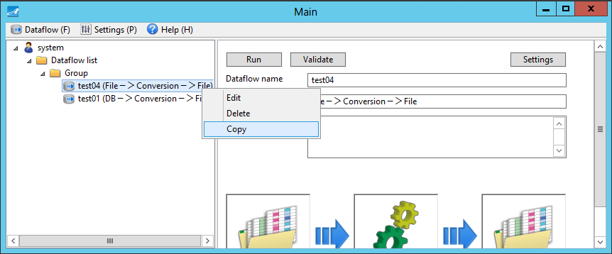

1. On the tree view of the left window, right click on a group, then click on “Paste”.

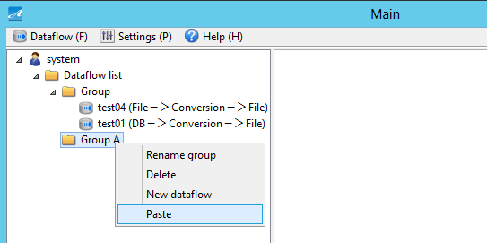

1. Then the copied Dataflow is pasted.

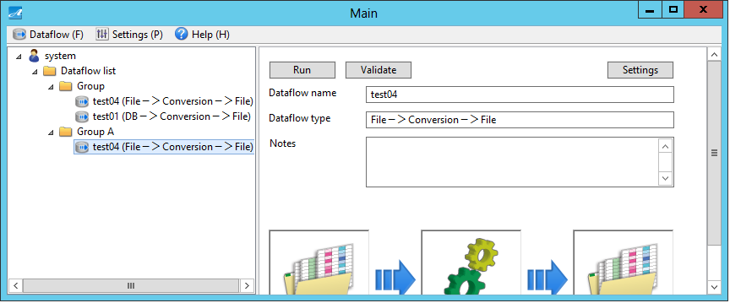

### Edit Dataflow

1. On the tree view of the left window, right click on a dataflow, then click “Edit”.

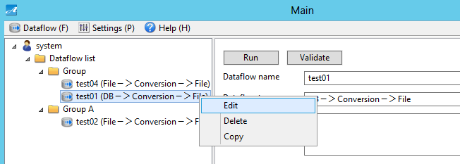

1. Edit any item, then click “Save”.

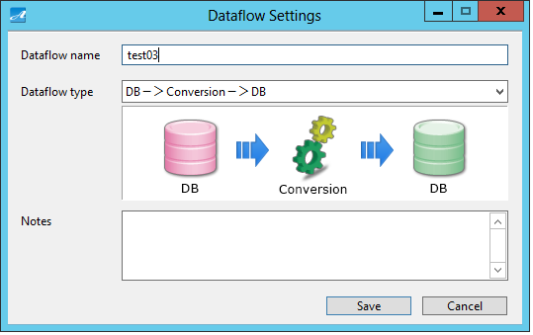

※ If you have selected dataflow type to be “Load” or “File - > Conversion - > File”, you cannot change to other dataflow types.

1. A message is displayed to confirm your action. Click “Yes”.

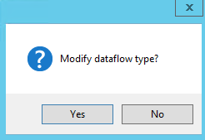

1. Then the Dataflow is changed.

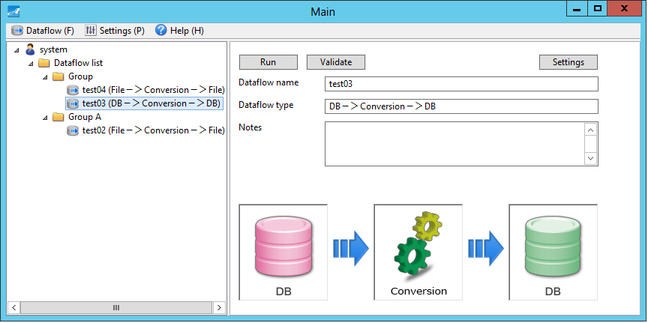

### Delete Dataflow

1. On the tree view of the left window, right click on a dataflow, then click “Delete”.

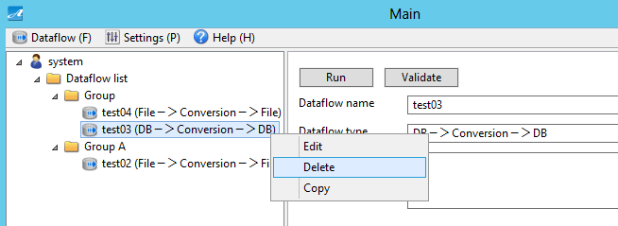

1. A message is displayed to confirm your action. Click “Yes”.

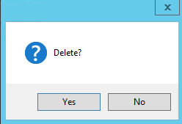

1. Then the dataflow is deleted.

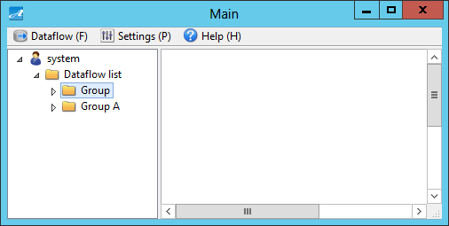

### Dataflow Detail

This section explains about dataflow detail displayed in the right window.



**④**

**⑥**

**⑦**

**⑤**

**②**

**③**

**①**

|  |  |
| --- | --- |
| Screen Item | Function |
| ① “Run” button | Run the dataflow. |
| ② “Validation” button | Validate dataflow settings. |
| ③ “Settings” button | Report, CUI Run Settings. |
| ④ Dataflow Name | Display name of the dataflow. |
| ⑤ Dataflow Type | Display type of the dataflow. |
| ⑥ Notes | Display notes of the dataflow. |
| ⑦ Icons | Display screens of specific settings. |

1. Explanation of icons:

① “DB Input Info Settings” icon

This icon displays DB Input Information Settings screen. (Refer to “5.12 DB Input Information Settings Screen)

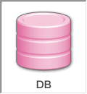

② “Conversion Info Settings” icon

This icon displays Conversion Information Settings screen. (Refer to “5.16 Conversion Information Settings Screen”)

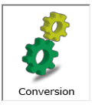

③ “File Output Info Settings” icon

This icon displays File Output Information Settings screen. (Refer to “5.15 File Output Information Settings Screen”)

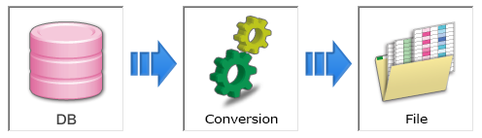

④ “File Input Info Settings” icon

This icon displays File Input Information Settings screen. (Refer to “5.14 File Input Information Settings Screen”)

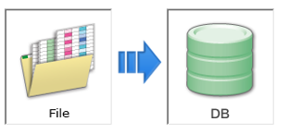

⑤ “DB Output Info Settings” icon

This icon displays DB Output Information Settings screen. ( Refer to “5.13 DB Output Information Settings Screen”)

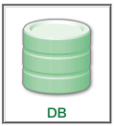

⑥ “DB Defining Info Settings” icon

This icon displays DB Input Information Settings screen. (Refer to “5.12 DB Input Information Settings Screen”)

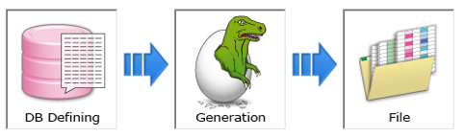

⑦ “Generation Info Settings” icon

This icon displays Conversion Information Settings screen. ( Refer to “5.16 Conversion Information Settings Screen”)



## DB Connection Info Screen

On DB Connection Information screen, you can set database information for Test Ace.

This screen is displayed when you select “Settings (P)” – “Connection Information (C)” – “DB Connection Information (D)” on the menu bar.

### Screen Outline

Below is the structure of DB Connection Info screen.



|  |  |
| --- | --- |
| Screen Item | Explanation |
| Left Window | Create, edit, delete DB Connection Information  Create new DB Connection Information Group, change group name and delete group. |
| Right Window Display | Display DB connection info. |

### Create New DB Connection Info

1. On the tree view of the left window, right click on a group, then click on “DB new connection info”.

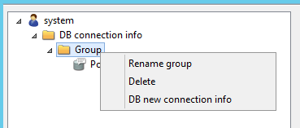

1. Input values for displayed items, then click on “Test connection”.

① If DB Type is Oracle:

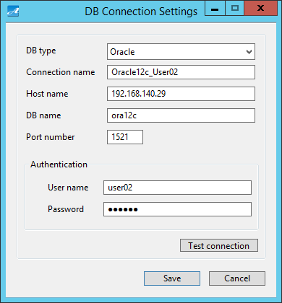

**⑥**

**⑦**

**①**

**②**

**③**

**④**

**⑤**

|  |  |
| --- | --- |
| Screen Item | Function |
| ① DB type | Set DB type |
| ② Connection name | Set connection name |
| ③ Host name | Set host name (you can set IP address) |
| ③ DB name | Set database name |
| ③ Port number | Set port number |
| ⑥ User name | Set user name  Set the correct value to be saved in the connected database. |
| ⑦ Password | Set password  Set the correct value to be saved in the connected database. |

※ If connection fails, please confirm that the input is correct (make sure that uppercase and lowercase letters are consistent with the environment to be connected).

② If DB type is SQL Server:

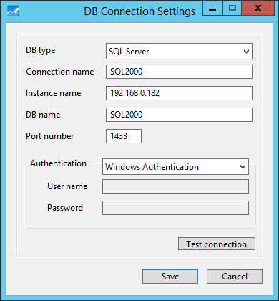

**⑦**

**⑧**

**⑥**

**①**

**②**

**③**

**④**

**⑤**

|  |  |
| --- | --- |
| Screen Item | Function |
| ① DB type | Set DB type |
| ②Connection name | Set connection name |
| ③Instance name | Set server name + instance name (you can set IP address and named instance).  If instance name is not input, the system will connect to the default instance. |
| ④ DB name | Set DB name |
| ⑤ Port number | Set port number |
| ⑥ Authentication | Set authentication type |
| ⑦ User name | Set user name  Set the correct value to be saved in the connected database. |
| ⑧ Password | Set password  Set the correct value to be saved in the connected database. |

※ If connection fails, please confirm that the input is correct (make sure that uppercase and lowercase letters are consistent with the environment to be connected).

※ If you make settings for both instance name and port number, the port number will be prioritized at the time of connection.

③ If DB type is PostgreSQL:

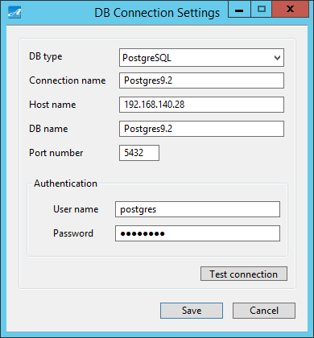

**⑥**

**⑦**

**①**

**②**

**③**

**④**

**⑤**

|  |  |
| --- | --- |
| Screen Item | Function |
| ① DB type | Set DB type |
| ②Connection name | Set connection name |
| ③ Host name | Set host name (you can set IP address) |
| ④ DB name | Set DB name |
| ⑤ Port name | Set port name |
| ⑥ User name | Set user name  Set the correct value to be saved in the connected database. |
| ⑦ Password | Set password  Set the correct value to be saved in the connected database. |

※ If connection fails, please confirm that the input is correct (make sure that uppercase and lowercase letters are consistent with the environment to be connected).

1. A message is displayed to inform that connection test has been run successfully. Click “OK”.



1. Click “Save”.
2. Then DB connection info is created.

### Edit DB Connection Info

1. On the tree view of the left window, right click on any DB connection info, then click “Edit”.

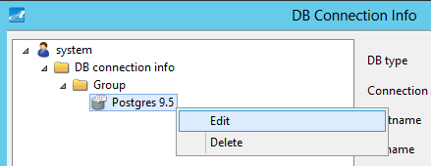

1. Edit displayed items, and if necessary, click on “Test connection”.



1. A message is displayed to inform that connection test has been run successfully. Click “OK”.



1. Click “Save”.
2. Then DB connection info is edited.

### Delete DB Connection Info

1. On the tree view of the left window, right click on any DB connection info, then click “Delete”.

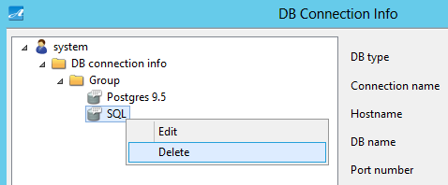

1. A message is displayed to confirm your action. Click “Yes”.
2. Then DB connection info is deleted.

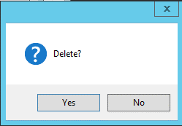

※ You cannot delete DB connection info which is being used in dataflow.

### Create New Group

1. On the tree view of the left window, right click on any DB connection info, then click “New Group”.

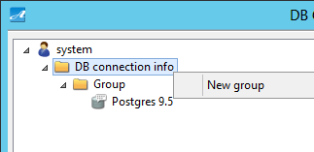

1. Then a new group is created.

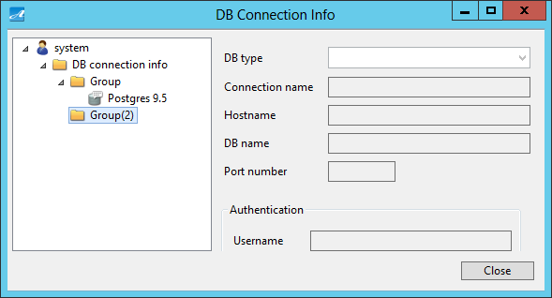

### Change Group Name

1. On the tree view of the left window, right click on a group, then click “Rename group”.

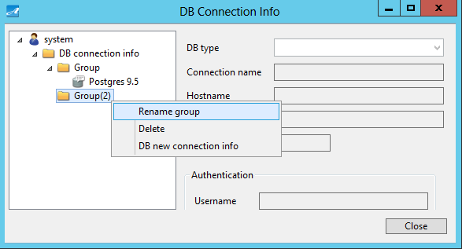

1. Input Group Name.
2. Then group name is changed.

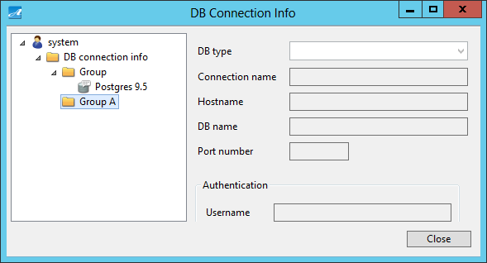

### Delete Group

1. On the tree view of the left window, right click on a group, then click “Delete”.

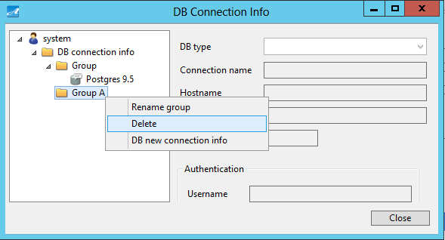

1. A message is displayed to confirm your action. Click “Yes”.
2. Then the group is deleted.

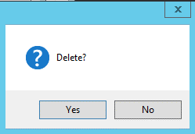

※ You cannot delete a group if in the group there is any DB connection info being used in dataflow.

## File Connection Info Screen

Set file info on File Connection Info screen.

This screen is displayed when you select “Settings (P)” – “Connection Information (C)” – “File Connection Information (F)” on the menu bar.

### Screen Outline

Below is the structure of File Connection Info screen.



**②**

**①**

|  |  |
| --- | --- |
| Screen Item | Function |
| ①Left Window | Create, edit, delete file connection info.  Create new group, change group name, delete group of file connection info. |
| ②Right Window Display | Display file connection info. |

### Create New File Connection Info

1. On the tree view of the left window, right click on a group, then click “New File Connection Info”.

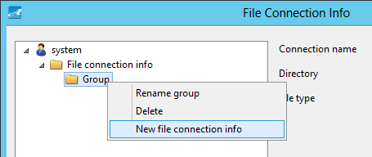

1. Input values for displayed items. Click “Save”.
2. Click “Save”. Then file connection setting is done.

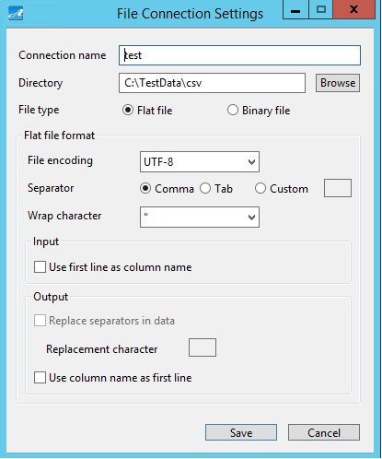

**⑪**

**⑨**

**⑩**

**⑧**

**⑤**

**②**

**①**

**③**

**⑦**

**④**

**⑥**

|  |  |
| --- | --- |
| Screen Item | Function |
| ① Connection name | Set connection name. |
| ② Directory | Set directory. |
| ② File types | Set file types. |
| ② File encoding | Set “UTF – 8” or “UTF – 16”. |
| ⑤ Separator | Set “Comma”, “Tab” or “Custom” |
| ⑥ Custom separator | If you select “Custom” for ⑤, set separator. |
| ⑦ Wrap character | Set “Double quotation” or “None”. |
| ⑧ Use column names in first line | Set to use column names in first line of file or not. |
| ⑨ Replace separators in data | Set to replace the separator contained in data with different characters or not. |
| ⑩ Replacement character | If you tick a check for ⑨, set replacement character. |
| ⑪ Output column names in the first line | Set to output column names in the first line of output file or not. |

### Edit File Connection Info

1. On the tree view of the left window, right click on any File connection info, then click “Edit”.

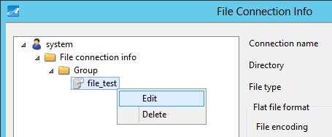

1. Edit displayed items.
2. Click “Save”. Then File connection info is changed.

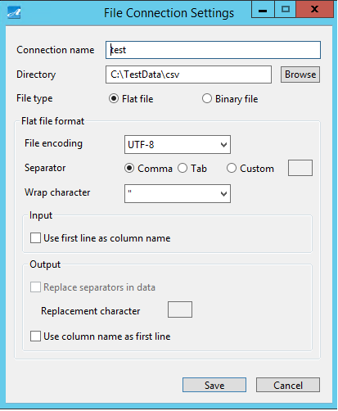

### Delete File Connection Info

1. On the tree view of the left window, right click on any File connection info, then click “Delete”.

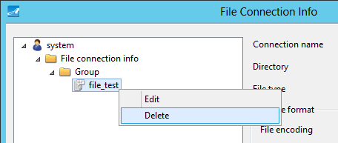

1. A message is displayed to confirm your action. Click “Yes”.

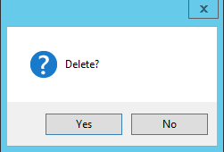

1. Then File connection info is deleted.

※ You cannot delete file connection info being used in dataflow.

### Create New Group

1. On the tree view of the left window, right click on the File connection info, then click on “New Group”.

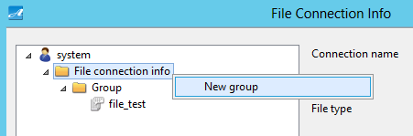

1. Then a new group is created.

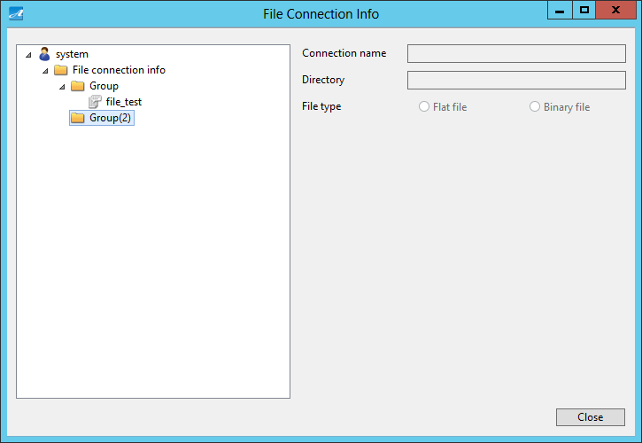

### Change Group Name

1. On the tree view of the left window, right click on a group, then click on “Rename group”.

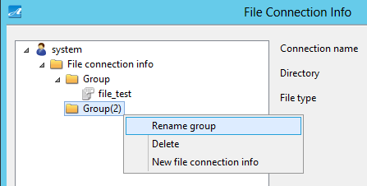

1. Input group name.
2. Then the group name is changed.

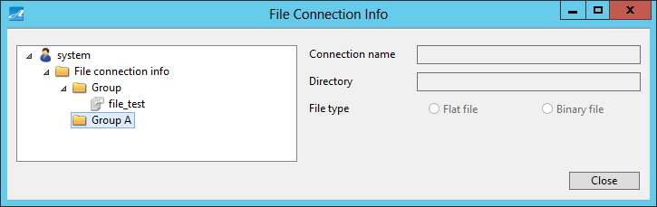

### Delete Group

1. On the tree view of the left window, right click on a group, then click “Delete”.

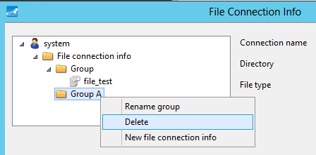

1. A message is displayed to confirm your action. Click “Yes”.

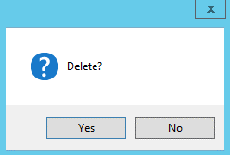

1. The group is deleted.

※ You cannot delete a group if in that group there is file connection information being used in dataflow.

## Pseudo Data Screen

You can set pseudo data on Pseudo Data screen.

This screen is displayed when you select “Settings (P)” – “Conversion (T)” – “Pseudo Data (G)” on the menu bar.

### Screen Outline

Below shows structure of Pseudo Data screen.

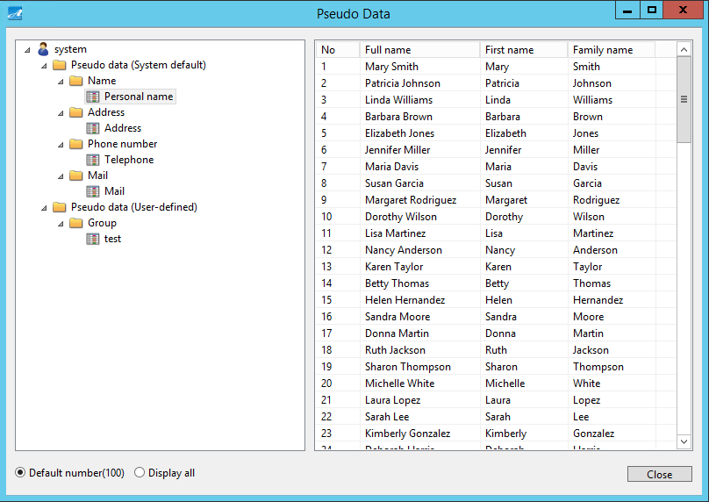

**③**

**④**

**②**

**①**

|  |  |
| --- | --- |
| Screen Item | Function |
| ① Left Window | Create, edit, delete pseudo data.  Create new group, change group name, delete group of pseudo data. |
| ② Right Window | Display pseudo data. |
| ③ Display Switch | Switch the number of pseudo data to be displayed (100 data/all) |
| ④ Close | Close the screen. |

### Create New Pseudo Data

1. On the tree view of the left window, right click on a group, then click on “New Pseudo Data”.

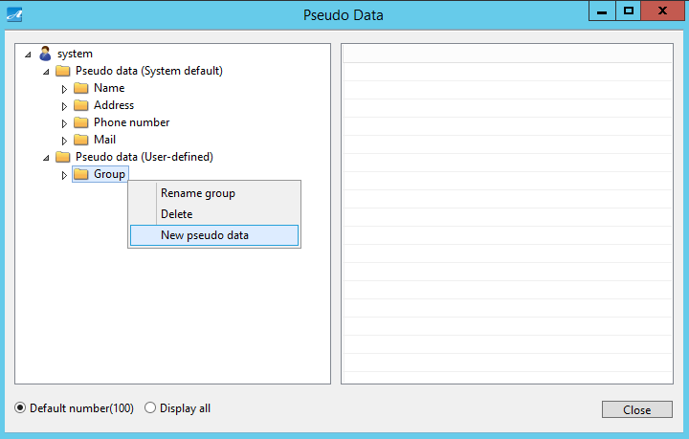

1. Pseudo Data Settings screen is displayed.

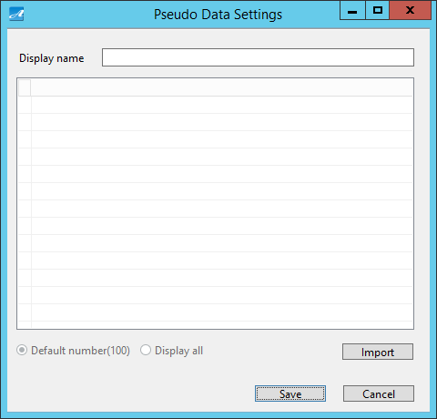

**②**

**④**

**①**

**③**

**⑤**

**⑥**

|  |  |
| --- | --- |
| Screen Item | Function |
| ① Display name | Set display name. |
| ② Pseudo data list | Set pseudo data list. |
| ③ Display switch | Number of data to be displayed (100 data/all) ※ This cannot be edited. |
| ④ Import | Display Pseudo Data File Import Settings screen. |
| ⑤ Save | Save |
| ⑥ Cancel | Cancel |

1. Input display name, then click “Import”.
2. Import Settings screen is displayed.

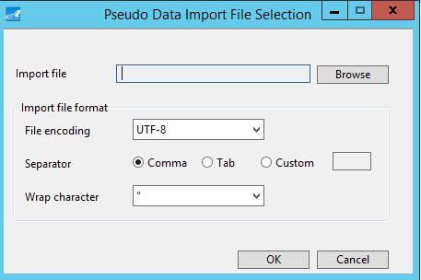

**⑥**

**③**

**④**

**⑤**

**②**

**①**

**⑧**

**⑦**

|  |  |
| --- | --- |
| Screen Item | Function |
| ① Import File | Display the path leading to import file. |
| ② Browse | Display File Selection screen. |
| ③ File encoding | Select “UTF – 8”, “UTF – 16”. |
| ④ Separator | Set “Comma”, “Tab”, “Custom”. |
| ⑤ Custom separator | If you select “Custom” for ⑤, set the separator. |
| ⑥ Wrap character | Set “Double quotation” or “None”. |
| ⑦ OK | Confirm your settings. |
| ⑧ Cancel | Cancel. |

1. Click “Browse”, then select a data file.

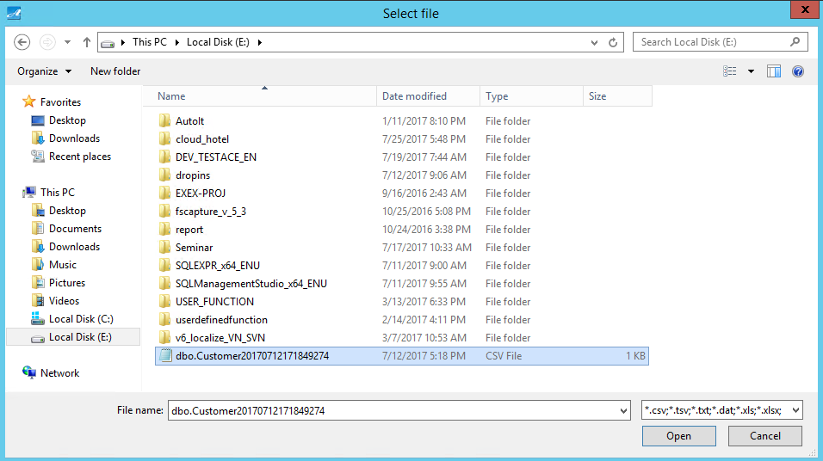

1. Set the file format, then click “OK”.

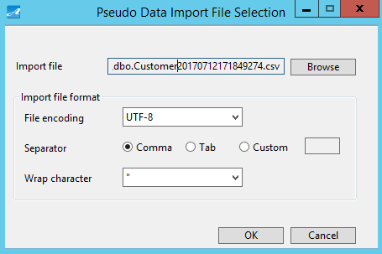

1. Then data of the imported file is displayed. Click “Save”.

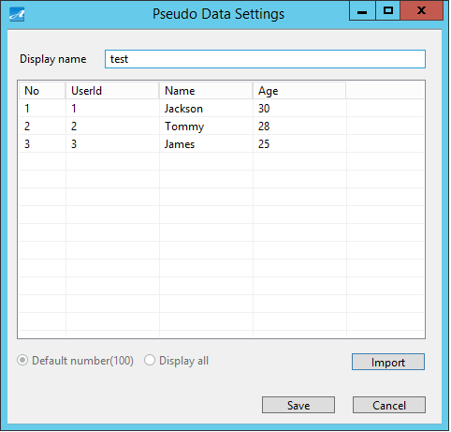

1. A message is displayed to inform that you have saved it successfully. Click “OK”.



1. Then pseudo data is created.

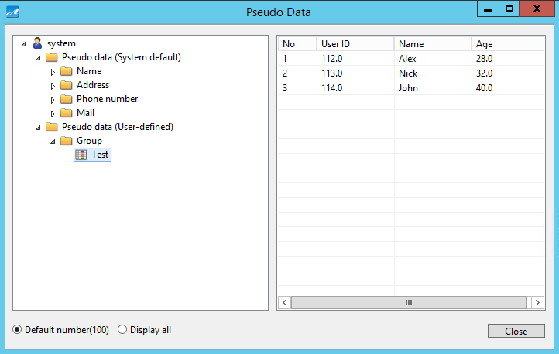

### Edit Pseudo Data

1. On the tree view of the left window, right click on any pseudo data, then click “Edit”.

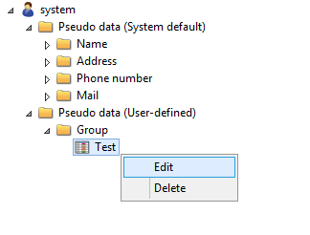

1. If necessary, import the file again, then click “Save”.

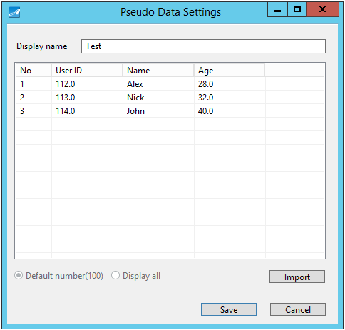

1. A message is displayed to inform that you have saved the file successfully. Click “OK”.



### Delete Pseudo Data

1. On the tree view of the left window, right click on any pseudo data, click “Delete”.

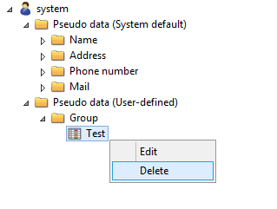

1. A message is displayed to confirm your action. Click “Yes”.

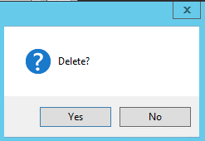

1. Then pseudo data is deleted.

※ You cannot delete pseudo data which is being used in Conversion Settings, Conversion By The Column Name Settings.

### Create New Group

1. On the tree view of the left window, right click on “Pseudo Data (User-defined)”, then click “New Group”.

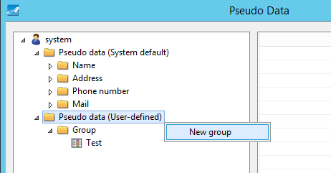

1. Then a new group is created.

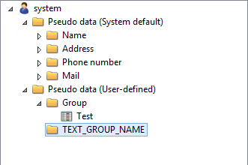 

### Change Group Name

1. On the tree view of the left window, right click on a group, then click on “Rename group”.

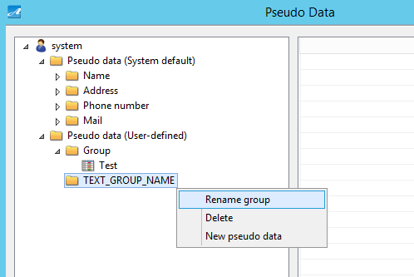

1. Input group name.
2. Then group name is changed.

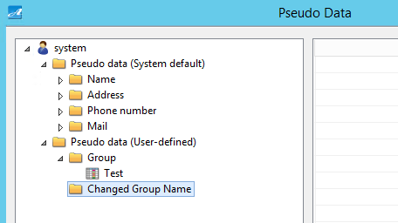 

### Delete Group

1. On the tree view of the left window, right click on a group, then click “Delete”.

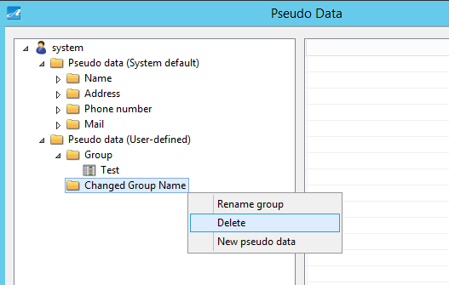

1. A message is displayed to confirm your action. Click “Yes”.



1. Then the group is deleted.

※ You cannot delete a group if in that group there is pseudo data being used in Conversion, Conversion By The Column Name Settings.

## User-Defined Functions Screen

On User-Defined Functions screen, you can set user-defined functions.

This sceen is displayed when you select “Settings (P)” – “Conversion (T)” – “User-Defined Functions (U)”.

### Screen Outline

Below shows the structure of User-Defined Functions screen.

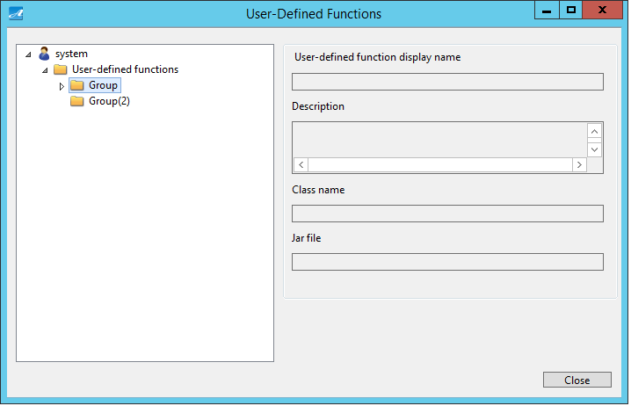

**②**

**①**

**③**

|  |  |
| --- | --- |
| Screen Item | Description |
| ① Left Window | Create, edit, delete user-defined functions.  Create new group, change group name, delete group of user-defined functions. |
| ② Right Window Display | Display user-defined functions. |
| ③ Close | Close the screen. |

### Create New User-Defined Functions

1. On the tree view of the left window, right click on a group, then click on “New User-Defined Functions”.

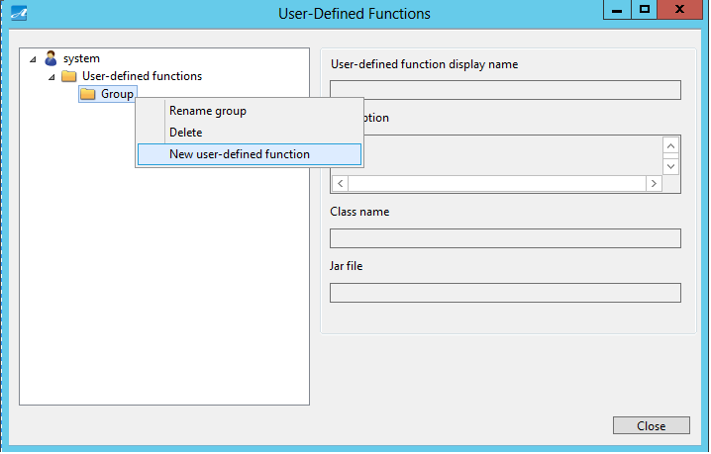

1. User-Defined Functions Settings screen is displayed.
2. Input Function name.
3. If necessary, input Description.
4. Select a jar file from “Jar File List”.
5. Select a Java class from “Class List”.
6. Click “Save”.

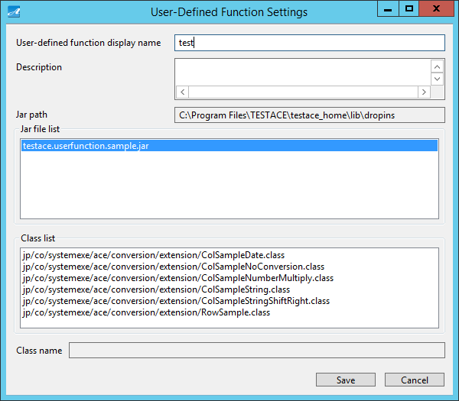

**⑧**

**⑦**

**⑥**

**④**

**③**

**②**

**①**

**⑤**

|  |  |
| --- | --- |
| Screen Item | Description |
| ① User-defined function display name | Set function display name |
| ② Description | Write description |
| ③ Jar path | The directory where Jar file is stored (This cannot be edited ) |
| ④ Jar file list | Display Jar file selection, list |
| ⑤ Class list | Display class file selection, list |
| ⑥ Class name | Display class for selection (this cannot be edited) |
| ⑦ Save | Save |
| ⑧ Cancel | Cancel |

1. Then a user-defined function is created.

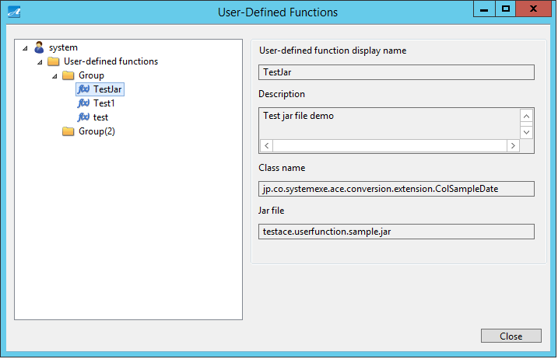

### Edit User-Defined Functions

1. On the tree view of the left window, rick click on a user-defined function, then click “Edit”.

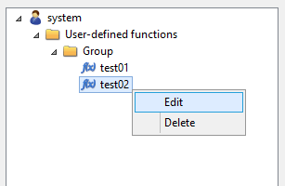

1. Edit displayed items, then click “Save”.

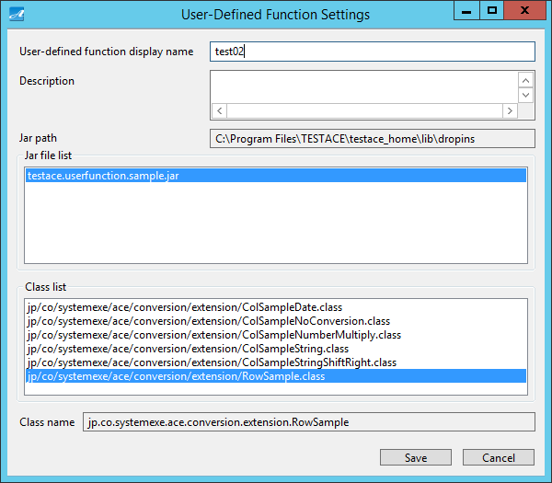

### Delete User-Defined Funtions

1. On the tree view of the left window, right click on a user-defined function, then click “Delete”.

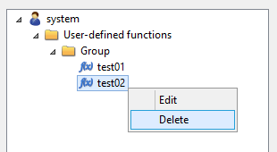

1. A message is displayed to confirm your action. Click “Yes”.
2. Then the user-defined function is deleted.

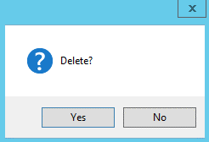

※ You cannot delete a user-defined function being used in Conversion Settings, Conversion By The Column Name Settings.

### Create New Group

1. On the tree view of the left window, right click on a user-defined function, then click on “New group”

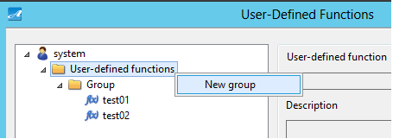

1. Then a new group is created.

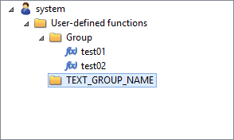

### Change Group Name

1. On the tree view of the left window, right click on a group, then click “Rename Group”.

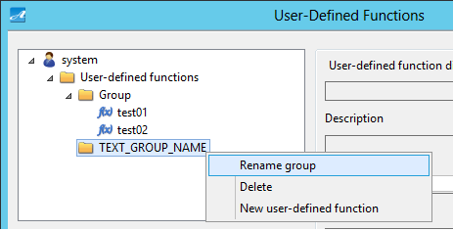

1. Input group name.
2. Then group name is changed.

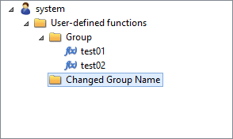

### Delete Group

1. On the tree view of the left window, right click on a group, then click “Delete”.

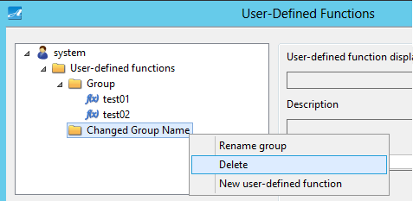

1. A message is displayed to confirm your action. Click “Yes”.



1. Then the group is deleted.

※ You cannot delete a user-defined function group if in this group a user-defined function is being used in Conversion Settings, Conversion By The Column Name Settings.

### Create User-Defined Functions

1. Run Eclipse.

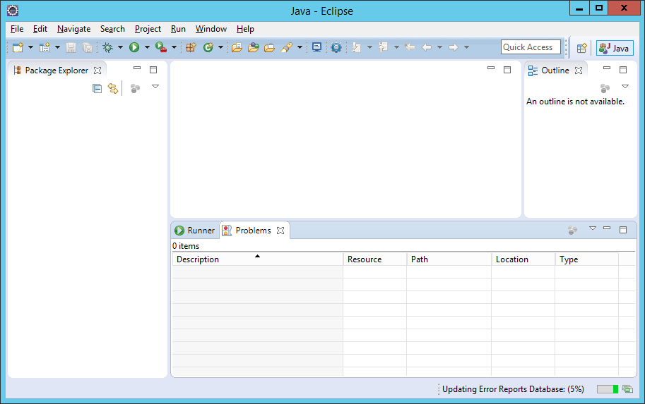

1. Create a Java project.

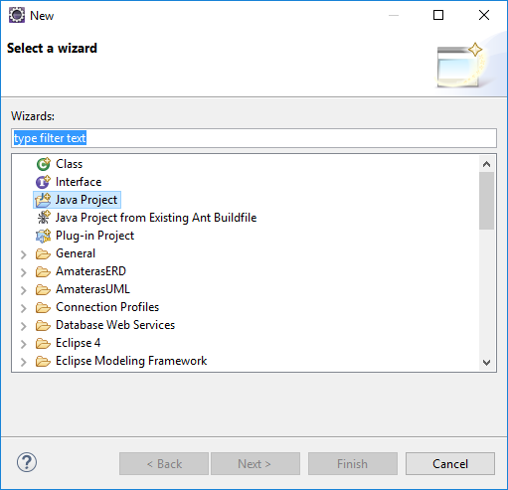

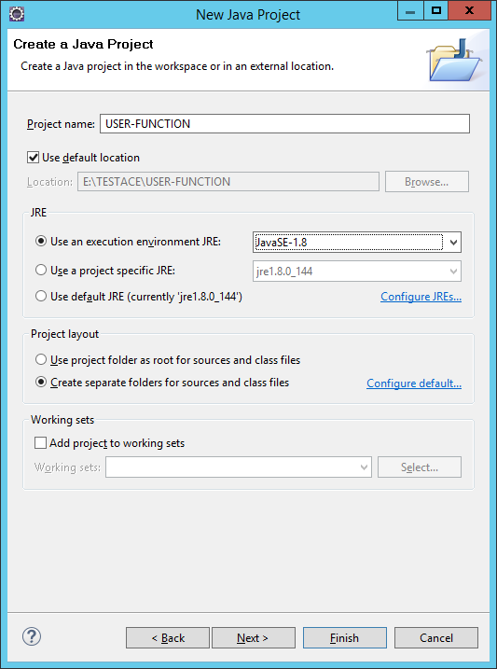

1. Set Java compiler of this project to be JDK1.8.

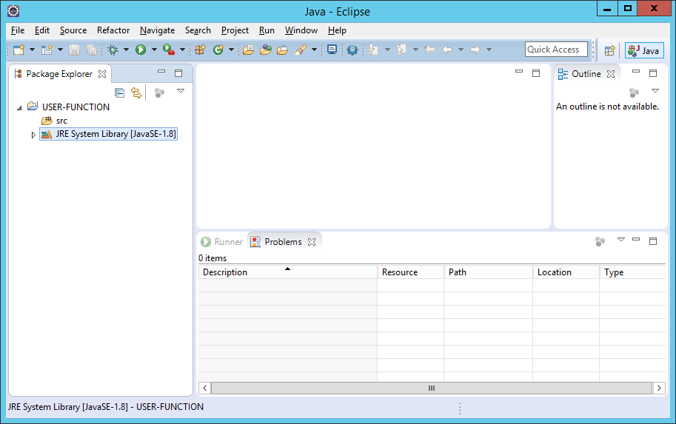

1. Set the following file in Build Path of this project.

[Test Ace Installation Folder]\testace_home\testace.core.jar

① Copy testace.core.jar from server to your working environment.

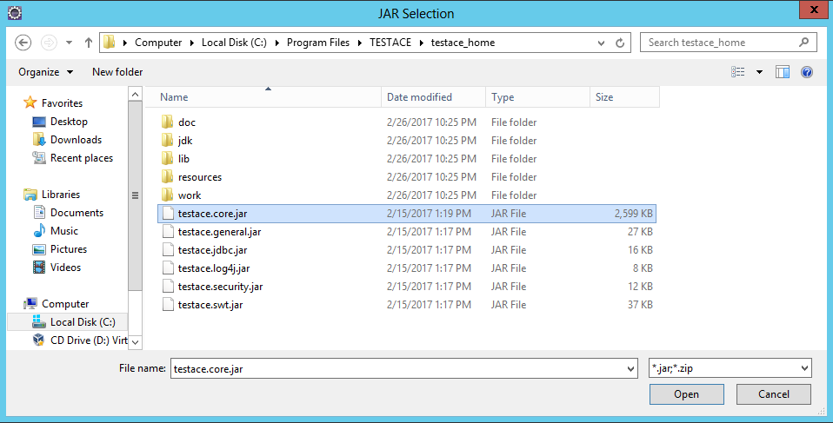

② Create a folder in this project.

In the example below, “lib” folder is created.

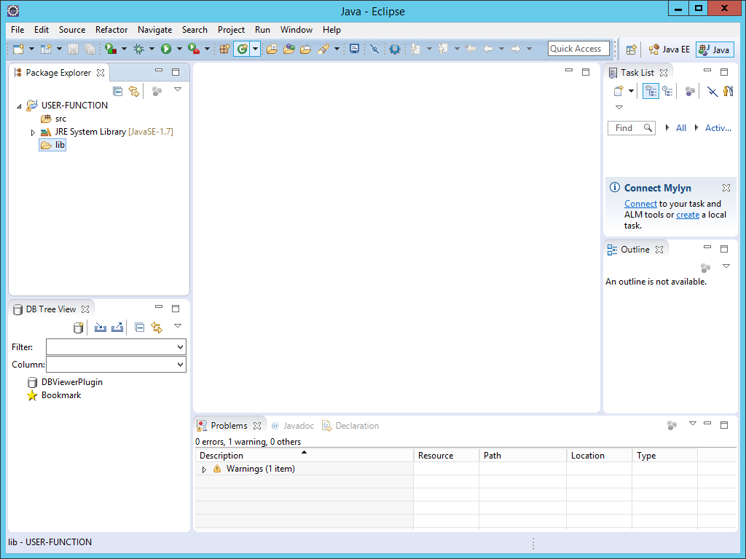

③ Place testace.core.jar in the created folder.

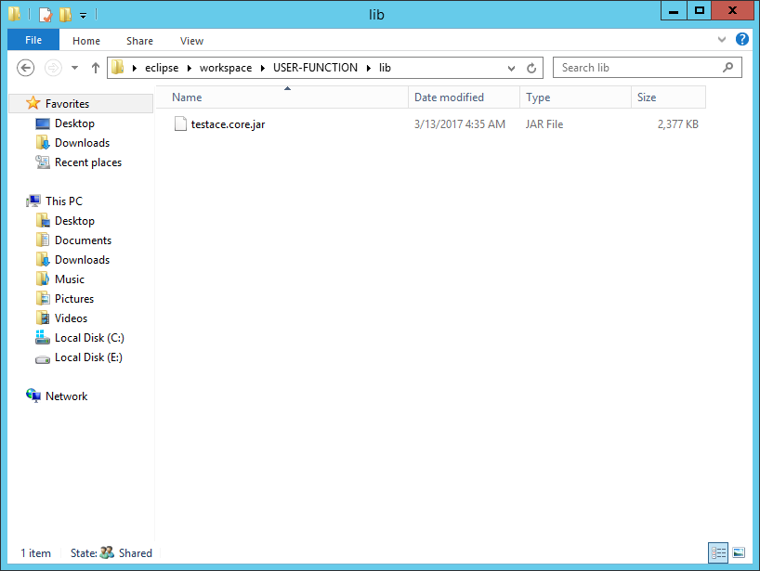

④ Set testace.core.jar in Build Path.

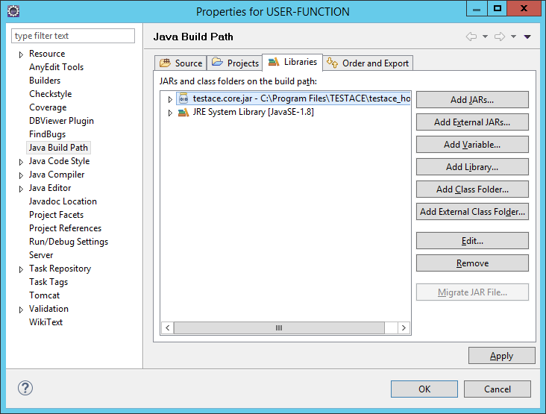

1. Create a class to process conversion rules peculiar to this project.

Set and create one of the following classes in testace.core.jar as Base class:

To convert value of a single column, set AbstractCustomColDataConversion to be the Base class.

To convert values of multiple columns at the same time, set AbstractCustomRowDataConversion to be the Base class.

|  |  |  |
| --- | --- | --- |
| Package Name | Class Name | Description |
| jp.co.systemexe.ace.conversion | AbstractCustomColDataConversion | Convert value of a single column |
| jp.co.systemexe.ace.conversion | AbstractCustomRowDataConversion | Convert values of multiple columns simultaneously |

1. Create a processing to convert value of a single column.

① Set AbstractCustomColDataConversion in testace.core.jar to be the Base Class and create a new class.

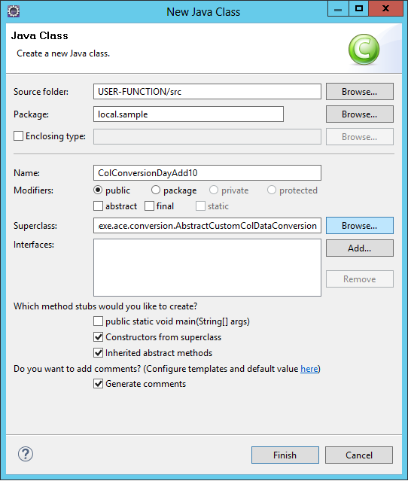

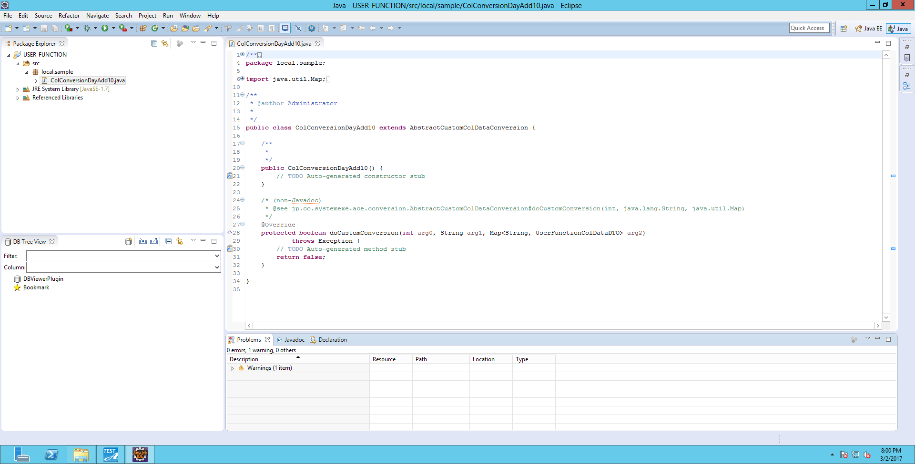

② Implement the following abstract method.

|  |
| --- |
| Method |
| protected abstract boolean doCustomConversion(  int rowIndex,  java.lang.String targetColumnName,  java.util.Map<java.lang.String,UserFunctionColDataDTO> rowdataMap)  throws java.lang.Exception  Parameter:  rowIndex - Row index.  targetColumnName - Column name.  rowdataMap - Key: Column name, Value: Column data.  Return Value:  If processing has succeeded, return “true”, or else, return “false”.  Exception:  java.lang.Exception - Exception. |

Basic processing:

・Use the column name as indicated in the parameter targetColumnName to get column data from rowdataMap.

UserFunctionColDataDTO userFunctionColDataDTO = rowdataMap.get(targetColumnName);

・Call getColumnValue() from the column data UserFunctionColDataDTO to get column value.

Object object = userFunctionColDataDTO.getColumnValue();

・If the return value of getColumnValue() is not null, cast the column value to Java class.

|  |  |
| --- | --- |
| Oracle　Column Data Format | Java Class |
| CHAR | java.lang.String |
| DATE | java.sql.Timestamp |
| FLOAT | java.math.BigDecimal |
| INTEGER | java.math.BigDecimal |
| NCHAR | java.lang.String |
| NUMBER | java.math.BigDecimal |
| NVARCHAR2 | java.lang.String |
| TIMESTAMP | java.sql.Timestamp |
| VARCHAR2 | java.lang.String |

|  |  |
| --- | --- |
| SQL Server　Column Data Format | Java Class |
| BIGINT | java.math.BigDecimal |
| BIT | java.math.BigDecimal |
| CHAR[(N)] | java.lang.String |
| DATE | java.sql.Timestamp |
| DATETIME | java.sql.Timestamp |
| DATETIME2 | java.sql.Timestamp |
| DECIMAL[(P[,S])] | java.math.BigDecimal |
| FLOAT[(N)] | java.math.BigDecimal |
| INT | java.math.BigDecimal |
| MONEY | java.math.BigDecimal |
| NCHAR[(N)] | java.lang.String |
| NUMERIC[(P[,S])] | java.math.BigDecimal |
| NVARCHAR[(N)] | java.lang.String |
| REAL | java.math.BigDecimal |
| SMALLDATETIME | java.sql.Timestamp |
| SMALLINT | java.math.BigDecimal |
| SMALLMONEY | java.math.BigDecimal |
| TIME | java.sql.Timestamp |
| TINYINT | java.math.BigDecimal |
| UNIQUEIDENTIFIER | java.lang.String |
| VARCHAR[(N)] | java.lang.String |

|  |  |
| --- | --- |
| PostgreSQL　Column Data Format | Java Class |
| BIGINT | java.math.BigDecimal |
| BIT[(N)] | java.lang.String |
| BIT VARYING[(N)] | java.lang.String |
| BOOLEAN | java.lang.String |
| CHARACTER[(N)] | java.lang.String |
| CHARACTER VARYING[(N)] | java.lang.String |
| CIDR | java.lang.String |
| DATE | java.sql.Timestamp |
| DOUBLE PRECISION | java.math.BigDecimal |
| INET | java.lang.String |
| INTEGER | java.math.BigDecimal |
| MACADDR | java.lang.String |
| MONEY | java.math.BigDecimal |
| NUMERIC[(P,S)] | java.math.BigDecimal |
| REAL | java.math.BigDecimal |
| SMALLINT | java.math.BigDecimal |
| TIME[(P)][WITHOUT TIME ZONE] | java.sql.Timestamp |
| TIMESTAMP[(P)][WITHOUT TIME ZONE] | java.sql.Timestamp |
| "CHAR" | java.lang.String |
| NAME | java.lang.String |

・Convert the column value, and call setColumnValue() of UserFunctionColDataDTO, then redo the setting.

userFunctionColDataDTO.setColumnValue(convertedValue);

Example: Add 10 days to value with Date-Time format data.

|  |
| --- |
| /**  * Example of converting column data of user-defined function.  * If column data has Date-Time format, add 10 days to the column value.  */  public class ColSampleDate extends AbstractCustomColDataConversion {  /**  * long value of 1 Day.  */  private static final long DAY_TIME = 1000L * 60 * 60 * 24;    /**  * Number of added days (unit: day).  */  private static final long ADD_DAY = 10;    /**  * Constructor。  */  public ColSampleDate() {  super();  }  @Override  protected boolean doCustomConversion(int rowIndex, String targetColumnName,  Map<String, UserFunctionColDataDTO> rowdataMap) throws Exception {  //Use the column name as indicated to get column data from rowdataMap.  UserFunctionColDataDTO userFunctionColDataDTO = rowdataMap.get(targetColumnName);  //Get column value.  Object object = userFunctionColDataDTO.getColumnValue();  if (null != object) {  if (object instanceof java.sql.Timestamp) {  //If data has Date-Time format, cast it to java.sql.Timestamp.  Timestamp colValue = (Timestamp) object;  //Add 10 days to the current date-time.  colValue.setTime(colValue.getTime() + DAY_TIME * ADD_DAY);  //Set the after-change value.  userFunctionColDataDTO.setColumnValue(colValue);  }  }  return true;  }  } |

Example: Replace data of character type with the replacement character “*”. Space and hyphen characters are not replaced.

|  |
| --- |
| /**  * Example of converting column data of user-defined function.  * If column data is character type, replace column value with the replacement character “*”. Space and hyphen characters are not replaced.  */  public class ColSampleString extends AbstractCustomColDataConversion {  /**  * Half-size space.  */  private static final char HANKAKU_SPACE = ' ';  /**  * Full-size space.  */  private static final char ZENKAKU_SPACE = '　';  /**  * Full-size hyphen.  */  private static final char ZENKAKU_HYPHEN = '‐';    /**  * Half-size hyphen.  */  private static final char HANKAKU_HYPHEN = ' - ';    /**  * Replacement character.  */  private static final char MASK_CHAR = '*';  /**  * List of characters not to be replaced.  */  private static final List<Character> NOT_REPLACE_CHAR_LIST;  static {  // Register characters not to be replaced.  NOT_REPLACE_CHAR_LIST = new ArrayList<Character>();  NOT_REPLACE_CHAR_LIST.add(HANKAKU_SPACE);  NOT_REPLACE_CHAR_LIST.add(ZENKAKU_SPACE);  NOT_REPLACE_CHAR_LIST.add(ZENKAKU_HYPHEN);  NOT_REPLACE_CHAR_LIST.add(HANKAKU_HYPHEN);  }  /**  * Constructor。  */  public ColSampleString() {  super();  }  @Override  protected boolean doCustomConversion(int rowIndex, String targetColumnName,  Map<String, UserFunctionColDataDTO> rowdataMap) throws Exception {  //Use the column name as indicated, get column data from rowdataMap.  UserFunctionColDataDTO userFunctionColDataDTO = rowdataMap.get(targetColumnName);  //Get column value.  Object object = userFunctionColDataDTO.getColumnValue();  //If this data is character type, cast it to java.lang.String.  String colValue = (null != object) ? (String) object : null;  //Replace column value with the replacement character “*”. Space and hyphen characters are not replaced.  //Reset after-change value.  userFunctionColDataDTO.setColumnValue(mask(colValue, MASK_CHAR, NOT_REPLACE_CHAR_LIST));  return true;  }    /**  * Return a new string in which the “target” string had been replaced with “replacement”.  * The characters in “notReplaceCharList” are not replaced.  * @param target is the string to be replaced.  * @param replacement is the replacement character.  * @param notReplaceCharList is the list of characters not to be replaced.  * @return the new string in which the target string had been replaced with “replacement”.  * The characters in notReplaceCharList are not replaced.  */  public static final String mask(String target, char replacement,  List<Character> notReplaceCharList) {  if (null == target) {  return target;  }  if (0 == target.length()) {  return target;  }  final StringBuilder stringBuilder = new StringBuilder();  for (int i = 0; i < target.length(); i++) {  final char ch = target.charAt(i);  if (null != notReplaceCharList && notReplaceCharList.contains(ch)) {  stringBuilder.append(ch);  } else {  stringBuilder.append(replacement);  }  }  return stringBuilder.toString();  }  } |

Example: Shift string data to the right.

|  |
| --- |
| /**  * Example of converting column data of user-defined function.  * If column data format is string, shift it to the right.  * (1) The last character is to be shifted to the beginning. (2) Move the target character 1 unit to the right (except for the last character).  * ex)ABCDE　 - ＞　EABCD  */  public class ColSampleStringShiftRight extends AbstractCustomColDataConversion {  /**  * Constructor。  */  public ColSampleStringShiftRight() {  super();  }  @Override  protected boolean doCustomConversion(int rowIndex, String targetColumnName,  Map<String, UserFunctionColDataDTO> rowdataMap) throws Exception {  //Use the column name as indicated, get column data from rowdataMap.  UserFunctionColDataDTO userFunctionColDataDTO = rowdataMap.get(targetColumnName);  //Get column value.  Object object = userFunctionColDataDTO.getColumnValue();    if (object instanceof java.lang.String) {  //If this data is character type, cast it to java.lang.String.  String colValue = (String) object;  //Shift it to the right.  String result = shiftRight(colValue);  //Reset after-change value.  userFunctionColDataDTO.setColumnValue(result);  return true;  }  return true;  }  /**  * Shift the indicated string “original” to the right.  * (1) Move the last character to the beginning. (2) Move the target character 1 unit to the right (except for the last character).  * ex)ABCDE　 - ＞　EABCD  * @param original is the target string.  * @return the string which had been shifted to the right.  */  public static String shiftRight(String original) {  if (null == original || original.length() == 0) {  return original;  }  final StringBuilder stringBuilder = new StringBuilder();  //Move the last character to the beginning.  stringBuilder.append(original.charAt(original.length() - 1));  //Add 1 character except for the last character.  for (int i = 0; i < original.length() - 1; i++) {  stringBuilder.append(original.charAt(i));  }  return stringBuilder.toString();  }  } |

Example: Double the data that has numeric format.

|  |
| --- |
| /**  * Example of converting column data of user-defined function.  * If column data format is numeric, multiply it by 2.  */  public class ColSampleNumberMultiply extends AbstractCustomColDataConversion {  /**  * Multiply.  */  private static final BigDecimal multiplicand = new BigDecimal(2);  /**  * Constructor。  */  public ColSampleNumberMultiply() {  super();  }  @Override  protected boolean doCustomConversion(int rowIndex, String targetColumnName,  Map<String, UserFunctionColDataDTO> rowdataMap) throws Exception {  //Use the column name as indicated, get column data from rowdataMap.  UserFunctionColDataDTO userFunctionColDataDTO = rowdataMap.get(targetColumnName);  //Get column value.  Object object = userFunctionColDataDTO.getColumnValue();    if (object instanceof java.math.BigDecimal) {  //If data has numeric format, cast it to java.math.BigDecimal.  BigDecimal colValue = (BigDecimal)object;  //Multiply.  BigDecimal result = colValue.multiply(multiplicand);  //Reset the after-change value.  userFunctionColDataDTO.setColumnValue(result);  return true;  }  return true;  }  } |

Example: Do nothing.

In case of Data Generation, the system keeps result of the user-defined function processing which had been set in Conversion Settings Column Data, and use this result instead of converting the data.

|  |
| --- |
| /**  * Example of converting column data of user-defined function.  * Do nothing.  * @author is SystemEXE.  */  public class ColSampleNoConversion extends AbstractCustomColDataConversion {    /**  * Constructor。  */  public ColSampleNoConversion() {  super();  }  @Override  protected boolean doCustomConversion(int rowIndex, String targetColumnName,  Map<String, UserFunctionColDataDTO> rowdataMap) throws Exception {  return true;  }  } |

1. Create a processing to convert values of multiple columns simultenously.

① Set AbstractCustomRowDataConversion in testace.core.jar to be the Base Class, create a new class.

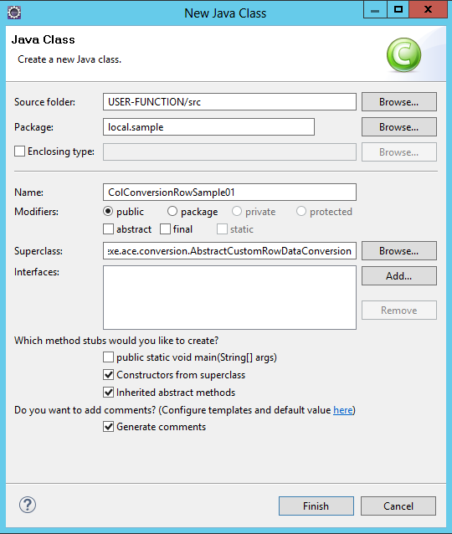

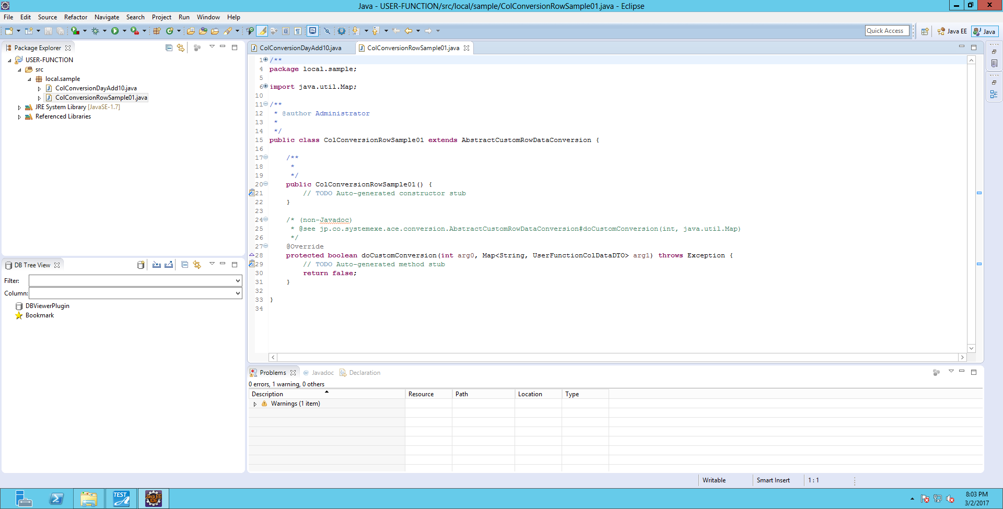

② Implement the following abstract method.

|  |
| --- |
| Method |
| protected abstract boolean doCustomConversion(  int rowIndex,  java.util.Map<java.lang.String,UserFunctionColDataDTO> rowdataMap)  throws java.lang.Exception  Parameter:  rowIndex - Row index.  rowdataMap - Key: column name, Value: column data.  Return Value:  If processing has succeeded, return “true”, or else, return “false”.  Exception:  java.lang.Exception - Exception. |

Example: If “GENDER” column is "1", convert “GENDER” column to be "M".

If “GENDER” column is "2", convert “GENDER” column to be "W", and convert “SERVICE” column to be "A0".

|  |
| --- |
| /**  * Example of converting column data of user-defined functions.  * If “GENDER” column is "1", convert “GENDER” column to be "M".  * If “GENDER” column is "2", convert “GENDER” column to be "W", and convert “SERVICE” column to be "A0".  */  public class RowSample extends AbstractCustomRowDataConversion {  /**  * Column name: GENDER.  */  private static final String COL_GENDER = "GENDER";    /**  * Column name: SERVICE.  */  private static final String COL_SEVICE = "SERVICE";  /**  * New value of Male.  */  private static final String MEN_NEW_VALUE = "M";    /**  * Old value of Male.  */  private static final String MEN_OLD_VALUE = "1";    /**  * New value of Female.  */  private static final String WOMEN_NEW_VALUE = "W";    /**  * Old value of Female.  */  private static final String WOMEN_OLD_VALUE = "2";    /**  * Setting value of Female “SERVICE” column.  */  private static final String WOMEN_SERVICE_VALUE = "A0";    /**  * Constructor。  */  public RowSample() {  super();  }  @Override  protected boolean doCustomConversion(int rowIndex,  Map<String, UserFunctionColDataDTO> rowdataMap) throws Exception {  //Get column data of column name “GENDER”  UserFunctionColDataDTO colGenderDTO = rowdataMap.get(COL_GENDER);  //Get column value  Object objColGender = colGenderDTO.getColumnValue();  //If this is string format, cast it to java.lang.String.  String colGenderValue = (null != objColGender) ? (String) objColGender : null;  if (MEN_OLD_VALUE.equals(colGenderValue)) {  //Set new value to “GENDER” column  colGenderDTO.setColumnValue(MEN_NEW_VALUE);  } else if (WOMEN_OLD_VALUE.equals(colGenderValue)) {  //set new value to “GENDER” column  colGenderDTO.setColumnValue(WOMEN_NEW_VALUE);  //Get column data of the column name “SERVICE”  UserFunctionColDataDTO colServiceDTO = rowdataMap.get(COL_SEVICE);  //Set new value of “SERVICE” column  colServiceDTO.setColumnValue(WOMEN_SERVICE_VALUE);  }  return true;  }  } |

### Location of User-Defined Functions

1. Prepare a class to process your conversion rules in Java Archive (JAR) file.
2. Save the file in [Test Ace Installation Folder]\testace_home\lib\dropins.

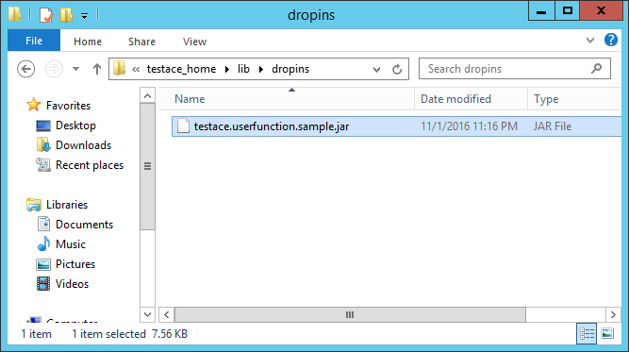

※ After saving user-defined functions in Java Archive (JAR) file, you need to restart Test Ace in order to use this file.

## User Password Change Screen

On User Password Change screen, you can set user password in order to log in.

This sceen is displayed when you select “Settings (P)” – “Change User Password (O)”.

### Screen Outline

Below shows the structure of Change User Password screen.

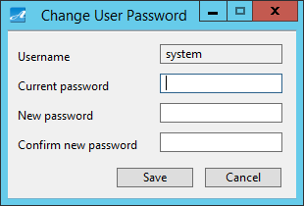

**②**

**④**

**①**

**③**

**⑥**

**⑤**

|  |  |
| --- | --- |
| Screen Item | Description |
| ① Username | Username display (This cannot be edited ) |
| ② Current password | Input current password |
| ③ New password | Input new password |
| ④ Confirm new password | Input new password again to confirm |
| ⑤ Save | Save |
| ⑥ Cancel | Cancel |

### Change User Password

1. Input current password in “Current password” field.

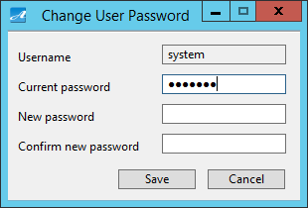

1. Input new password in “New password” field.

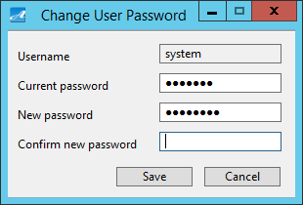

1. Input password again in “Confirm new password” field, then click “Save”.

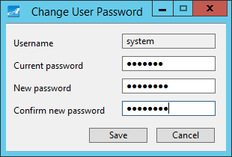

1. A message is displayed to inform that the information on screen has been saved successfully. Click “OK”.

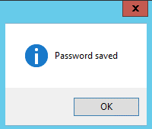

## Pseudo Data Coefficient Eigenvalue Initial Value Settings Screen

On Pseudo Data Coefficient Eigenvalue Initial Value Settings screen, you can set the initial value for coefficient, eigenvalue of pseudo data.

This sceen is displayed when you select “Settings (P)” – “Conversion (T)” – “Pseudo Data Coefficient Eigenvalue Initial Value Settings (P)”.

### Screen Outline

Below shows the structure of Pseudo Data Coefficient Eigenvalue Initial Value Settings screen.

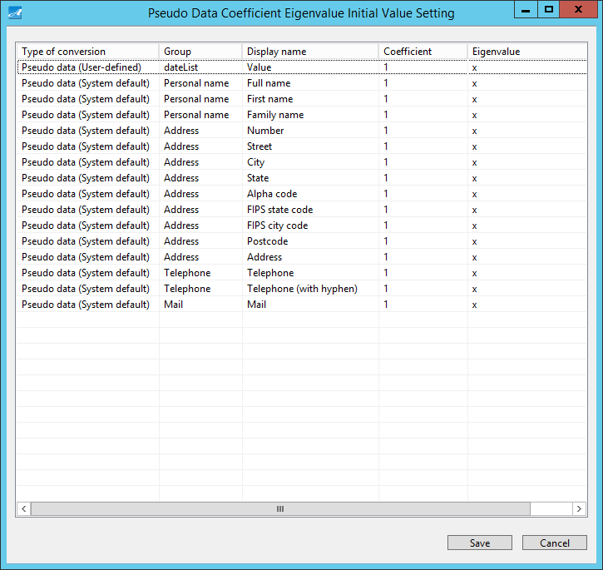

**③**

**②**

**①**

|  |  |
| --- | --- |
| Screen Item | Description |
| ① List | Display conversion type, group, display name, coefficient, eigenvalue.  Edit coefficient.  Edit eigenvalue. |
| ② Save | Save |
| ③ Cancel | Cancel |

### Change Initial Value of Coefficient and Eigenvalue

1. Click on “Coefficient” field of any pseudo data to input a numeric value.

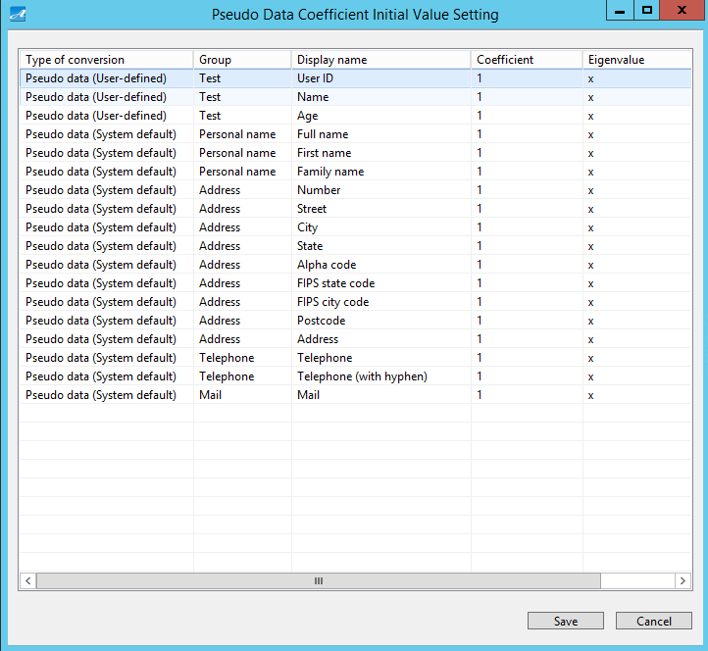

1. Click on “Eigenvalue” field to input a numeric value, then click “Save”.



1. A message is displayed to confirm your action. Click “Yes”.

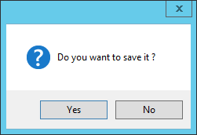

1. A message is displayed to inform that the information on screen has been saved successfully. Click “OK”.



## CUI Run Login File Screen

On CUI Run Login File screen, you can output the login file used in CUI Run.

On the tree view of the left window of Main screen, select “Dataflow”, then click “Settings” on the right window.

Click on “CUI” tab to display CUI Run Settings screen.

This screen is displayed when you click “CUI run login file output” at the bottom left of CUI Run Settings screen.

### Screen Outline

Below shows the structure of CUI Run Login File screen.

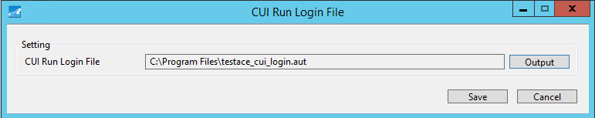

**④**

**③**

**②**

**①**

|  |  |
| --- | --- |
| Screen Item | Description |
| ① CUI Run Login File | Display CUI Run login file |
| ② Output | Output CUI Run login file |
| ③ Save | Save |
| ④ Cancel | Cancel |

### Change the Setting of CUI Login File Output Destination

1. Click on “Output” button.



1. Set an output destination, then click “Save”.

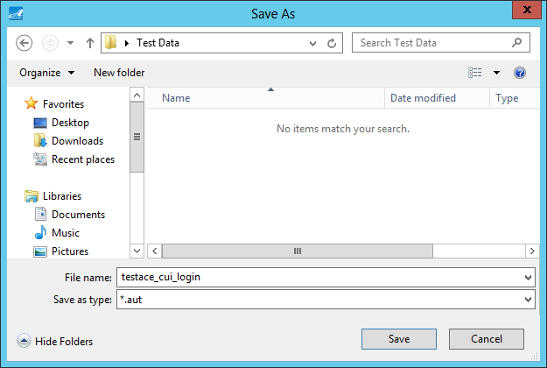

1. A message is displayed to inform that file has been output successfully. Click “OK”.

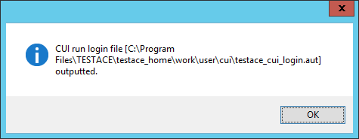

1. The output destination that had been changed is displayed on screen. Click “Save”.

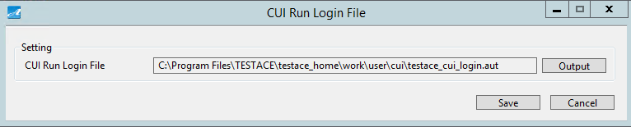

1. A message is displayed to inform that the information on screen has been saved successfully. Click “OK”.



## Conversion By The Column Name Settings Screen

On Conversion By The Column Name Settings screen, you can make conversion settings by the column name.

This screen is displayed when you select “Settings (P)” – “Conversion (T)” – “Conversion By The Column Name Settings (R)”.

### Screen Outline

Below shows the structure of Conversion By The Column Name Settings.

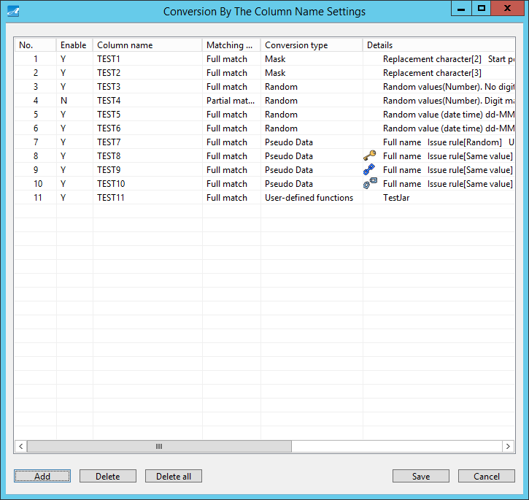

**⑥**

**⑤**

**④**

**②**

**③**

**①**



|  |  |
| --- | --- |
| Screen Item | Description |
| ① List | Display No., Enable, Column name, Matching condition, Conversion type, Detail. |
| ② Add | Add settings |
| ③ Delete | Delete 1 selected setting |
| ④ Delete all | Delete all settings |
| ⑤ Save | Save |
| ⑥ Cancel | Exit conversion by the column name settings. |

### Add Conversion By The Column Name Settings

1. Click “Add”.



1. Conversion By The Column Name Settings Details screen is displayed.

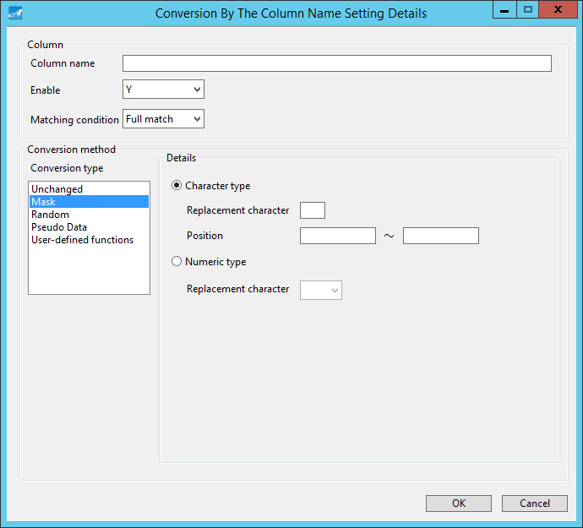

**⑥**

**⑦**

**⑤**

**①**

**②**

**③**

**④**

|  |  |
| --- | --- |
| Screen Item | Description |
| ① Column name | Input column name. |
| ② Enable | Set if you want to enable this setting or not. |
| ③ Matching condition | For matching condition of column name, select Partial match or Full match. |
| ④ Conversion type | Set conversion type※ |
| ⑤ Details | Set detail for conversion type ※ |
| ⑥ OK | Confirm your settings |
| ⑦ Cancel | Cancel |

※ For more information of conversion type, refer to “5.16 Conversion Settings Screen”.

※ You cannot set conversion type, detail in case of Data Generation.

1. Set optional values for displayed items, then click “OK”.
2. Then input values are displayed in list. Click “Save”.

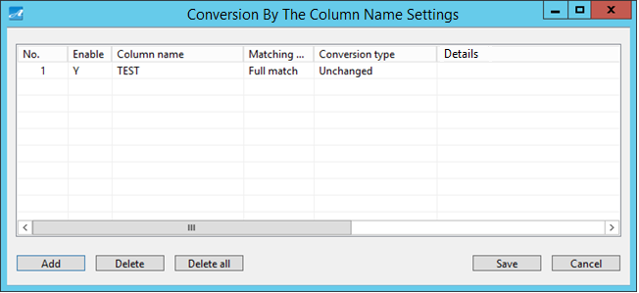

### Delete Conversion By The Column Name Settings

1. Click on any setting in the list, then click “Delete”.
2. Click “Save”.



### Delete All Conversion By The Column Name Settings

1. Click “Delete all.
2. Click “Save”.



## Help Screen

Help is displayed on Help screen.

This screen is displayed when you select “Help (H)” – “Test Ace Help (H)” on the menu bar.

### Screen Outline

Below shows the structure of Help screen.

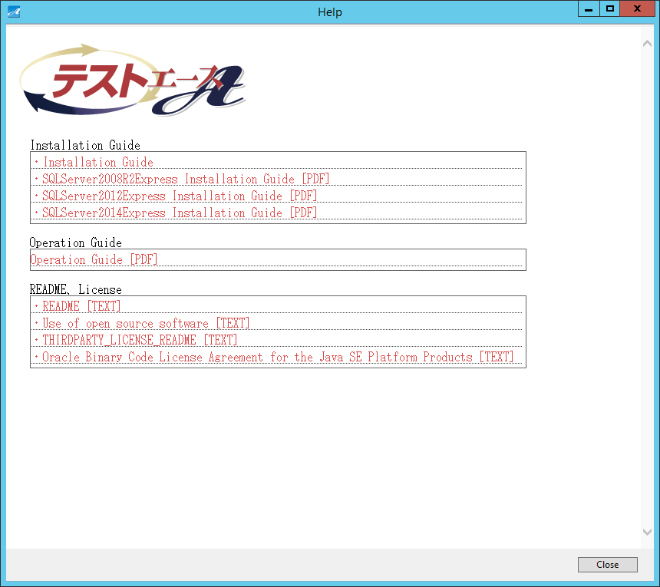

**②**

**①**

|  |  |
| --- | --- |
| Screen Item | Description |
| ① Link | Link to each corresponding document. |
| ② Close | Close the screen. |

## Version Information Screen

Version information is displayed on Version Information screen.

This screen is displayed when you select “Help (H)” – “Test Ace Version Information (A)”.

### Screen Outline

Below shows the structure of Test Ace Version Information screen.

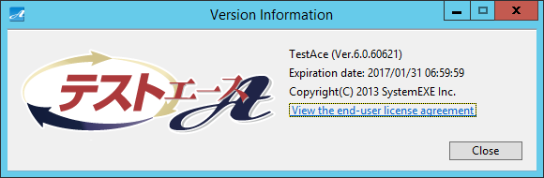

**①**

**②**

|  |  |
| --- | --- |
| Screen Item | Description |
| ① View the end-user license agreement | Display end-user license agreement. |
| ② Close | Close the screen. |

### End-User License Agreement Display

1. Click on “View the end-user license agreement”.



1. Then End-User License Agreement is displayed.

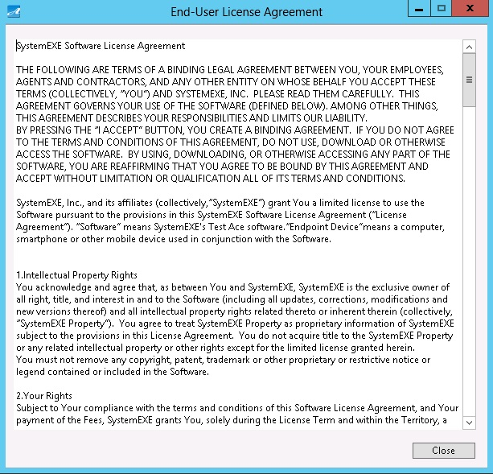

## DB Input Information Screen

On DB Input Information screen, you can set connection info for database which is used as input information of dataflow.

This screen is displayed after you select Dataflow from Main screen, and select the dataflow icon “DB Input Information”.

※ You can also display this screen by selecting “DB Defining Information”.

### Screen Outline

Below shows the structure of DB Input Information screen.

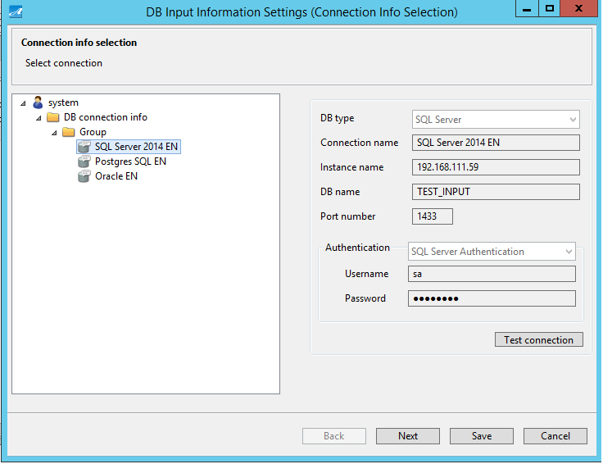

**③**

**⑥**

**⑦**

**⑤**

**④**

**②**

**①**

|  |  |
| --- | --- |
| Screen Item | Description |
| ① DB connection info tree | Display DB connection information. |
| ② DB connection info | Display detail of DB connection information. |
| ③ Test connection | Run connection test. |
| ④ Back | This is disabled on this screen. |
| ⑤ Next | Display Table Selection screen. |
| ⑥ Save | Save |
| ⑦ Cancel | Cancel |

### DB Connection Info Selection

1. On the tree view of the left window, when you click on any DB connection info, detail of that DB connection information is displayed.



### Table Selection Screen

1. On DB Input Information screen, select any DB connection info, then click “Next”.
2. Then Table Selection screen is displayed.

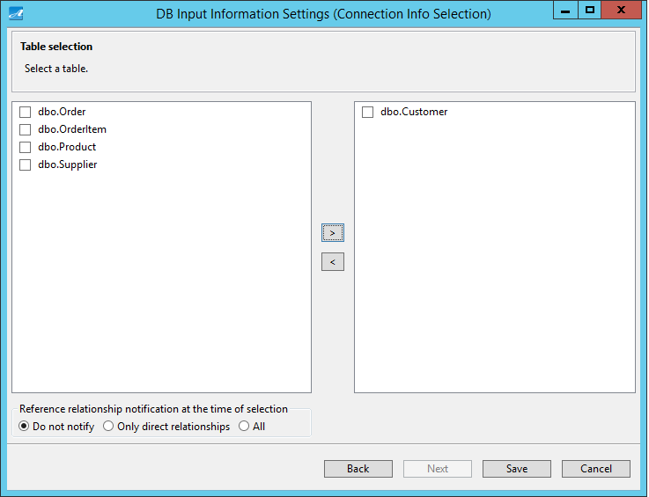

**⑤**

**⑨**

**⑧**

**⑦**

**⑥**

**④**

**③**

**②**

**①**

|  |  |
| --- | --- |
| Screen Item | Description |
| ① Unselected table list | Display unselected tables. |
| ② > | Move tables selected from ① to ④ |
| ③ < | Move tables selected from ④ to ① |
| ④ Selected table list | Display selected tables |
| ⑤ Reference relationship notification at the time of selection | Reference relationship notification. |
| ⑥ Back | Display DB Input Information Settings screen |
| ⑦ Next | This button is disabled in this screen |
| ⑧ Save | Save |
| ⑨ Cancel | Cancel |

### Reference Relationship Notification At The Time Of Selection

When you select tables, you can set to receive reference relationship notification or not. Notification can be set for “Only direct relationships” or “All.”

1. If you select “Only direct relationships”:

Tables which have direct parent-child relationship will be notified. (parent, child)

For the example below, if you select Employee table, Store table will be notified, but Company table will not.

Company table

Company ID

Company Name

Scale

Employee table

Employee ID

Store ID (FK)

Name

Store table

Store ID

Company ID (FK)

Store Name

1. If you select “All”:

All tables with reference relationship will be notified. (parent of parent, child of child etc.)

For the example below, if you select Employee table, both Store table and Company table will be notified.

Company table

Company ID

Company Name

Scale

Store table

Store ID

Company ID (FK)

Store name

Employee table

Employee ID

Store ID (FK)

Name



### Reference Relationship Notification Screen

1. Select table.
2. Under “Reference relationship notification at the time of selection”, check for “Only direct relationships” or “All”.
3. Click “＞”.

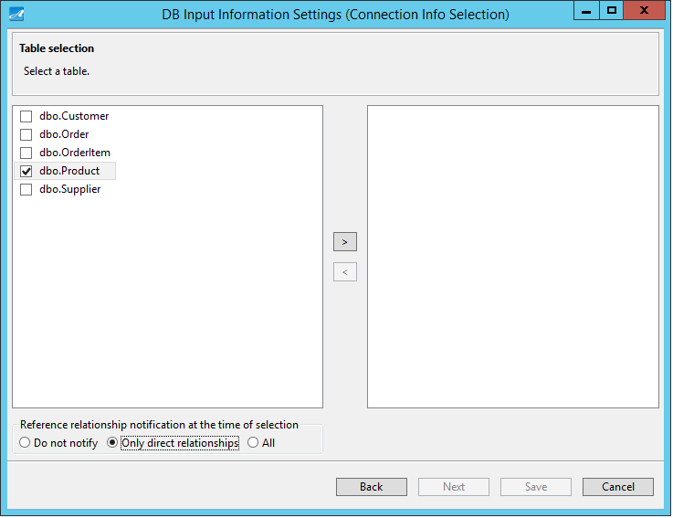

1. For tables which you have pressed “＞”, if you have not selected its reference relationship table, DB Input Information Set Referential Integrity Notification screen will be displayed.

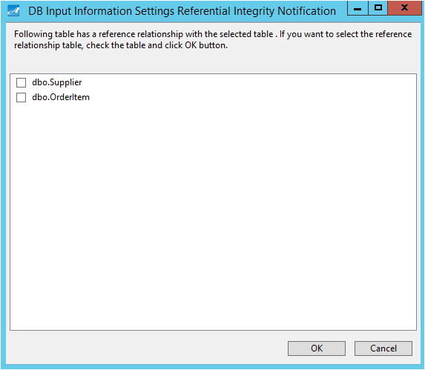

**③**

**②**

**①**

|  |  |
| --- | --- |
| Screen Item | Description |
| ① Reference relationship table list | Display reference relationship tables. |
| ② OK | Apply settings. |
| ③ Cancel | Cancel. |

1. If you also want to select the notified reference relationship, check on the item, then click “OK”.

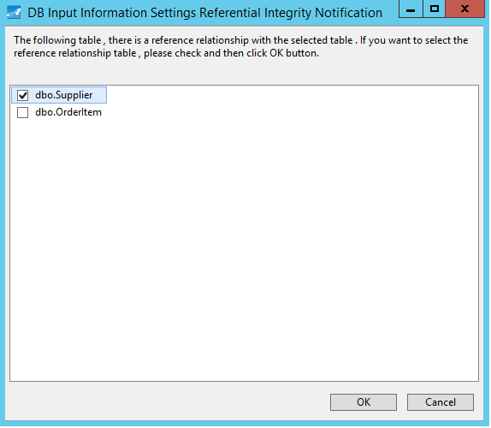

1. The table which had been checked on DB Input Information Set Referential Integrity Notification screen will also be displayed on the selected table list.
2. Click “Save”.

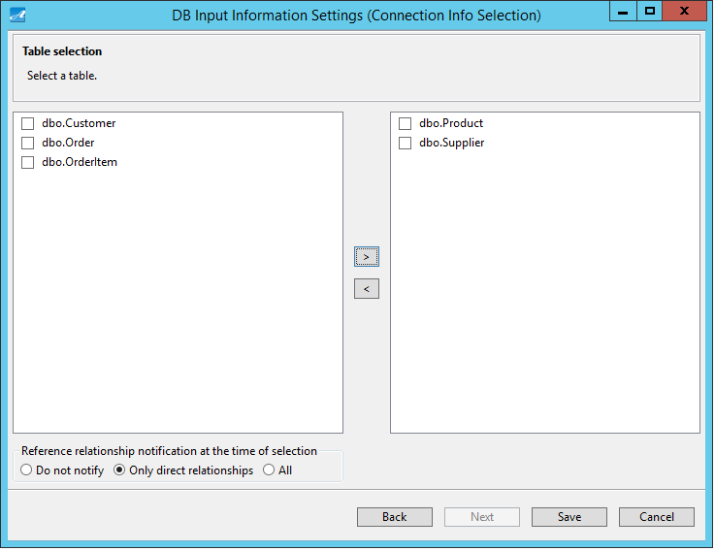

## DB Output Information Settings Screen

On DB Output Information Settings screen, you can set connection info to database which is used as output information of dataflow.

This screen is displayed after you select Dataflow from Main screen, and select the dataflow icon “DB Output Information Settings”.

### Screen Outline

Below shows the structure of DB Output Information Settings screen.

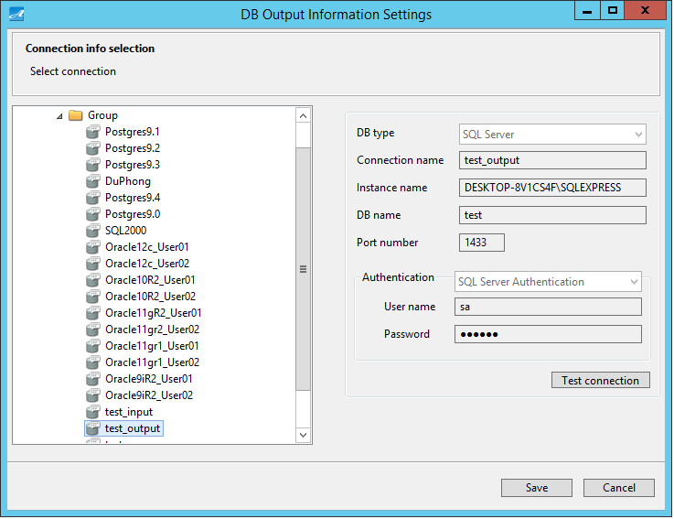

**④**

**⑤**

**③**

**①**

**②**

|  |  |
| --- | --- |
| Screen Item | Description |
| ① DB connection information tree | Display DB connection information. |
| ② DB connection info | Display detail of DB connection information. |
| ③ Test connection | Test connection. |
| ④ Save | Save. |
| ⑤ Cancel | Cancel. |

### DB Connection Information Selection

1. On the tree view of the left window, click on any DB output info, then detail of that DB connection info is displayed.



## File Input Information Settings Screen

On File Input Information Settings screen, you can set connection information for the file which is used as input information of dataflow.

This screen is displayed after you select Dataflow from Main screen, and select the dataflow icon File Input Information Settings.

### Screen Outline

Below shows the structure of File Input Information Settings screen.

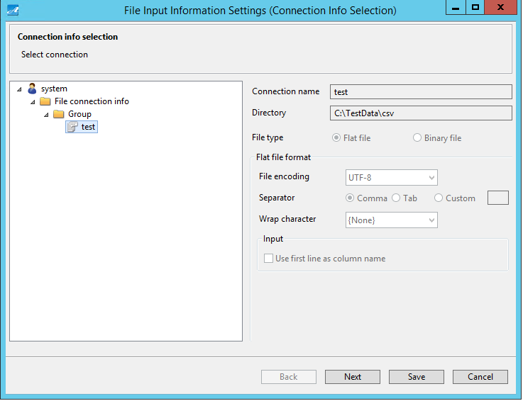 

**⑥**

**⑤**

**④**

**③**

**②**

**①**

|  |  |
| --- | --- |
| Screen Item | Description |
| ① File connection info tree | Display file connection information. |
| ② File connection info | Display detail of file connection information. |
| ③ Back | This button is disabled on this screen. |
| ④ Next | Display file selection screen. |
| ⑤ Save | Save. |
| ⑥ Cancel | Cancel. |

### File Connection Information Selection

1. On the tree view of the left window, when you click on any file connection info, detail of that file connection information will be displayed.



### File Selection Screen

1. On File Input Information Settings screen, select any file connection info, then click “Next”.
2. File Selection screen is displayed.

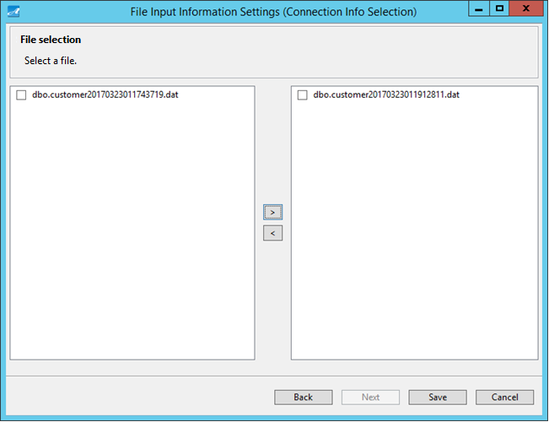

**②**

**③**

**⑧**

**⑦**

**⑥**

**⑤**

**①**

**④**

|  |  |
| --- | --- |
| Screen Item | Description |
| ① Unselected file list | Display unselected files. |
| ② > | Move selected files from ① to ④ |
| ③ < | Move selected files from ④ to ① |
| ④ Selected file list | Display selected files. |
| ⑤ Back | Display File Input Information Settings screen. |
| ⑥ Next | This button is disabled on this screen. |
| ⑦ Save | Save. |
| ⑧ Cancel | Cancel. |

## File Output Information Settings Screen

On File Output Information Settings screen, you can set connection information for the file which is used as output information of dataflow.

This screen is displayed after you select Dataflow from Main screen, and select the dataflow icon “File Output Information Settings”.

### Screen Outline

Below shows the structure of File Output Information Settings screen.

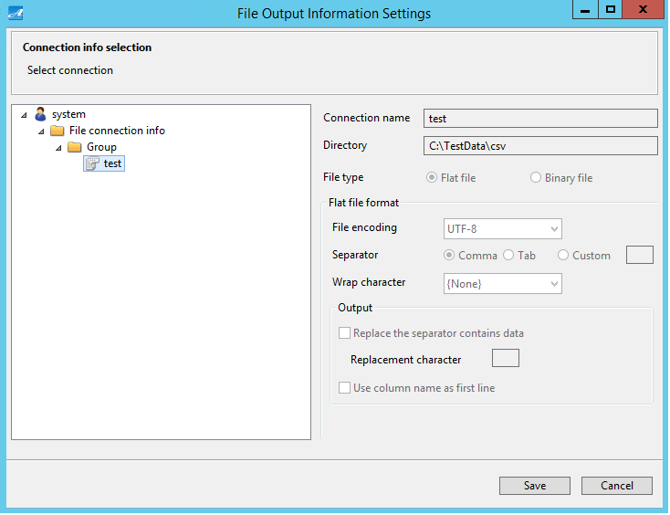

**④**

**③**

**②**

**①**

|  |  |
| --- | --- |
| Screen Item | Description |
| ① File connection information tree | Display file connection information. |
| ② File connection information | Display detail of file connection information. |
| ③ Save | Save. |
| ④ Cancel | Cancel. |

### File Connection Information Selection

1. On the tree view of the left window, when you click on any file conection info, detail of that file connection information is displayed.



## Conversion Settings Screen

On Conversion Settings screen, you can set conversion rules to create test data.

This screen is displayed after you select Dataflow from Main screen, and select the Conversion Settings icon.

|  |  |  |  |  |  |
| --- | --- | --- | --- | --- | --- |
| Conversion Rules | Processing | Attribute  (Refer to “5.16.12 Data Format that Can Be Converted”) | | | |
| Character | Number | Date Time | Other |
| Unchanged | Data is not converted. | ○ | ○ | ○ | - |
| Mask | Replace with arbitrary characters. | ○ | ○ | - | - |
| Random | Replace with random value. | - | ○ | ○ | - |
| Pseudo Data | Replace with registered data. | ○ | ○ | ○ | - |
| User-defined functions | Special conversion by JAVA | ○ | ○ | ○ | - |
| Foreign key | Convert data by conversion rules the same with reference columns. | ○ | ○ | ○ | - |
| Dependent columns | Convert data by conversion rulesthe same with dependent columns. | ○ | ○ | ○ | - |

|  |  |  |  |  |  |
| --- | --- | --- | --- | --- | --- |
| Data Generation Conversion Rules | Processing | Attribute  (Refer to “5.16.12 Data Format that Can Be Converted”) | | | |
| Character | Number | Date Time | Other |
| Sequence number | Generate a sequence number. | ○ | ○ | ○ | - |
| Random | Generate random value. | ○ | ○ | ○ | - |
| Fixed value | Generate fixed value. | ○ | ○ | ○ | - |
| Pseudo Data | Issue registered data. | ○ | ○ | ○ | - |
| User-defined functions | Special conversion by JAVA. | ○ | ○ | ○ | - |
| Foreign key | Convert data by conversion rules the same with reference columns. | ○ | ○ | ○ | - |
| Dependent columns | Convert data by conversion rules the same with dependent columns. | ○ | ○ | ○ | - |

### Screen Outline

Below shows structure of Conversion Settings screen.

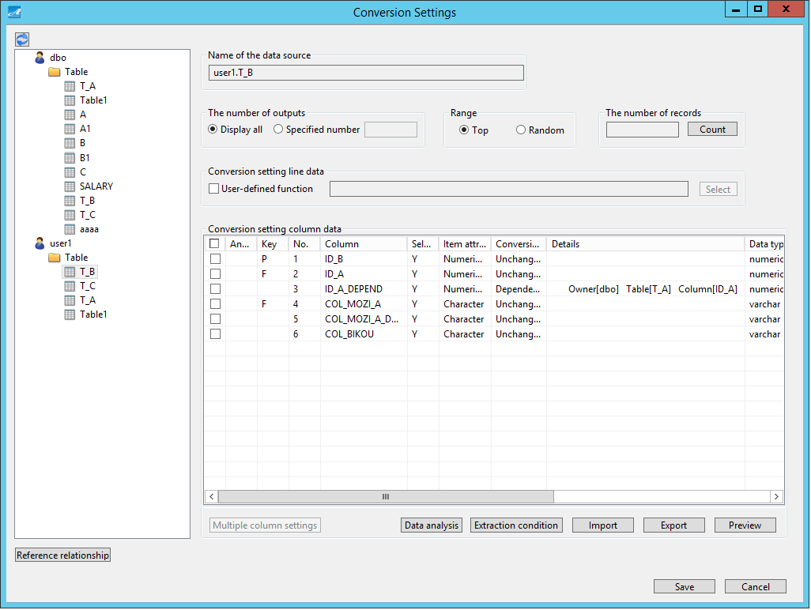

**⑭**

**⑯**

**⑮**

**⑬**

**⑫**

**⑪**

**⑩**

**⑨**

**⑦**

**⑥**

**⑤**

**③**

**④**

**①**

**⑧**

**②**

|  |  |
| --- | --- |
| Screen Item | Description |
| ① Refresh | Update the difference of defined information of input data (table or file). Refer to “5.16.11 Refresh”. |
| ② Table list | Display table and/or file which is input information. |
| ③ The number of outputs | Set the number of outputs. |
| ④ Range | Set the range to acquire data. |
| ⑤ The number of records | Acquire the number of records. |
| ⑥ Conversion setting line data | Set user-defined functions to convert multiple columns.  Refer to “5.16.2 Conversion Settings Line Data” |
| ⑦ Conversion setting column data | Set conversion rules for a single column.  Refer to “Conversion Settings Column Data” |
| ⑧ Multiple column settings | Set conversion rules simultenously for multiple columns.  Refer to “5.16.4 Multiple Columns Settings” |
| ⑨ Data analysist | Analyze data of database and/or file, and automatically set system’s default conversion rules for columns which are judged as personal information.  Set conversion rules that use Conversion By The Column Name Settings.  Refer to “5.16.5 Data Analysis” |
| ⑩ Extraction condition | Set extraction condition. Refer to “5.16.6 Extraction Condition” |
| ⑪ Import | Import the number of outputs, range, conversion rules, extraction condition from file. Refer to “5.16.7 Import” |
| ⑫ Export | Output the number of outputs, range, conversion rules, extraction condition to file. Refer to “5.16.8 Export”. |
| ⑬ Preview | Preview. Refer to “15.6.9 Preview” |
| ⑭ Reference relationship | Display relationship with foreign key columns.  Set conversion rules for “Dependent columns”.  Refer to “5.16.10 Reference Relationship”. |
| ⑮ Save | Save. |
| ⑯ Cancel | Cancel. |

Screen structure varies depending on dataflow type.

|  |  |  |  |
| --- | --- | --- | --- |
| Screen Item | Dataflow Type | | |
| DB - > Conversion - > File  DB - > Conversion - > DB | File - > Conversion - > File | Generation - > File Generation - > DB |
| ③ The number of outputs | Display all / Specified number | Display all / Specified number | Display all / Specified number |
| ④ Range | Enabled | - | - |
| ⑤ The number of records | Enabled | - | - |
| ⑩ Extraction condition | Enabled | - | - |

### Conversion Settings Line Data

Conversion Settings Line Data lets you set user-defined funtions to convert multiple columns.

1. Setting of Conversion Settings Line Data

① Check on “User-defined function”.

② Click “Select” to display User-Defined Functions Selection screen.



③ Select a user-defined function, then click “Select”.

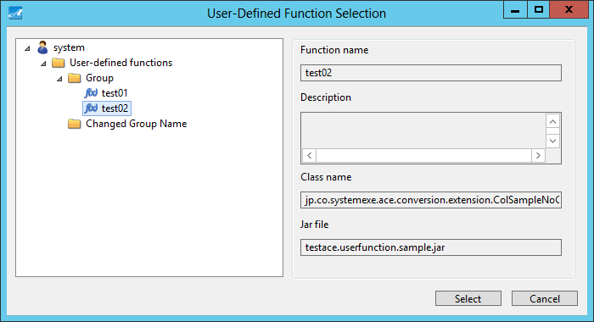

※ Under “Conversion Setting Line Data”: select the user-defined function which will convert multiple columns simultenously (with AbstractCustomRowDataConversion to be the base class) (Refer to “5.5.8 Create User-Defined Functions). Then the user-defined function selected at ④ is displayed.



【Example of running Line Data User-defined function】

Conversion rule: Set test data to match production date with consumption deadline based on code of reference columns.

Reference Column

H21-02-2

H25-02-2

H24-02-2

H20-02-2

Data Before Change

(Production Date)

2013/04/25

2013/01/16

2013/02/28

2013/03/09

Data Before Change (Consumption Deadline)

2013/07/24

2013/04/15

2013/05/27

2013/07/08

Data After Change (Production Date)

2009/02/10

2013/02/08

2012/02/04

2008/02/07

Data After Change (Consumption Deadline)

2009/05/07

2013/05/11

2012/05/09

2008/05/06

### Conversion Setting Column Data

Conversion Setting Column Data lets you set conversion rules for each column.

1. Below are items displayed for Conversion Setting Column Data.

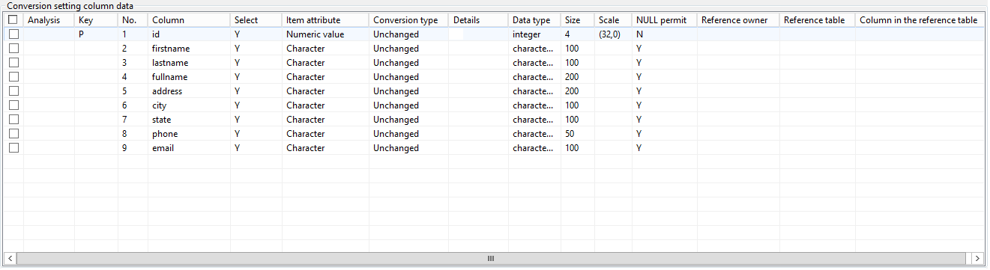

**⑯**

**⑮**

**⑭**

**⑫**

**⑬**

**⑪**

**⑩**

**⑨**

**⑧**

**⑦**

**⑥**

**⑤**

**④**

**③**

**②**

**①**

|  |  |
| --- | --- |
| Screen Item | Description |
| ① Checkbox | Select the data to set multiple columns conversion.  Refer to “5.16.4 Multiple Columns Conversion Settings” |
| ② Analysis | Display icon of “No need to set conversion settings”.  Display icon of “Data anlysis result”.  Meanings of icons displayed in Analysis field:   |  |  | | --- | --- | | Icon | Meaning | |  | Analysis result: Personal Info (Accuracy level: High) | |  | Analysis result: Personl Info (Accuracy level: Low) | |  | Settings as indicated in column names | |  | Data type that needs conversion rule settings. |   Refer to “5.16.5 Data Analysis” |
| ③ Key | Display constraints.  P: Primary Key constraint.  U: Unique Key constraint.  F: Referential Integrity constraint (Foreign Key constraint). |
| ④ № | Display sequence number. |
| ⑤ Column | Display column name. |
| ⑥ Select | Display selection. |
| ⑦ Item attribute | Display data attribute.  Refer to “5.16.12 Data Type that Can Be Converted” |
| ⑧ Conversion type | Display conversion type. |
| ⑨ Details | Display details of ⑧  Meanings of icons displayed in Details field.   |  |  | | --- | --- | | Icon | Meaning | |  | “Reference column” in Detail Settings of “Pseudo Data” | |  | “Synchronize with the reference column” in Detail Settings of “Pseudo Data” | |  | “Do not synchronized” in Detail Settings of “Pseudo Data” | |
| ⑩ Data type | Display data type. |
| ⑪ Size | Display information related to size. |
| ⑫ Scale | Display information related to scale. |
| ⑬ NULL Permit | Display permission of NULL value |
| ⑭ Reference Owner | Display schema name of reference table of Foreign Key constraint. |
| ⑮ Reference Table | Display reference table name of Foreign Key constraint. |
| ⑯Reference Column | Display reference column name of Foreign Key constraint. |

1. Conversion Settings Details screen:

Double click on the column which sets conversion rules, then Conversion Settings Details screen is displayed.

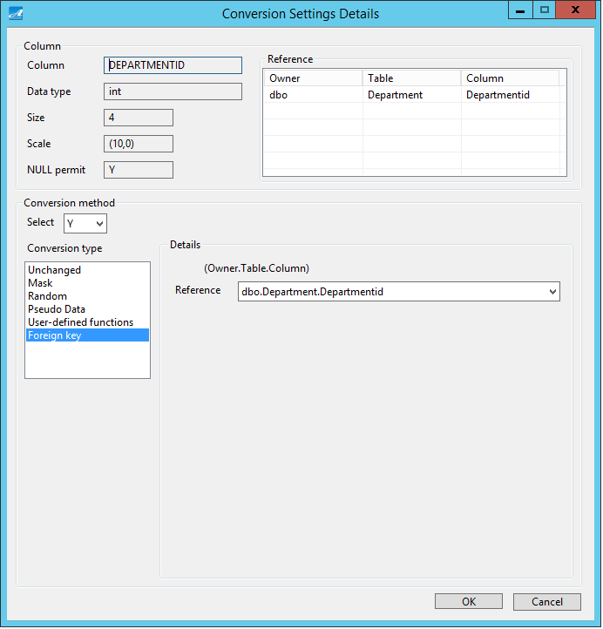

**②**

**③**

**⑤**

**⑥**

**④**

**①**

|  |  |
| --- | --- |
| Screen Item | Description |
| ①Column properties | Display column information. |
| ② Select | Set selection:  Y: Select  N: Not select |
| ③ Conversion type | Set conversion rules. |
| ④ Detail | Display Detail items of conversion rules. |
| ⑤ OK | Confirm your settings. |
| ⑥ Cancel | Cancel. |

Screen structure varies depending on dataflow type.

|  |  |  |  |
| --- | --- | --- | --- |
| Screen Item | Dataflow type | | |
| DB - > Conversion - > File  DB - > Conversion - > DB | File - > Conversion - > File | Generation - > File  Generation - > DB |
| ② Select | Enabled | - | Enabled |
| ⑦ Item attribute | - | Set item attributes. | - |
| ⑧ NULL ratio | - | - | Set NULL ratio. |

For the dataflow type “File - > Conversion - > File”:

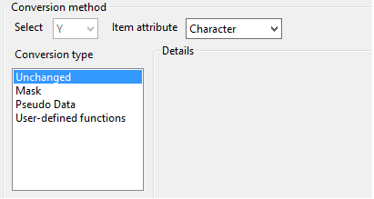

**⑦**

※ When “Item attribute” is changed, “Conversion type” is switched accordingly. When that happens, the “Dependent column” of the previously displayed “Conversion type” will also disappear.

(The condition for “Dependent column” is the same for Reference destination and “Item attribute”)

If you want to keep the “Dependent column”, click on “Cancel” button to exit.)

For the dataflow type “Generation - > File”, “Generation - > DB”:

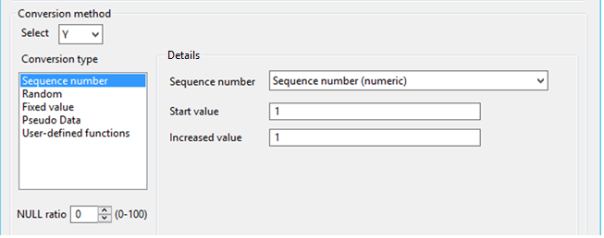

**⑧**

1. When Conversion type is “Unchanged”:

If you select “Unchanged”, the original data will be output without being converted.

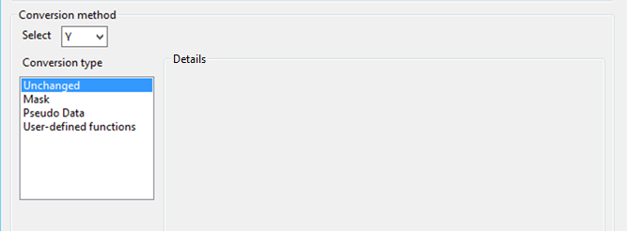

**①**

|  |  |
| --- | --- |
| Screen Item | Description |
| ① Detail field | Not available. |

※ Due to character settings in database, the calculation result may not be right.

Calculation result may not be consistent with database and Java API.

If you are using the 3rd and 4th level of JIS2000/2004, calculation result may be inconsistent with database.

1. When Conversion type is “Mask”:

If you select “Mask”, the original data will be replaced with your indicated Replacement character.

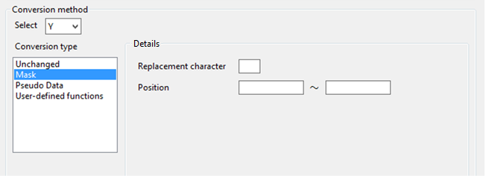

① Below shows Masking of when Item attribute is “Character”:

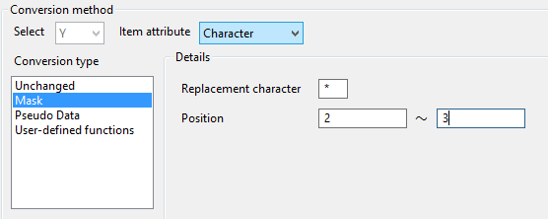

**②**

**①**

|  |  |
| --- | --- |
| Screen Item | Description |
| ①Replacement character | Set replacement character. |
| ② Position | Set Start position and End position (the first character in the beginning is counted as 1). |

【Example of Masking (Character)】

Replacement character: ＊

Start position: 6

End position: 9

Original Data

system-exe

After Change Data

syste＊＊＊＊e

② Below shows Masking of when Item attribute is “Numeric”:

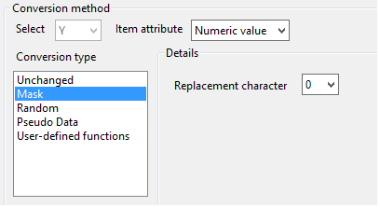

**①**

|  |  |
| --- | --- |
| Screen Item | Description |
| ① Replacement character | Set the replacement character. |

【Example of Masking (Numeric)】

Replacement character: 3

Original Data

1234567890

After Change Data

3333333333

Original Data

-0.05

After Change Data

-3.33

1. When Conversion type is “Pseudo Data”:

If you select “Pseudo Data”, the original data will be replaced with registered data.

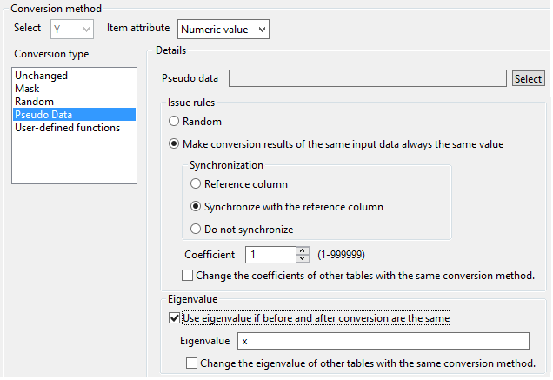

**⑨**

**⑧**

**⑥**

**⑦**

**⑤**

**④**

**③**

**②**

**①**

|  |  |
| --- | --- |
| Screen Item | Description |
| ① Pseudo Data | Set pseudo data. |
| ② Random | Issue random pseudo data. |
| ③ Make conversion results of the same input data always the same value | When issueing pseudo data, the original data and pseudo data issued from ④ Synchronization and ⑤ Coefficient are determined. |
| ④ Synchronization | Set synchronization.  Reference column: to be refered to.  Synchronize with the reference column: synchronize with the column being set to be reference column.  Do not synchronize: do not synchronize. |
| ⑤ Coefficient | If you select ③, set coefficient.  Coefficient: conversion result changes when coefficient changes. |
| ⑥ Change the coefficients of other tables with the same conversion method | Change the setting of coefficients of other columns which set the same pseudo data at the same time. |
| ⑦ Use eigenvalues if before and after conversion are the same | If issued pseudo data is the same with the original data, use an indicated eigenvalue. |
| ⑧ Eigenvalue | If the original data and pseudo data are the same, set the eigenvalue you want to use. |
| ⑨ Change the coefficients of other tables with the same conversion method. | Change the setting of eigenvalue of other columns which set the same pseudo data at the same time. |

① When Issue rule is “Random”:

Because pseudo data is issued randomly, result varies every time.

【Example of Random issuing】

Run the 1st time

Original Data

Washinton

Florida

After Change Data

California

Colorado

Run the 2nd time

Original Data

Washinton

Georgia

After Change Data

Arkansas

Hawaii

② When Issue rule is “Make conversion results of the same input data always the same value”:

Because the same result is returned for the same input data value, execution result is the same every time.

Result changes when registered pseudo data is changed.

【Example 1 of running “Make conversion results of the same input data always the same value”】

Run the 1st time (Coefficient 100)

Original Data

Washinton

Florida

After Change Data

Idaho

Illinois

Run the 2nd time (Coefficient 100)

Original Data

Washinton

Florida

After Change Data

Idaho

Illinois

You can change the result by changing coefficient.

Run the 3rd time (Coefficient 500)

Original Data

Washinton

Florida

After Change Data

Indiana

New York

【Example 2 of running “Make conversion results of the same input data always the same value”】

Street

12th St Sw

City

Birmingham

Registered Pseudo Data

State

Alabama

・・・・・・

Maitland Drive

South Loop Road

・・・・・・

Alameda

Alameda

Catalina Avenue

Alameda

・・・・・・

California

California

California

Hillery Way

Alameda

Mcsherry Way

Alameda

California

California

Trellis Lane

Alameda

Lane Campania

Alameda

California

California

Flower Lane

Alameda

Holly Street

Alameda

California

California

Mecartney Road

Alameda

California

Run the 1st time



Original Data ①

Washinton

Original Data ②

Seattle

Original Data ③

Southwest Orchard Street

Target Column:

Original Data ②

Pseudo Data: City

Synchronization:

Base Column

Coefficient: 100

Target Column:

Original Data ①

Psuedo Data: State

Synchronization:

Base Column

Coefficient: 100

Target Column:

Original Data ③

Pseudo Data: Street

Synchronization:

Base Column

Coefficient: 100

Washinton

Washinton

Washinton

Seattle

Seattle

Seattle

Beacon Avenue South

Federal Avenue East

South Austin Street

After Change Data ①

New York

After Change Data ②

New York

After Change Data ③

Columbus Cir

New York

New York

New York

New York

New York

New York

Broadway

Madison St

Avenue Of The Americas

Run the 2nd time

The result is the same with the 1st time.

③ About “Use eigenvalue if before and after conversion are the same”:

If issued pseudo data are the same with the original data, it will be replaced with an indicated eigenvalue.

【Example of running “Use eigenvalue if before and after conversion are the same”】

Original Data

Washinton

Issued Data

Washinton

After Change Data

eigenvalue

1. When Conversion type is “Random”:

If you select “Random”, the original data will be replaced with a random number.

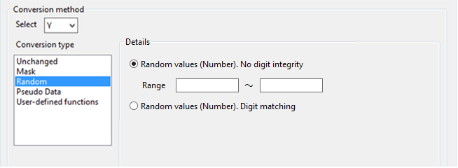

① “Random” when Item attribute is “Numeric”:

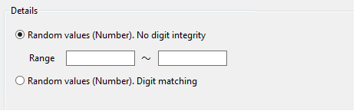

**①**

**②**

**③**

|  |  |
| --- | --- |
| Screen Item | Description |
| ①Random values (Number). No digit integrity | Issue a random number from the range between minimum and maximum number as being set at ②. |
| ② Range | Set minimum and maximum numbers. |
| ③ Random values (Number). Digit matching | Issue a random number while keeping the same number of digits with the original data. |

【Example of “Random values (Number). No digit integrity”】

Minimum value: 1

Maximum value: 99999

Original Data

13579

After Change Data

925

【Example of “Random values(Number). Digit matching”】

Original Data

13579

After Change Data

24680

Original Data

-13579

After Change Data

-59603

② “Random” when Item attribute is “Date”:

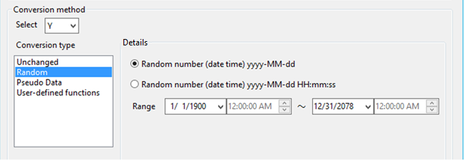

**③**

**②**

**①**

|  |  |
| --- | --- |
| Screen Item | Description |
| ① Random number (date time) yyyy – MM – dd | Issue a random date with Year Month Date format |
| ② Random number (date time) yyyy - MM - dd HH:mm:ss | Issue a random date with Year Month Date Hour Minute format. |
| ③ Range | Input minimum value, maximum value. |

【Example of Random number (date time) yyyy – MM - dd】

Minimum value: 2013 - 01 - 01

Maximum value: 2013 - 12 - 31

Original Data

2013-04-30 12:34:56

After Change Data

2013/12/25

【Example of Random number (date time) yyyy - MM - dd HH:mm:ss】

Minimum value: 2013 - 01 - 01 00:00:00

Maximum value: 2013 - 12 - 31 23:59:59

Original Data

2013-04-30 12:34:56

After Change Data

2013-03-04 05:06:07

1. When Conversion type is “User-defined functions”:

If you select “User-defined functions”, the original data will be replaced with special conversion rules.

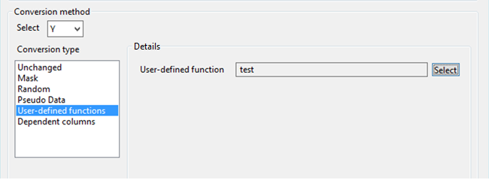

**①**

|  |  |
| --- | --- |
| Screen Item | Description |
| ① User-defined functions | Select a user-defined function. |

【Example of running “User-defined functions”】

Conversion rule: shift the beginning character 1 unit to the right.



Original Data

AB12345

After Change Data

5AB1234

1. When Conversion type is “Foreign key”:

If you select “Foreign key”, the original data will be replaced with a conversion result determined by the conversion rule the same with the reference column.

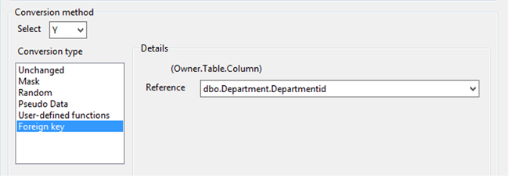

**①**

|  |  |
| --- | --- |
| Screen Item | Description |
| ① Reference | Input the reference column. |

【Example of running “Foreign key”】

Reference column

Original Data

3141592

After Change Data

1414216

Results are equal

The column which had been set Conversion Type “Foreign Key”



Original Data

3141592

After Change Data

1414216

1. When Conversion type is “Dependent columns”:

If you select “Dependent columns”, the original data will be replaced with a conversion result determined by the conversion rule the same with the reference column.

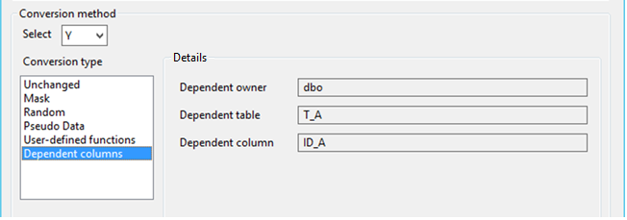

**③**

**①**

**②**

|  |  |
| --- | --- |
| Screen Item | Description |
| ① Dependent owner | Display the owner of the dependent column table. |
| ② Dependent table | Display the dependent column table. |
| ③ Dependent column | Display the dependent column. |

【Example of running the dependent column】

Dependent column

Original Data

3141592

After Change Data

1414216

Results are equal

The column which had been set Conversion Type “Dependent column”

Original Data

3141592

After Change Data

1414216

1. In case of Data Generation, and Conversion type is “Sequence Number”:

Sequense number issues continuous data.

① If you select “Sequence number (numeric)” for Sequence number:

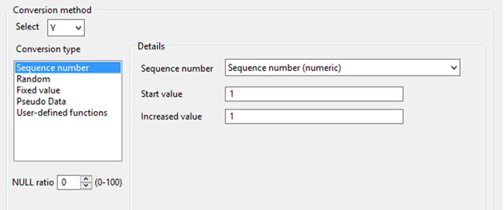

**②**

**①**

|  |  |
| --- | --- |
| Screen Item | Description |
| ① Start value | Set a Start value. |
| ② Increased value | Set an increased value. |

【Example of running “Sequense number (numeric)”】

Start value: 1

Increased value: 1

Generated Data

1

2

3

4

5

② When Conversion type is “Sequence value (character)”:

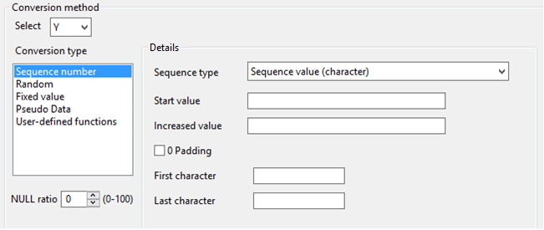

**⑤**

**④**

**①**

**②**

**③**

|  |  |
| --- | --- |
| Screen Item | Description |
| ① Start value | Set a Start value. |
| ② Increased value | Set an increased value. |
| ③0 Padding | Set if you want to add 0 to fit the size in the beginning of the generated sequence number. |
| ④ First character | Set the first character to the generated sequence number. |
| ⑤ Last character | Set the last character to the generated sequence number. |

【Example of running “Sequence value (character)”】

Start value: 1

Increased value: 1

0 Padding：the Check is ON

First character：PID_

Last character：

Size: 10

Generated Data

PID_000001

PID_000002

PID_000003

③ If Sequence number is “Sequence number (date time) yyyy - MM – dd”, “Sequence number (date time) yyyy - MM - dd HH:mm:ss:

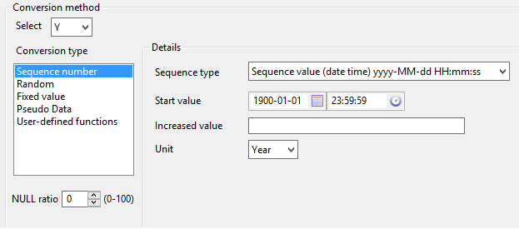

**①**

**②**

**③**

|  |  |
| --- | --- |
| Screen Item | Description |
| ① Start value | Set a Start value. |
| ② Increased value | Set an increased value. |
| ③ Unit | Set the unit of increased value. |

【Example of running “Sequence number (date time) yyyy - MM – dd”】

Start value: 2013/09/01

Increased value: 1

Unit：Month



Generated Data

2013-09-01

2013-10-01

2013-11-01

2013-12-01

2014-01-01

1. In case of Data Generation, and Conversion type is “Random”:

If you select “Random”, random data will be issued.

① If Random type is “Random value (Number)”:

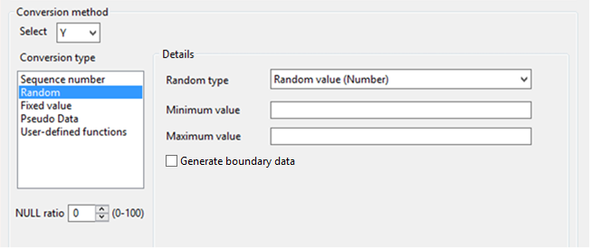

**③**

**②**

**①**

|  |  |
| --- | --- |
| Screen Item | Description |
| ① Minimum value | Input minimum value. |
| ② Maximum value | Input maximum value. |
| ③Generate boundary data | Set if you want to issue boundary data or not.  1st record…Minimum value  2nd record…Maximum value  3rd record…Minimum value - 1  4th record…Minimum value + 1  5th record…Maximum value - 1  6th record…Maximum value + 1 |

Minimum value

Maximum value

Minimum value -1

Minimum value +1

Maximum value -1

Maximum value +1

【Example 1 of running

“Random value (number)”】

Minimum value: 1

Maximum value: 100

Generate boundary data: is checked OFF

Generated Data

87

51

50

【Example 2 of running

“Random value (number)”】

Minimum value: 1

Maximum value: 100

Generate boundary data: is checked ON

Generated Data

1

100

0

2

99

101

31

27

3

44

12

96

20

61

14



② If Random type is “Random value (character)”:

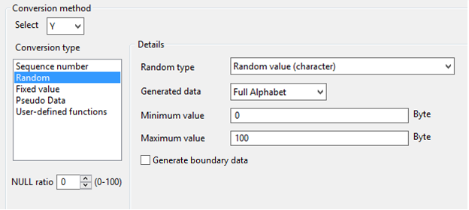

**④**

**③**

**②**

**①**



|  |  |
| --- | --- |
| Screen Item | Description |
| ① Generated data | Set character type for the random value. |
| ② Minimum value | Input minimum value. |
| ③ Maximum value | Input maximum value. |
| ④Generate boundary data | Set if you want to issue boundary data or not.  1st record…Minimum value  2nd record…Maximum value  3rd record…Minimum value - 1  4th record…Minimum value + 1  5th record…Maximum value - 1  6th record…Maximum value + 1 |

Generated Data

oE

LcwYAMFOSG

KTXsTc

【Example 2 of running

“Random value (character)】

Generated data: Half Alphabet

Minimum value: 1

Maximum value: 10

Generate boundary data: is checked ON

Generated Data

u

PTvcyMEAhz

Ps

jYDGTSzDp

ZMLnILEcKjK

nw

TVgaEqI

RvoVt

TIIoySVKt

r

yoGA

EIDRs

rAXJyBbSl

qLtpNPjX

【Example of running

“Random value (character)”】

Generated data: Half Alphabet

Minimum value: 1

Maximum value: 10

Generate boundary data: is checked OFF



Minimum value

Maximum value

Minimum value -1

Minimum value +1

Maximum value -1

Maximum value +1

③ If Random type is “Random value (date time) yyyy - MM – dd”, “Random value (date time) yyyy - MM - dd HH:mm:ss”:

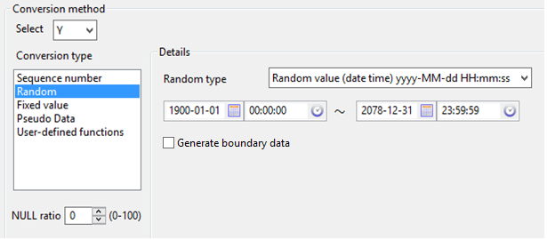

**①**

**②**

|  |  |
| --- | --- |
| Screen Item | Description |
| ① Range | Input minimum value, maximum value. |
| ②Generate boundary data | Set if you want to issue boundary data or not.  1st record…Minimum value  2nd record…Maximum value  3rd record…Minimum value - 1  4th record…Minimum value + 1  5th record…Maximum value - 1  6th record…Maximum value + 1 |

【Example 1 of running

Generated Data

2013-03-30

2013-08-23

2013-10-19

【Example 2 of running“Random value (date time) yyyy – MM – dd”】

Minimum value: 2013-01-01

Maximum value: 2013-12-31

Generate boundary data: is checked ON

Generated Data

2013-01-01

2013-12-31

2012-12-31

2013-01-02

2013-12-30

2014-01-01

2013-10-10

2013-04-09

2013-07-25

2013-07-21

2013-06-09

2013-05-19

2013-06-28

2013-11-26

2013-09-10

“Random value (date time) yyyy - MM – dd”】

Minimum value: 2013 - 01 - 01

Maximum value: 2013 - 12 - 31

Generate boundary data: is checked OFF

Minimum value

Maximum value

Minimum value -1

Minimum value +1

Maximum value -1

Maximum value +1

1. If Data Generation and Conversion type is “Fixed value”,

a fixed value will be issued.

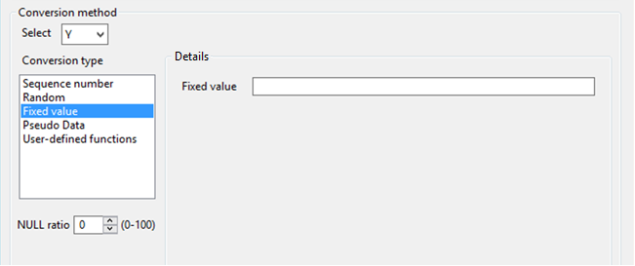

**①**



|  |  |
| --- | --- |
| Screen Item | Description |
| ① Fixed value | Input a fixed value. |

【Example of running “Fixed value”】

Fixed value: 2013 - 09 - 01

Generated Data

2013-09-01

2013-09-01

2013-09-01

2013-09-01

2013-09-01

1. If Data Generation and Conversion type is “Pseudo data”,

registered pseudo data will be issued.

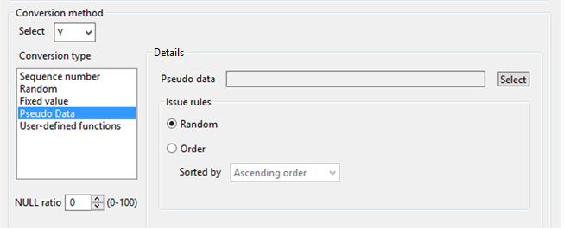

**①**

**④**

**③**

**②**



|  |  |
| --- | --- |
| Screen Item | Description |
| ① Pseudo Data | Set pseudo data. |
| ② Random | Issue random pseudo data. |
| ③ Order | Issue pseudo data in a certain order. |
| ④ Sorted by | If you select ③, set the sort order. |

① When Issue rule is “Random”,

This is the same with “Random” of the Conversion type “Psuedo Data”.

② When Issue rule is “Order”,

The registered pseudo data is issued in a certain order.

【Example of “Order issuing”】

Order: is checked ON

Sorted by: Asceding order

Registered Pseudo Data

Seattle

Aberdeen

Algona

Edmonds

Generated Data

Seattle

Aberdeen

Algona

Edmonds

### Multiple Columns Conversion Settings

Multiple Columns Conversion Settings lets you set conversion rules for the columns that have the same Item attributes.

1. Setings of “Multiple Columns Settings”:

① Turn ON for the checkboxes next to all the columns you want to apply the settings.

② Click on “Multiple Columns Conversion Settings”

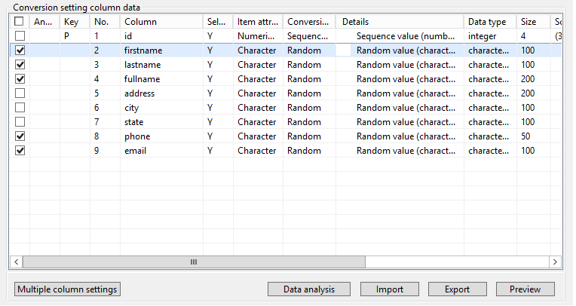

③ Then Conversion Settings Detail screen is displayed.

④ Set the conversion rule, then click on “OK” button.

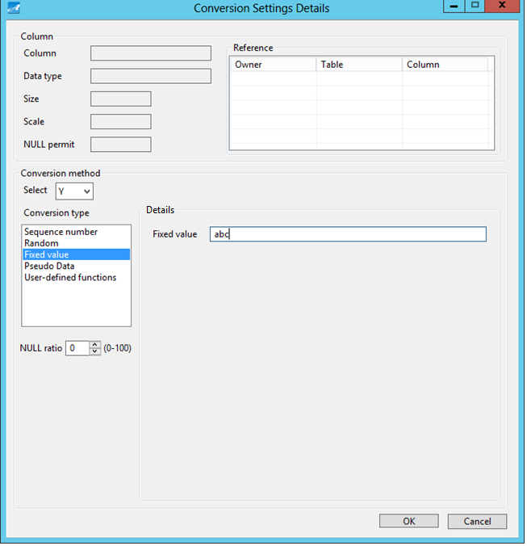

⑤ Then all the columns are applied with your settings.

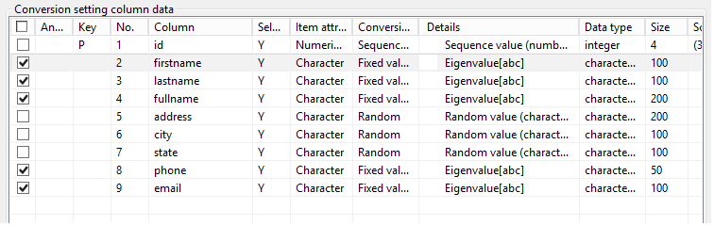

※ When applying Multiple Columns Conversion Settings, under Conversion type, “Foreign key” and “Dependent column” are not displayed.

### Data Analysis

Data Analysis lets you set personal information of the product by special algorithms (patent-acquired technology).

The system will automatically set default appropriate conversion rule for the columns that are deemed to contain personal information, and support data protection at the time test data is created.

When running data analysis, you can select whether to apply appropriate conversion rule by “Conversion By The Column Name Settings” or not.

1. Run Data Analysis:

① Click on “Data analysis”.

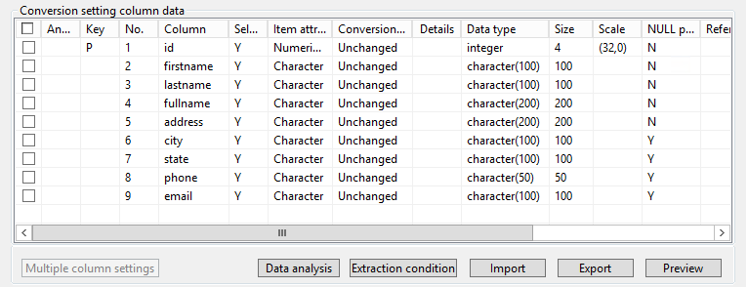

② Data Analysis screen is displayed.

③ Select an analysis method, then click “Run”.

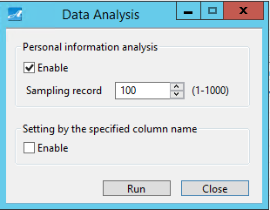

**⑤**

**④**

**③**

**②**

**①**

|  |  |
| --- | --- |
| Screen Item | Description |
| ① Personal information analysis | Recognize personal information of product data by special algorithms (patent-acquired technology), then automatically set the system’s default appropriate conversion rule for columns which are deemed to contain personal information. |
| ② Sampling number | Set the sampling number to be used at ①. |
| ③ Setting by the column name specified | Set the conversion rule based on “Conversion By The Column Name Settings”. |
| ④ Run | Execute. |
| ⑤ Close | Close the screen. |

Screen structure varies depending on dataflow type.

|  |  |  |  |
| --- | --- | --- | --- |
| Screen Item | Dataflow type | | |
| DB - > Conversion - > File  DB - > Conversion - > DB | File - > Conversion - > File | Generation - > File  Generation - > DB |
| ① Persional information analysis | ON／OFF | ON／OFF | Always ON  ※ The checkbox is not displayed. |
| ③ Setting by the column name specified | Enabled | Enabled | - |

④ Then the conversion rule is set based on analysis result.

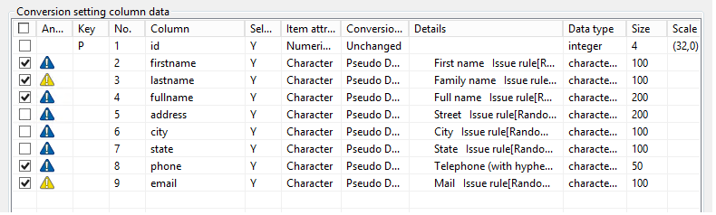

Below table shows explanation for the icons displayed in Analysis field.

|  |  |
| --- | --- |
| Icon | Meaning |
|  | Analysis result: Personal information (Accuracy level: High) |
|  | Analysis result: Personal information (Accuracy level: Low) |
|  | Setting by the column name specified. |
|  | Data type to be applied with conversion rule settings. |

### Extraction Condition

Extraction Condition lets you set the condition to extract data.

1. Set Extraction Condition:

① Click on “Extraction condition”.



② Extraction Condition Settings screen is displayed.

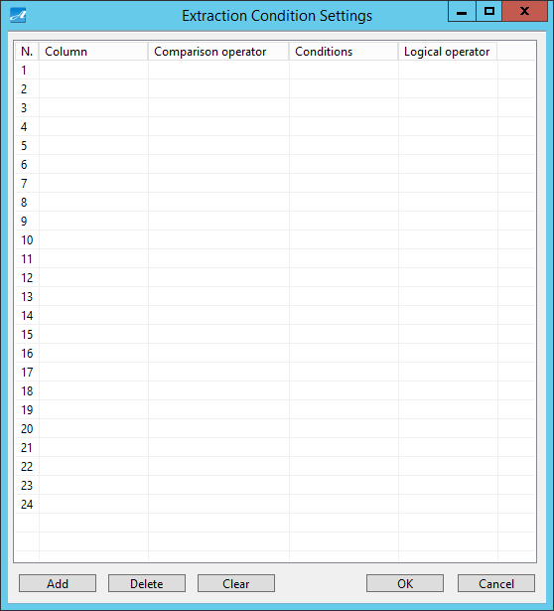

**⑥**

**⑤**

**③**

**④**

**②**

**①**

|  |  |
| --- | --- |
| Screen Item | Description |
| ① Extracted conditions | Set the conditions to be extracted. |
| ② Add | Add the conditions to ①. |
| ③ Delete | Delete the conditions from ①. |
| ④ Clear | Delete all the extracted condition |
| ⑤ OK | Apply the settings. |
| ⑥ Cancel | Cancel. |

③ Select a column.

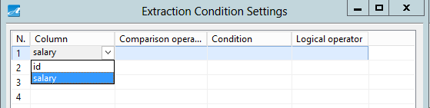

④ Select a Comparison operator.

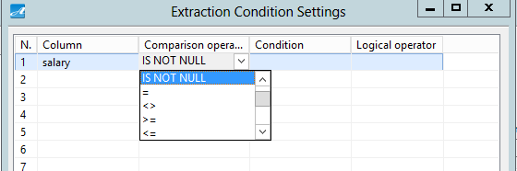

The comparison operators are shown below.

|  |  |
| --- | --- |
| Comparison operator | Description |
| IS NULL | Column’s value is NULL. |
| IS NOT NULL | Column value is not NULL. |
| = | Column value is equivalent with the condition. |
| <> | Column value is not equivalent with the condition. |
| >= | Column value is equivalent to or larger than the condition. |
| <= | Column value is equivalent or smaller than the condition. |
| > | Column value is larger than the condition. |
| < | Column value is smaller than the condition. |
| LIKE(contain) | Column value includes the value of the condition. |
| LIKE(start) | Column value starts at the value of the condition. |
| LIKE(end) | Column value ends at the value of the condition. |
| NOT LIKE(not contain) | Column value does not include the value in the condition. |
| NOT LIKE(not start) | Column value does not start at the value of the condition. |
| NOT LIKE(not end) | Column value does not end at the value of the condition. |

⑤ Input the condition.

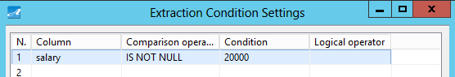

⑥ If necessary, select a logical operator.

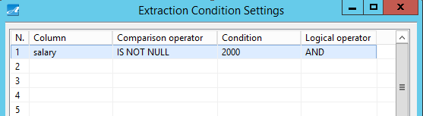

The logical operators are shown below.

|  |  |
| --- | --- |
| Logical operator | Description |
| AND | Extract consistent data from both the line for which logical operator is being set and the line below it. |
| OR | Extract consistent data from either the line for which logical operator is being set or the line below it. |

※ You cannot use bracket in the extraction condition.

【Example】　Conditions like （A OR B） AND （C OR D）

⑦ Click “OK”.



1. Delete the extraction condition:

① Click on “Extraction condition”.

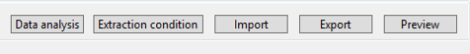

② Extraction Condition Settings screen is displayed.

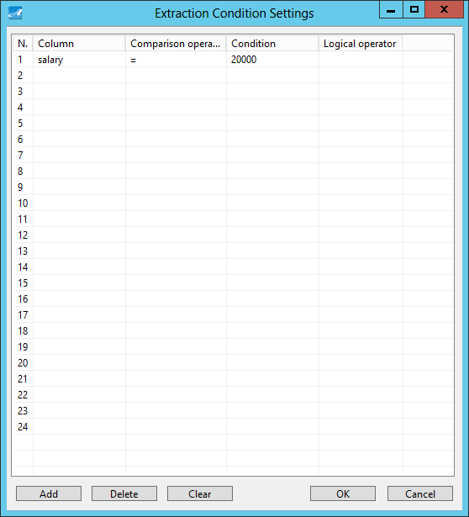

③ Click on “Clear”.



④ Make sure that all extraction conditions had been canceled, then click “OK”.



### Import

“Import” lets you import conversion settings from a file in which all the conversion information settings are registered (the number of output, range, conversion rule, extraction condition).

1. Import:

① Click on “Import”.

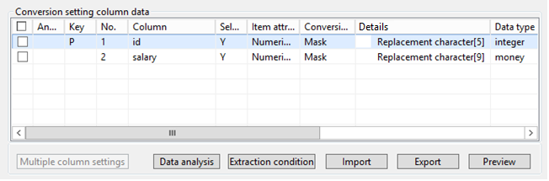

② Select a file, then click “Open” button.

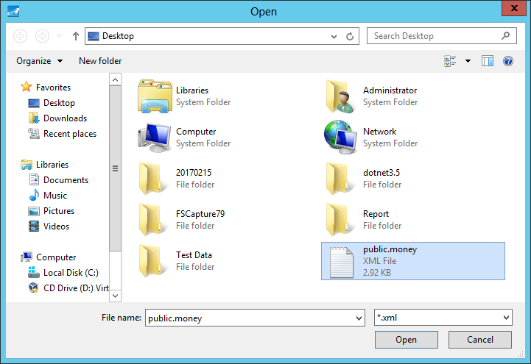

③ Then conversion information settings in the file are applied.

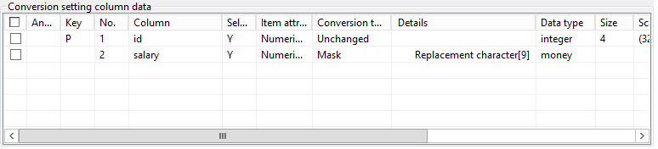

※ If the conversion information settings in the imported file are not consistent with the table definitions at that time, a message will be displayed. (Except for the case of inconsistency between two Conversion types “Foreign key” and “Dependent column”)

If there is inconsistency, system’s default settings may be applied.

Example: system’s default settings

① Select “N”

② Select “Y” / Conversion type “Unchanged” (In case of “File -> Conversion -> File”, you cannot select “N”)

※ In case of inconsistent extraction conditions, you will need to input the settings manually.

※ If Dataflow is Data Generation, and the Data-Generation-specific conversion information settings are registered in the imported file, the system may not import the file. (This is the same for when importing Data-Conversion-specific conversion information settings when Dataflow is Data Generation)

### Export

“Export” lets you output conversion information settings (the number of output, range, conversion rule, extraction condition) to file.

1. Export:

① Click on “Export”.



② Select a Save destination, then click “Save”.

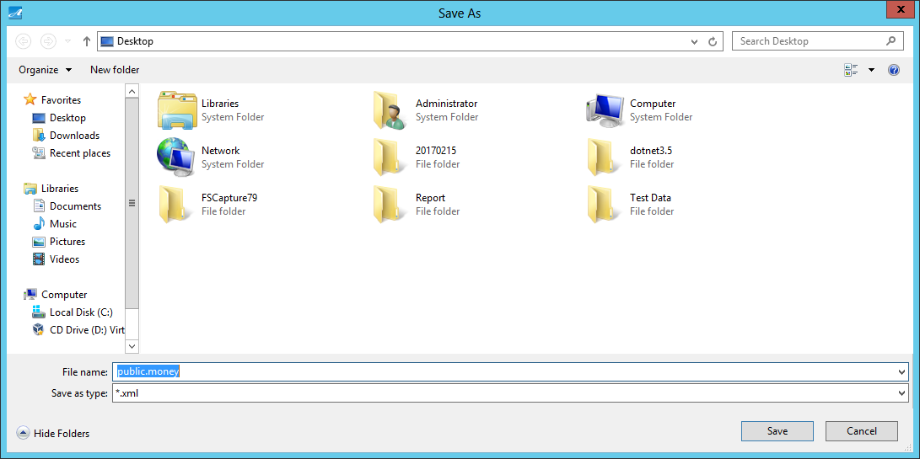

### Preview

“Preview” lets you check execution result of the conversion information settings before hand.

1. Preview:

① Click on “Preview” button.



② Then Preview screen is displayed.

③ If necessary, indicate Sampling number, then click “Run”.

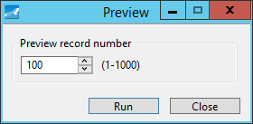

**③**

**②**

**①**

|  |  |
| --- | --- |
| Screen Item | Description |
| ① Sampling number | Indicate the amount of data you want to preview. |
| ② Run | Run. |
| ③ Close | Close the screen. |

④ Preview Result screen is displayed.

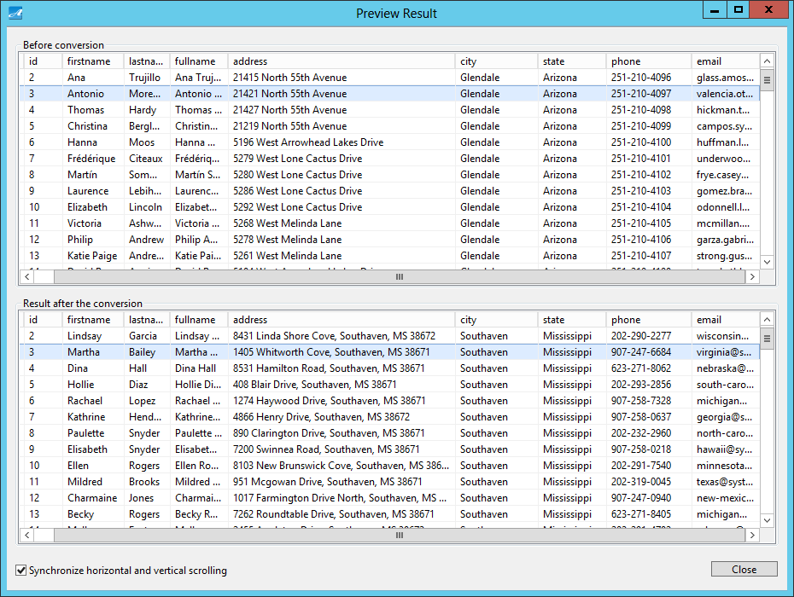

**④**

**③**

**②**

**①**



|  |  |
| --- | --- |
| Screen Item | Description |
| ① Before conversion | Display the data of before conversion. |
| ② Image after the conversion | Display the image of data after conversion. |
| ③ To synchronize horizontal and vertical scrolling | Synchronize scrolling of ① and ②. |
| ④ Close | Close the screen. |

Screen structure varies depending on dataflow type.

|  |  |  |  |
| --- | --- | --- | --- |
| Screen Item | Dataflow type | | |
| DB - > Conversion - > File  DB - > Conversion - > DB | File - > Conversion - > File | Generation - > File  Generation - > DB |
| ① Before conversion | Enabled | Enabled | - |
| ③ To synchronize vertical and horizontal scolling | Enabled | Enabled | - |

※ If Foreign key conversion and Dependent column conversion are included in conversion rule of the previewed table, reference table will also be processed.

### Reference Relationship

“Reference relationship” lets you set the conversion rule “Dependent column” when showing the relationship of the Foreign key column.

1. Set the conversion rule “Dependent column”

① Click on “Reference relationship”.

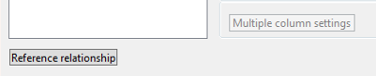

② Referential Integrity, Dependency Relationship screen is displayed.

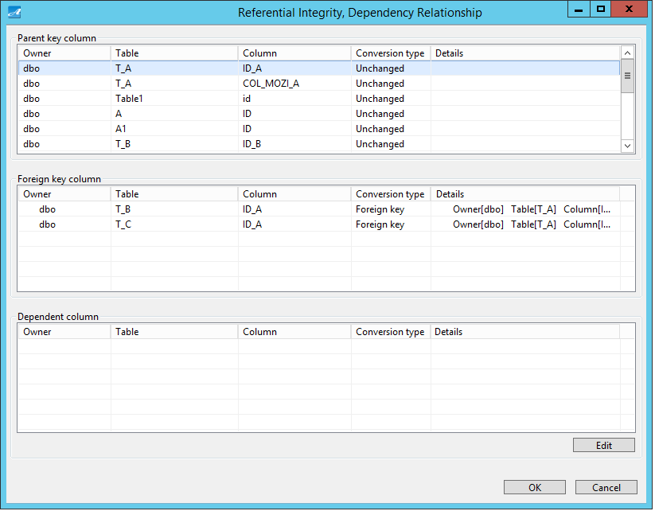

**⑥**

**⑤**

**④**

**③**

**①**

**②**

|  |  |
| --- | --- |
| Screen Item | Description |
| ① Parent key column | Display column names which have Primary key restriction or Unique restriction. |
| ② Foreign key column | Display column names which have Foreign key restriction of the selected columns in ①. |
| ③ Dependent column | Display column names as reference for Conversion Rules (Dependent Column) for columns which had been selected at ① |
| ④ Edit | Display Dependent Column Settings screen. |
| ⑤ OK | Submit your settings. |
| ⑥ Cancel | Cancel |

③ Select a column name from Paranet key column

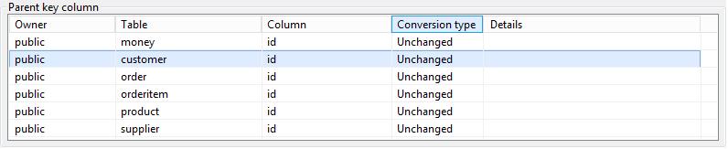

④ Click on “Edit”.

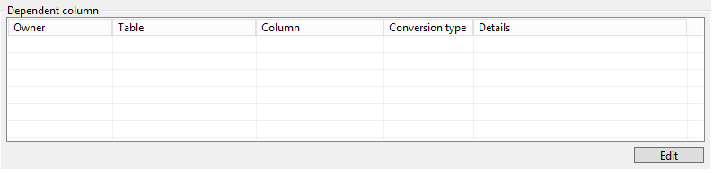

⑤ Then Referential Integrity, Dependency Relationship Settings screen is displayed.

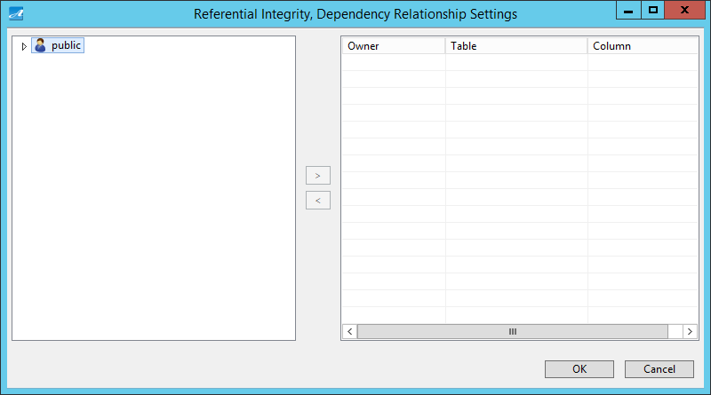

**④**

**⑤**

**⑥**

**②**

**①**

**③**

|  |  |
| --- | --- |
| Screen Item | Description |
| ① Table List | Display table of objects that will be conversed. |
| ② Columns which is set to be the Conversion Rule “Dependent Column” | Display columns which is set to be the Conversion Rule “Dependent Column” |
| ③> | Move columns selected from ① to ② |
| ④< | Move columns selected from ② to ① |
| ⑤OK | Apply these settings. |
| ⑥Cancel | Cancel |

⑥ Select the column name for which you want to set Conversion Rule “Dependent column”, click “>”.

⑦ Click “OK”.

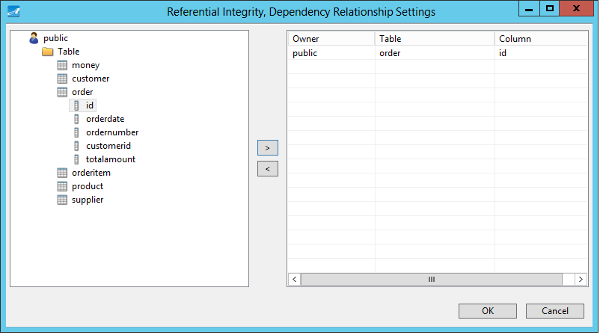

⑧ Then Column info is displayed in Dependent Column field.

⑨ Click “OK”.

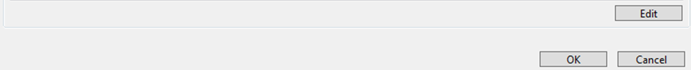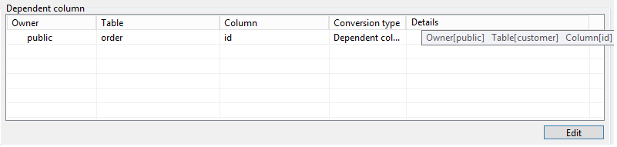

(2) Remove Conversion Rule “Dependent Column”

① Click on “Reference relationship” button

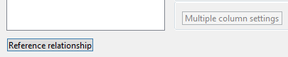

② Select a column from “Parent key column”.

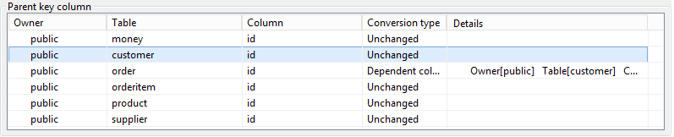

③ Click on “Edit”.

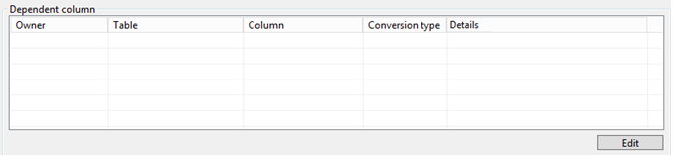

④ Then Referential Integrity, Dependency Relationship Settings screen is displayed.

⑤ Click on a column, then click “<” button.

⑥ Click on “OK” button.



⑦ Confirm that column info which had been removed in Dependent column field has disappeared.

⑧ Click “OK”.

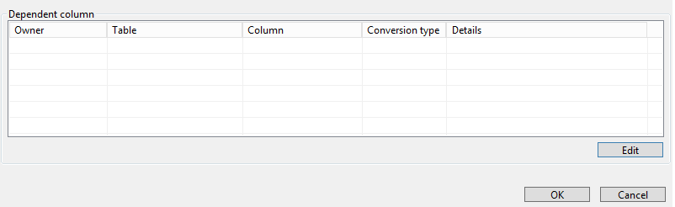

### Refresh

The “Refresh” function lets you update the input information (table or file).

(1) Refresh

① Click on “Refresh”

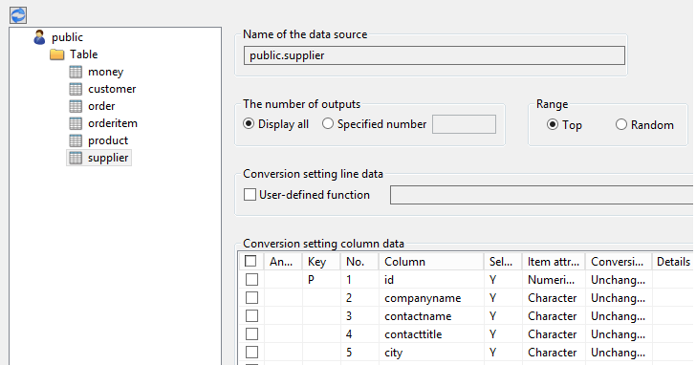

② If the information has been changed, a message is displayed to confirm your action. Click “Yes”.

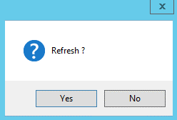

③ Then the change is synchronized.

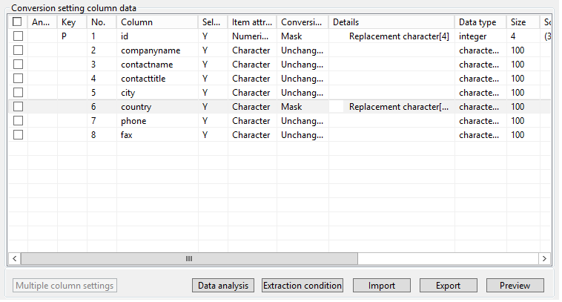

### Data Type That Can Be Converted

1. Oracle

Below shows Column Data Format for which conversion rules can be applied.

|  |  |  |  |  |
| --- | --- | --- | --- | --- |
| Oracle　Column Data Format | Oracle12c | Oracle11g | Oracle10g | Item attribute |
| CHAR | ○ | ○ | ○ | Character |
| DATE | ○ | ○ | ○ | Date time |
| FLOAT | ○ | ○ | ○ | Numeric |
| INTEGER | ○ | ○ | ○ | Numeric |
| NCHAR | ○ | ○ | ○ | Character |
| NUMBER | ○ | ○ | ○ | Numeric |
| NVARCHAR2 | ○ | ○ | ○ | Character |
| TIMESTAMP | ○ | ○ | ○ | Date time |
| VARCHAR2 | ○ | ○ | ○ | Character |
| VIRTUAL COLUMN | △※ | △※ | - | Depending on column type |

* You can only do this for Unload and Conversion. This cannot be applied for Load.

1. SQL Server

Below shows Column Data Format for which conversion rules can be applied.

|  |  |  |  |  |  |
| --- | --- | --- | --- | --- | --- |
| SQL Server　Column Data Format | 2014 | 2012 | 2008 | 2005 | Item attribute |
| BIGINT | ○ | ○ | ○ | ○ | Numeric |
| BIT | ○ | ○ | ○ | ○ | Numeric |
| CHAR[(N)] | ○ | ○ | ○ | ○ | Character |
| DATE | ○ | ○ | ○ | - | Date time |
| DATETIME | ○ | ○ | ○ | ○ | Date time |
| DATETIME2 | ○ | ○ | ○ | - | Date time |
| DECIMAL[(P[,S])] | ○ | ○ | ○ | ○ | Numeric |
| FLOAT[(N)] | ○ | ○ | ○ | ○ | Numeric |
| INT | ○ | ○ | ○ | ○ | Numeric |
| MONEY | ○ | ○ | ○ | ○ | Numeric |
| NCHAR[(N)] | ○ | ○ | ○ | ○ | Character |
| NUMERIC[(P[,S])] | ○ | ○ | ○ | ○ | Numeric |
| NVARCHAR[(N)] | ○ | ○ | ○ | ○ | Character |
| REAL | ○ | ○ | ○ | ○ | Numeric |
| SMALLDATETIME | ○ | ○ | ○ | ○ | Date time |
| SMALLINT | ○ | ○ | ○ | ○ | Numeric |
| SMALLMONEY | ○ | ○ | ○ | ○ | Numeric |
| TIME | ○ | ○ | ○ | - | Date time |
| TINYINT | ○ | ○ | ○ | ○ | Numeric |
| UNIQUEIDENTIFIER | ○ | ○ | ○ | ○ | Character |
| VARCHAR[(N)] | ○ | ○ | ○ | ○ | Character |

1. PostgreSQL

Below shows Column Data Format for which conversion rules can be applied.

|  |  |  |  |  |  |  |  |
| --- | --- | --- | --- | --- | --- | --- | --- |
| PostgreSQL　Column Data Format | 9.5 | 9.4 | 9.3 | 9.2 | 9.1 | 9.0 | Item attribute |
| BIGINT | ○ | ○ | ○ | ○ | ○ | ○ | Numeric |
| BIT[(N)] | ○ | ○ | ○ | ○ | ○ | ○ | Character |
| BIT VARYING[(N)] | ○ | ○ | ○ | ○ | ○ | ○ | Character |
| BOOLEAN | ○ | ○ | ○ | ○ | ○ | ○ | Character |
| CHARACTER[(N)] | ○ | ○ | ○ | ○ | ○ | ○ | Character |
| CHARACTER VARYING[(N)] | ○ | ○ | ○ | ○ | ○ | ○ | Character |
| CIDR | ○ | ○ | ○ | ○ | ○ | ○ | Character |
| DATE | ○ | ○ | ○ | ○ | ○ | ○ | Date time |
| DOUBLE PRECISION | ○ | ○ | ○ | ○ | ○ | ○ | Numeric |
| INET | ○ | ○ | ○ | ○ | ○ | ○ | Character |
| INTEGER | ○ | ○ | ○ | ○ | ○ | ○ | Numeric |
| MACADDR | ○ | ○ | ○ | ○ | ○ | ○ | Character |
| MONEY | ○ | ○ | ○ | ○ | ○ | ○ | Numeric |
| NUMERIC[(P,S)] | ○ | ○ | ○ | ○ | ○ | ○ | Numeric |
| REAL | ○ | ○ | ○ | ○ | ○ | ○ | Numeric |
| SMALLINT | ○ | ○ | ○ | ○ | ○ | ○ | Numeric |
| TIME[(P)][WITHOUT TIME ZONE] | ○ | ○ | ○ | ○ | ○ | ○ | Date time |
| TIMESTAMP[(P)][WITHOUT TIME ZONE] | ○ | ○ | ○ | ○ | ○ | ○ | Date time |
| "CHAR" | ○ | ○ | ○ | ○ | ○ | ○ | Character |
| NAME | ○ | ○ | ○ | ○ | ○ | ○ | Character |

※ This software does not support Array type of PostgreSQLColumn Data Format above.

## Report Settings Screen

On Report Settings screen, you can make settings for outputting report.

This screen is displayed when you click “Settings” on the right window, then click on “Report” tab.

### Screen Outline

Below shows screen structure of Report Settings screen.



**③**

**②**

**④**

**⑤**

**①**

|  |  |
| --- | --- |
| Screen item | Description |
| ①Output the report | Set if you want to output the report or not. |
| ② Report file output destination | Set output destination for the report file. |
| ③ Output data after conversion to report | Set if you want to include converted data in the output report or not. |
| ④ Save | Save report settings. |
| ⑤ Close | Close the screen. |

### Output Converted Data in Report

(1) Output converted data.

① On Report Settings screen, put a check to “Output data after conversion to report”.

② Click “Save”.

③ Run dataflow.

④ 3 records of converted data are output in the report.

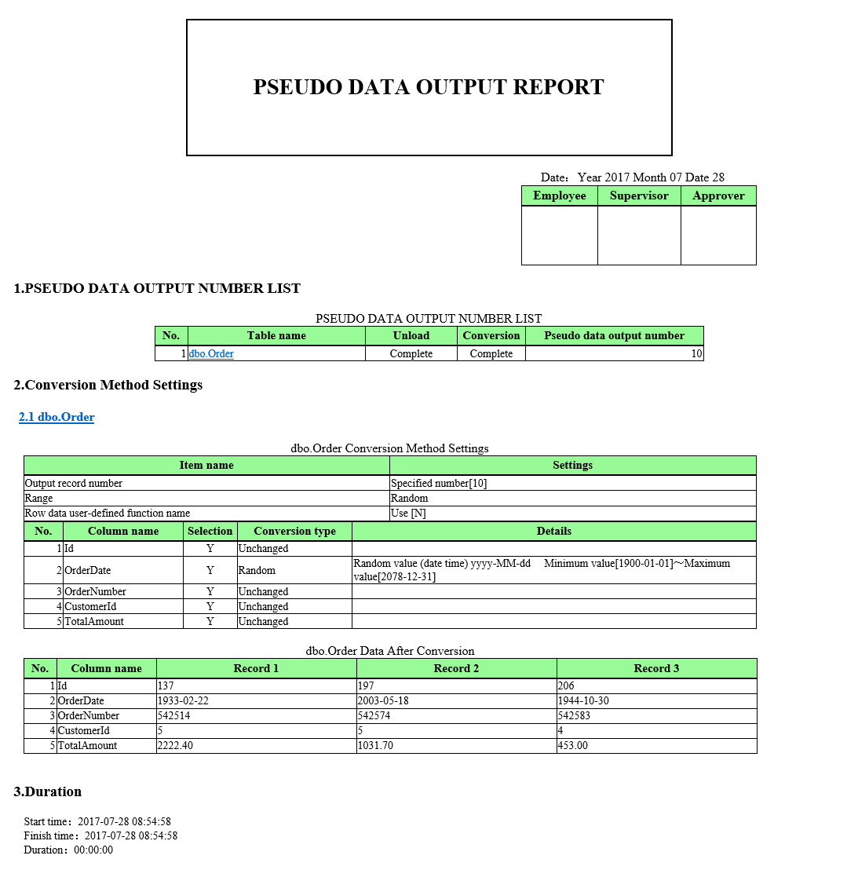

## CUI Settings Screen

On CUI Settings screen, you can make settings for CUI Run.

This screen is displayed when you click “Settings” on the right window, then click on “CUI” tab.

### Screen Outline

Below shows screen structure of CUI Settings screen.

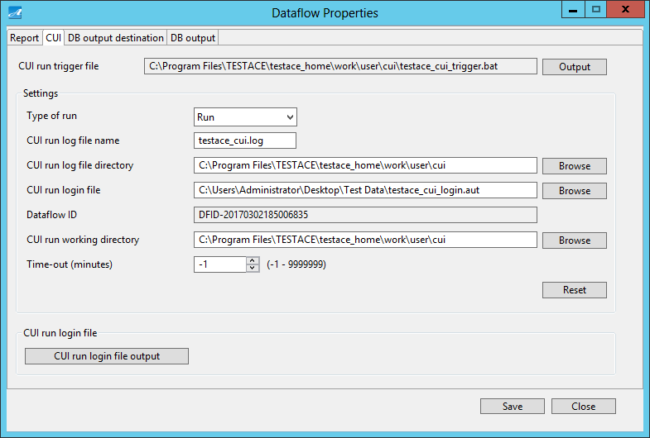

**①**

**⑧**

**⑦**

**⑥**

**⑤**

**④**

**③**

**⑩**

**⑫**

**⑪**

**⑨**

|  |  |
| --- | --- |
| Screen item | Description |
| ① CUI run trigger file | Output the CUI run trigger file. |
| ② Type of run | Set type of run. |
| ③ CUI run log file name | Set the log file name of CUI run. |
| ④ CUI run log file directory | Set the output directory of log file of CUI run. |
| ⑤ CUI run login file | Set the location of log-in file of CUI run. |
| ⑥ Dataflow ID | Display dataflow ID. |
| ⑦ CUI run working directory | Set the working directory that executes CUI run. |
| ⑧ Time-out | Make settings for time-out.  - 1: No time-out |
| ⑨ Reset | Reset the settings. |
| ⑩ CUI run login file output | Display CUI Run Log Login File Execution screen. |
| ⑪ Save | Save CUI settings. |
| ⑫ Close | Close the screen. |

### CUI Run

(1) If you want to execute CUI Run,

① On CUI Settings screen, set “Run” for “Type of run”.

② Click “Save”.

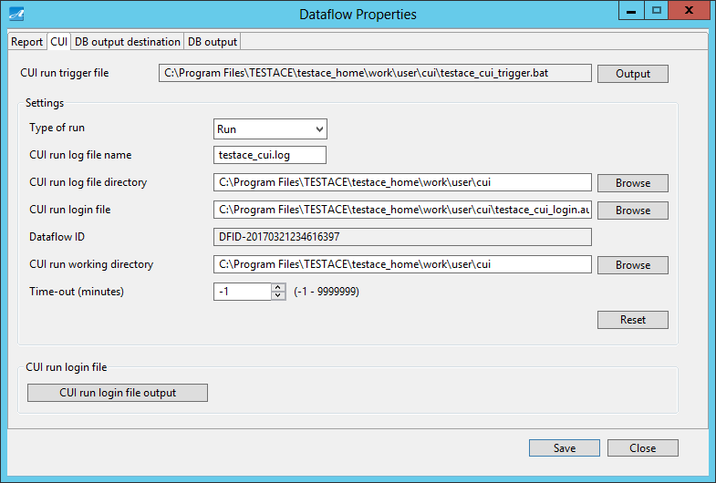

③ When trigger file is run, execution progress is displayed in Console.

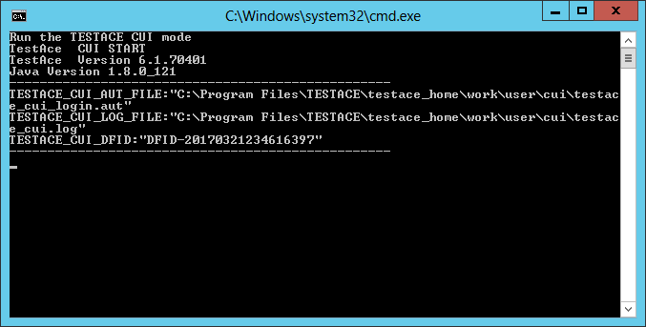

④ Then execution result of dataflow is output.

### CUI Settings Validation

(1) If you want to validate CUI settings,

① On CUI Settings screen, set “Validation” for “Type of run”.

② Click “Save”.

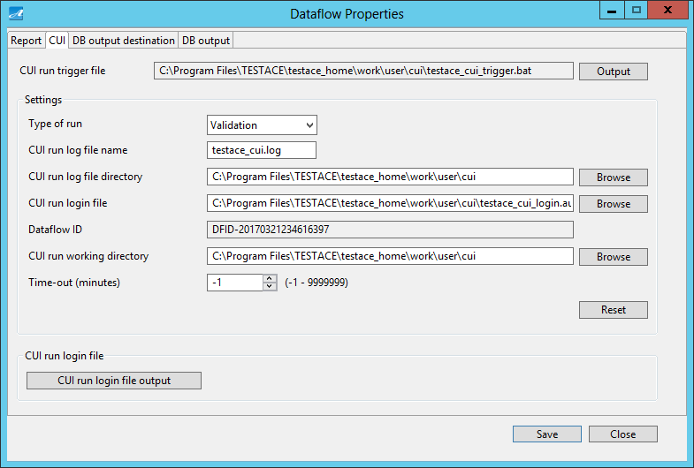

③ When trigger file is run, validation result is displayed in Console.

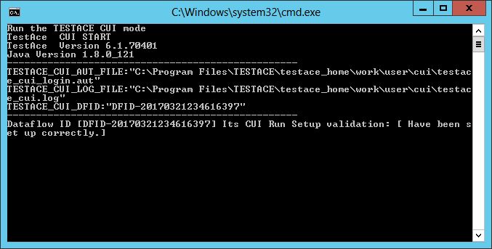

④ Only validation of CUI settings value is implemented. Pseudo data file is not to be output.

## DB Output Destination Screen

On DB Output Destination screen, you can make settings for schema of DB output destination.

This screen is displayed when you click “Settings” on the right window, and click on “DB output destination” tab.

If the output destination of dataflow is a file, this screen is not to be displayed.

|  |  |
| --- | --- |
| Dataflow type | DB Output Destination screen |
| DB - > Conversion - > File | Not displayed. |
| DB - > Conversion - > DB | Displayed. |
| Load | Displayed. |
| File - > Conversion - > File | Not displayed. |
| Generation - > File | Not displayed. |
| Generation - > DB | Displayed. |

### Screen Outline

(1) If dataflow type is “DB - > Conversion - > DB”, “Generation - > DB”, structure of DB Output Destination screen is as below.

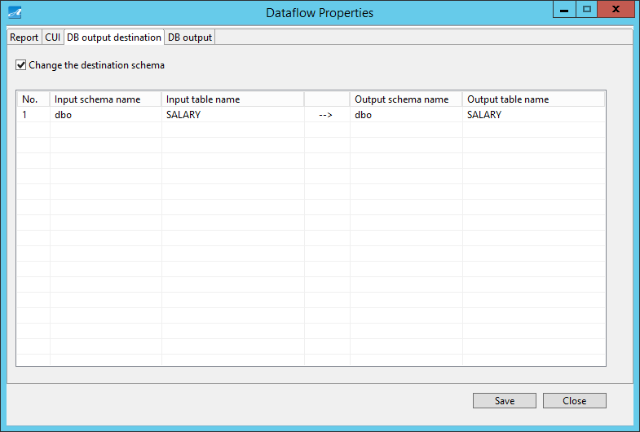

**②**

**④**

**③**

|  |  |
| --- | --- |
| Screen item | Description |
| ① Change the destination schema | Set if you want to change the schema or not.  If you check on this item, “② DB Output Destination Info List” is to be displayed.  If you do not check on this item, “② DB Output Destination Info List” is to be cleared. |
| ② DB Output Destination Info List | Display DB Output Destination Info List. |
| ③ Save | Save the settings of DB output destination. |
| ④ Close | Close the screen. |

Below shows the structure of “DB Output Destination Info List”.

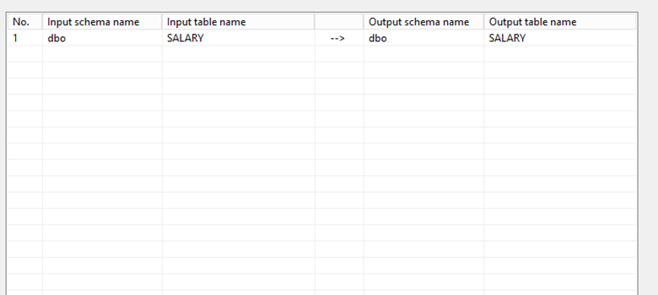

**④**

**⑤**

**③**

**②**

|  |  |  |
| --- | --- | --- |
| Screen item | Can be input or not | Description |
| ① No. | No | Display sequence number. |
| ② Input schema name | No | Display input schema name. |
| ③ Input table name | No | Display input table name. |
| ④ Output schema name | Yes | Set schema name for the output destination. |
| ⑤ Output table name | No | Set table name for the output destination. |

(2) If dataflow type is “Load”,

Structure of DB Output Destination screen is as below.

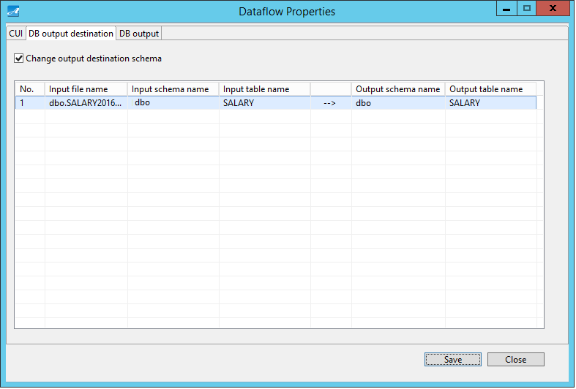

**③**

**④**

**②**

**①**

|  |  |
| --- | --- |
| Screen item | Description |
| ①To change the output destination schema | Set if you want to change the schema or not.  If you check on this, “②DB Output Destination Info List” is displayed.  If you do not check on this, “DB Output Destination Info List” is cleared. |
| ② DB Output Destination Info List | Display DB Output Destination Info List. |
| ③ Save | Save settings of DB output destination. |
| ④ Close | Close the screen. |

Below shows the structure of “DB Output Destination Info List”

**①**

**②**

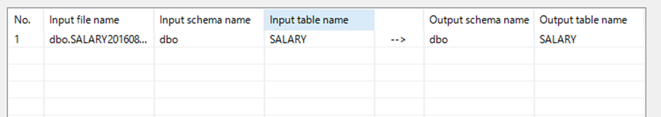

**⑥**

**⑤**

**④**

**③**

|  |  |  |
| --- | --- | --- |
| Screen item | Can be input or not | Description |
| ① No. | No | Display sequence number. |
| ② Input file name | No | Display input file name. |
| ③ Input schema name | No | Display the schema name registered in input file. |
| ④ Input table name | No | Display the table name registered in input file. |
| ⑤ Output schema name | Yes | Set schema name for the output destination. |
| ⑥ Output table name | No | Set table name for the output destination. |

### DB Output Destination Settings

(1) If you set not to change schema of the output destination,

these settings are unnecessary.

(2) If you set to change schema of the output destination,

① Check on “Change output destination schema”

② Then “DB Output Destination Info List” is displayed.

③ Change “Output schema name”.

If you make this setting, you can input data in the schema set in “Output schema name”.

④ Click on “Save” button.

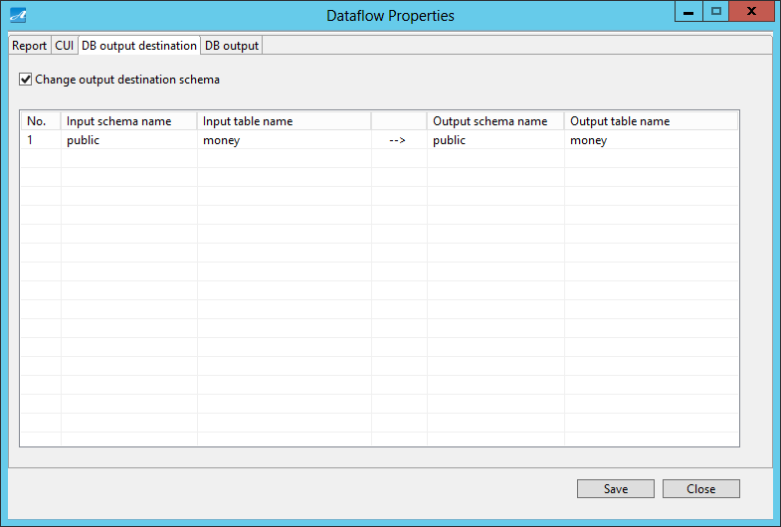

### Clear DB Output Destination Settings

(1) Clear the settings of DB output destination.

Once you clear the settings of DB output destination, data is to be input in the same schema.

① Clear the check on “Change the destination schema”.

② Click on “Save” button.

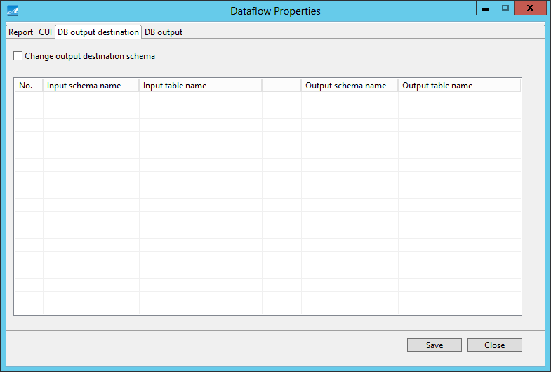

## DB Output Screen

On DB Output screen, you can set whether to delete data existing in database of the output destination at the time of test data registration or not.

This screen is displayed when you click “Settings” on the right window, and click on “DB output” tab.

If the output destination of dataflow is a file, this screen is not to be displayed.

|  |  |
| --- | --- |
| Dataflow type | DB Output screen |
| DB - > Conversion - > File | Not displayed. |
| DB - > Conversion - > DB | Displayed. |
| Load | Displayed. |
| File - > Conversion - > File | Not displayed. |
| Generation - > File | Not displayed. |
| Generation - > DB | Displayed. |

### Screen Outline

Below shows the structure of DB Output Settings screen.

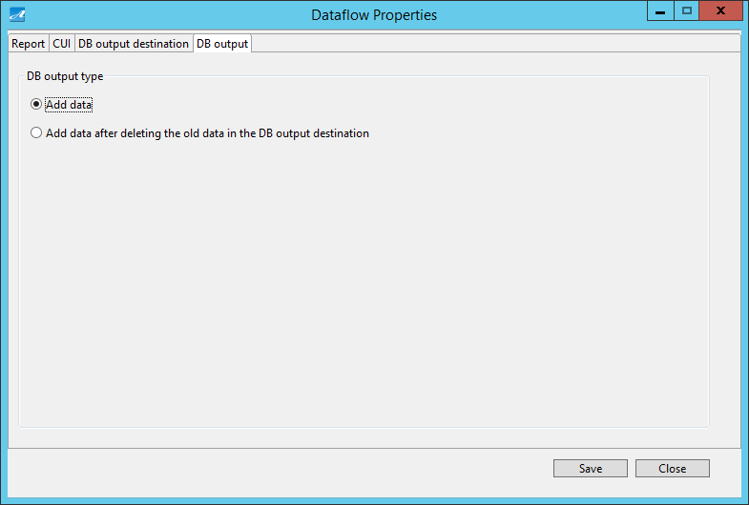

**①**

**③**

**②**

|  |  |
| --- | --- |
| Screen item | Description |
| ① DB output type | Set to delete data existing in database of the output destination or not at the time of test data registration. |
| ② “Save” button | Save settings of DB output. |
| ③ Close | Close the screen. |

### DB Output Settings

1. When you want to add data:

① Select “Add data”.

② Click on “Save” button.



1. When you want to add data after having deleted existing data in DB output destination:

Select “Add data after deleting the old data in the DB output destination” to delete data in the tables of DB output destination.

① Select “Add data after deleting the old data in the DB output destination”.

② Click on “Save” button.

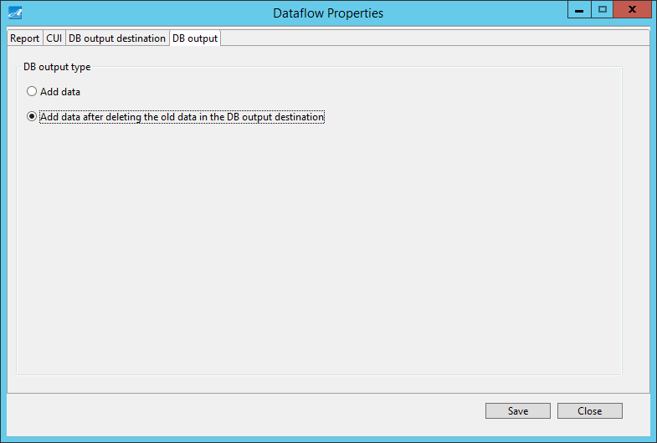

## 5.21 Format Setting Screen

Format Setting Screen allow you to setting language display and date format in TestAce.

|  |  |
| --- | --- |
| Screen item | Description |
| ① Screen display | Allow to choose language display for TestAce. |
| ② Date format | Allow to choose date format display for TestAce. |

### 5.21.1 Screen Outline

The [Format Setting] Screen is shown in the screen below.

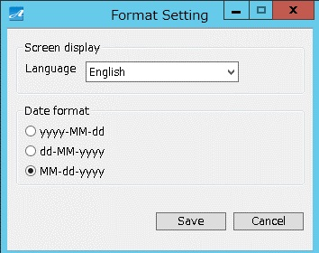

|  |  |
| --- | --- |
| Screen item | Description |
| ① Language | Select English to display English.  Select Japanese to display Japanese. |
| ② Date format | Setting date format  Date format can be set as 「yyyy-mm-dd 」or 「dd-mm-yyyy」or「mm-dd-yyyy」. |
| ③ Save | The selected language display and date Format are saved. |
| ④ Cancel | Cancel. |

# Constraint

This part explains about constraints.

## Windows 2008 Server’s User Account Control Feature

### Outline

Regarding authority issue at the time of running Test Ace by Windows 2008 Server or later versions, if the file system has access restriction, a copy of "each logged-on user" is created in the directory of logged-on user profile by OS function, and the whole series of input / output operations are to be redirected.

This may lead to the loss of characteristic of Test Ace's resource file.

This is a restriction of Windows 2008 Server and later versions due to the specification of its User Account Control Function (UAC).

### Detail

Detailed information is as below.

(a)『The Windows Vista and Windows Server 2008 Developer Story: Application Compatibility Cookbook』

- - > “User Account Control”

URL：http://msdn.microsoft.com/en-us/library/aa480152

### Avoid Restriction

When running Test Ace by Windows 2008 Server, you should execute 2 processings below.

① On running Test Ace, indicate that you “operate as Admin”.

Also indicate that you “operate as Admin” for CUI Run.

② Set apropriate Permission Attribute for CUI Run related files.

Above processings are verifed based on Microsoft Windows Server 2008 R2 Standard (Version 6.1.7600) information. Specifications and functions of Microsoft Windows Server 2008 R2 are subject to change.

## Conversion Issue regarding Microsoft Windows Codepage 932 Shift – JIS and Unicode

### Outline

For some code, conversion cannot be implemented between Microsoft Windows Codepage 932 Shift – JIS and Unicode (one-way conversion is possible, but not the other way around).

### Detail

You can refer to more detailed information below.

『[PRB] Conversion Problem Between Shift-JIS and Unicode』

URL：http://support.microsoft.com/kb/170559/en-us

## Oracle JDBC Driver’s Character Consistency Problem

### Outline

Due to character code conversion, some information may be missing, or garbled text incident may happen.

This is a restriction caused by differences in the conversion of character sets adopted by OS, Java, and databases.

However, this problem is limited to a small number of multibyte codes.

### Detail

You can refer to more detailed information below.

(a)『Oracle Database Online Documentation, 10g Release 2 (10.2)』

- - >「7 Programming with Unicode」

- - >「Character Integrity Issues in a Multibyte Database Environment」

URL：https://docs.oracle.com/cd/B19306_01/server.102/b14225/ch7progrunicode.htm#i1005901

(b)『Character consistency problem in NLS environment』

URL：http://docs.oracle.com/cd/A84870_01/doc/server.816/a76966/ch2.htm

## PostgreSQL JDBC Driver’s Error Message Garbled Text

### Outline

JDBC Driver while accessing to PostgreSQL may lead to error message garbled text.

This is a restriction due to the convention “Set Local Format” indiated in PostgreSQL’s document.

### Detail

You can refer to more detailed information below.

(a)『PostgreSQL 9.3 Documentation』

- - >「18.11.2. Locale and Formatting」

- - >「lc_messages (string)」

URL：https://www.postgresql.org/docs/9.3/static/runtime-config-client.html

#RUNTIME - CONFIG - CLIENT - FORMAT

(b)『PostgreSQL 9.3 Documentation』

- - >「22.1. Locale Support」

URL：http://www.postgresql.org/docs/9.3/interactive/locale.html

Example:

In the PostgreSQL to be connected, when the value of lc_messages parameter in postgresql.conf is specified as "Japanese_Japan.932" and the operation uses Test Ace, PostgreSQL JDBC Driver's error message garbled text may occur.

Above information is verified based on PostgreSQL JDBC Driver (9.3 JDBC4.1 (build 1101)) information. Specifications and features of PostgreSQL and PostgreSQL JDBC Driver are subject to change.

## Test Ace Feature Constraint

### Constraint of the Conversion Types “Foreign Key”, “Dependent Column”

In reference relationship of the conversion types "Foreign key" and "Dependent column", at least two hierarchical levels are referred to.

For tables, it is necessary to output all databases.

This constraint applies to the following dataflows.

(A) [DB -> Conversion -> DB]

(B) [DB -> Conversion -> File]

(C) [File -> Conversion -> File]

### Constraint of User-Specific Pseudo Data Registration

Regarding creating new pseudo data, when you register user-specific pseudo data in Test Ace, if the same information with data registered in import file has already been registered in “Pseudo Data (Add User)”, it cannot be registered in Test Ace.

Please refer to “5.4.5 Create New Pseudo Data”.

### Constraint of creating new user-Specific Pseudo Data

When you use 「Creating new Pseudo data」function in user-specific pseudo data of TestAce, it supports less than 1 million records because of applying the rule conversion of the program.

Out of the limitation which is described in this document, the program can be affected by other factors such as hardware specification.